Load Test Report

## Load Details

stack: S1

stack_url: https://jupiter.uptycs.net/

sprint: 138

build: 138023

load_type: ControlPlane

load_duration_in_hrs: 12 hrs

load_start_time_ist: 2023-09-04 00:30

load_end_time_ist: 2023-09-04 12:30

### Kafka topics

|  |
| --- |
| 138023 |
| Summary : New topics found |
| New Topics : __consumer_offsets __debezium-heartbeat.cdc __debezium-heartbeat.statedb agentghquery agentkubequery agentlesslog agentlesslogdecorator agentoktaquery agentosquery alert alert_replay api asset-capability assetgroup1 audit auto-exception az_events_blob bulk_replay cdc.public.alerts cdc.public.asset_cloud_infos cdc.public.asset_tags cdc.public.assets cdc.public.cloud_accounts cdc.public.customer_database cdc.public.customers cdc.public.incidents cdc.public.object_groups cdc.public.user_object_groups cdc.public.users cloudconnectorsink cloudqueryVuln cloudqueryevents cloudqueryinventory cloudtrail_objects compliance compliance_summary containers cqazevents cqcloudtrail cqcloudtrail_data_sink cqcloudtrail_ro_sink debezium_configs debezium_offsets debezium_statedb_configs debezium_statedb_offsets debezium_statedb_status_storage debezium_status_storage decorators detection ephermalresources epsink event event_cloud event_replay gcp_cloudlog_objects managedavtables notifications op osquery_cli_tags prestoquerylogs querypack realtimequery registryevent reportschedule1 scan_summary sidequerydecorator slackuser1 state statedb.public.containers_current statedb.public.kubernetes_nodes_current statedb.public.kubernetes_pods_containers_current statedb.public.kubernetes_pods_current statedb.public.vulnerabilities_scanned_images tag1 threat_indicators unified_dashboard uptycs-cloud-remediation vulnerabilities vulntickets |
| Old Topics : |

## Charts

### Live assets

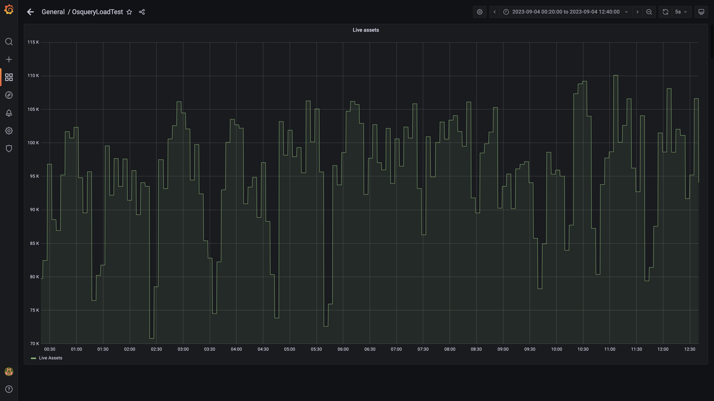

### Kafka lag for all groups

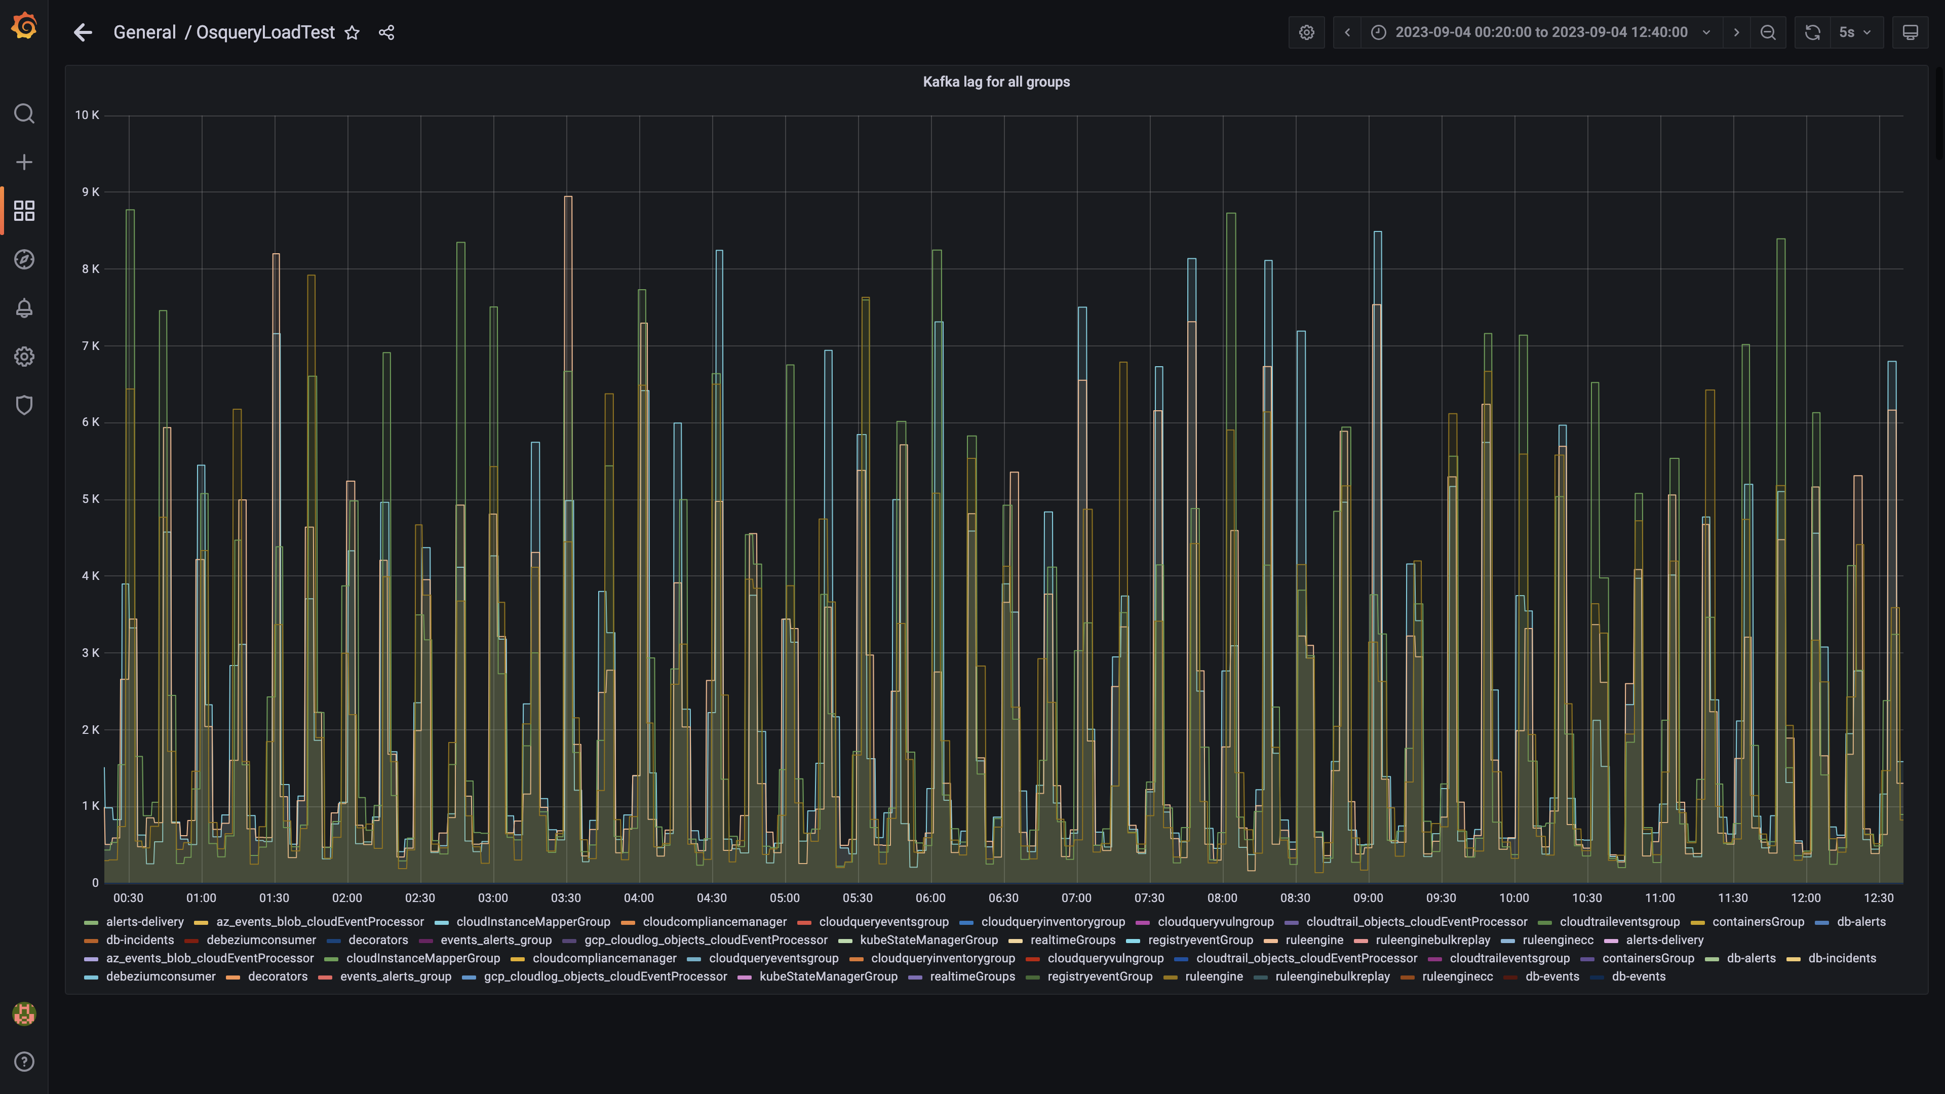

### Process node ram used percent

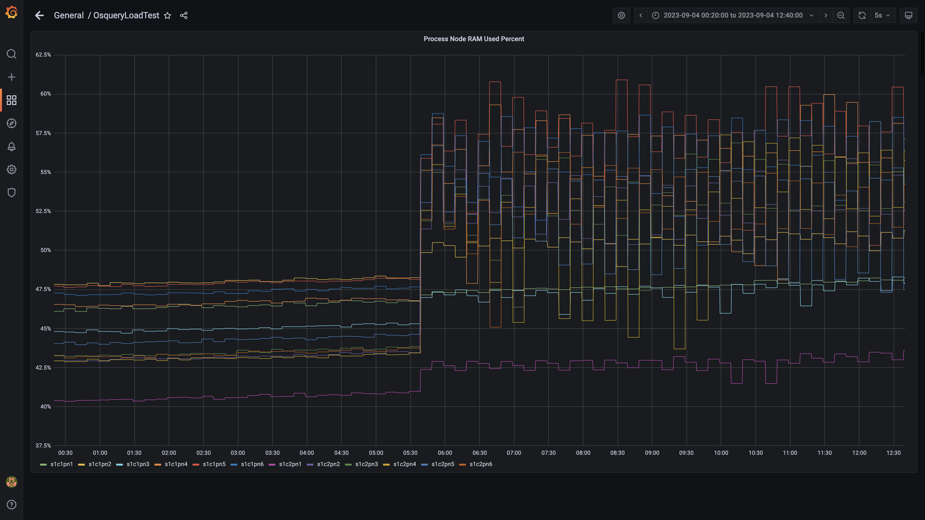

### Data node ram used percent

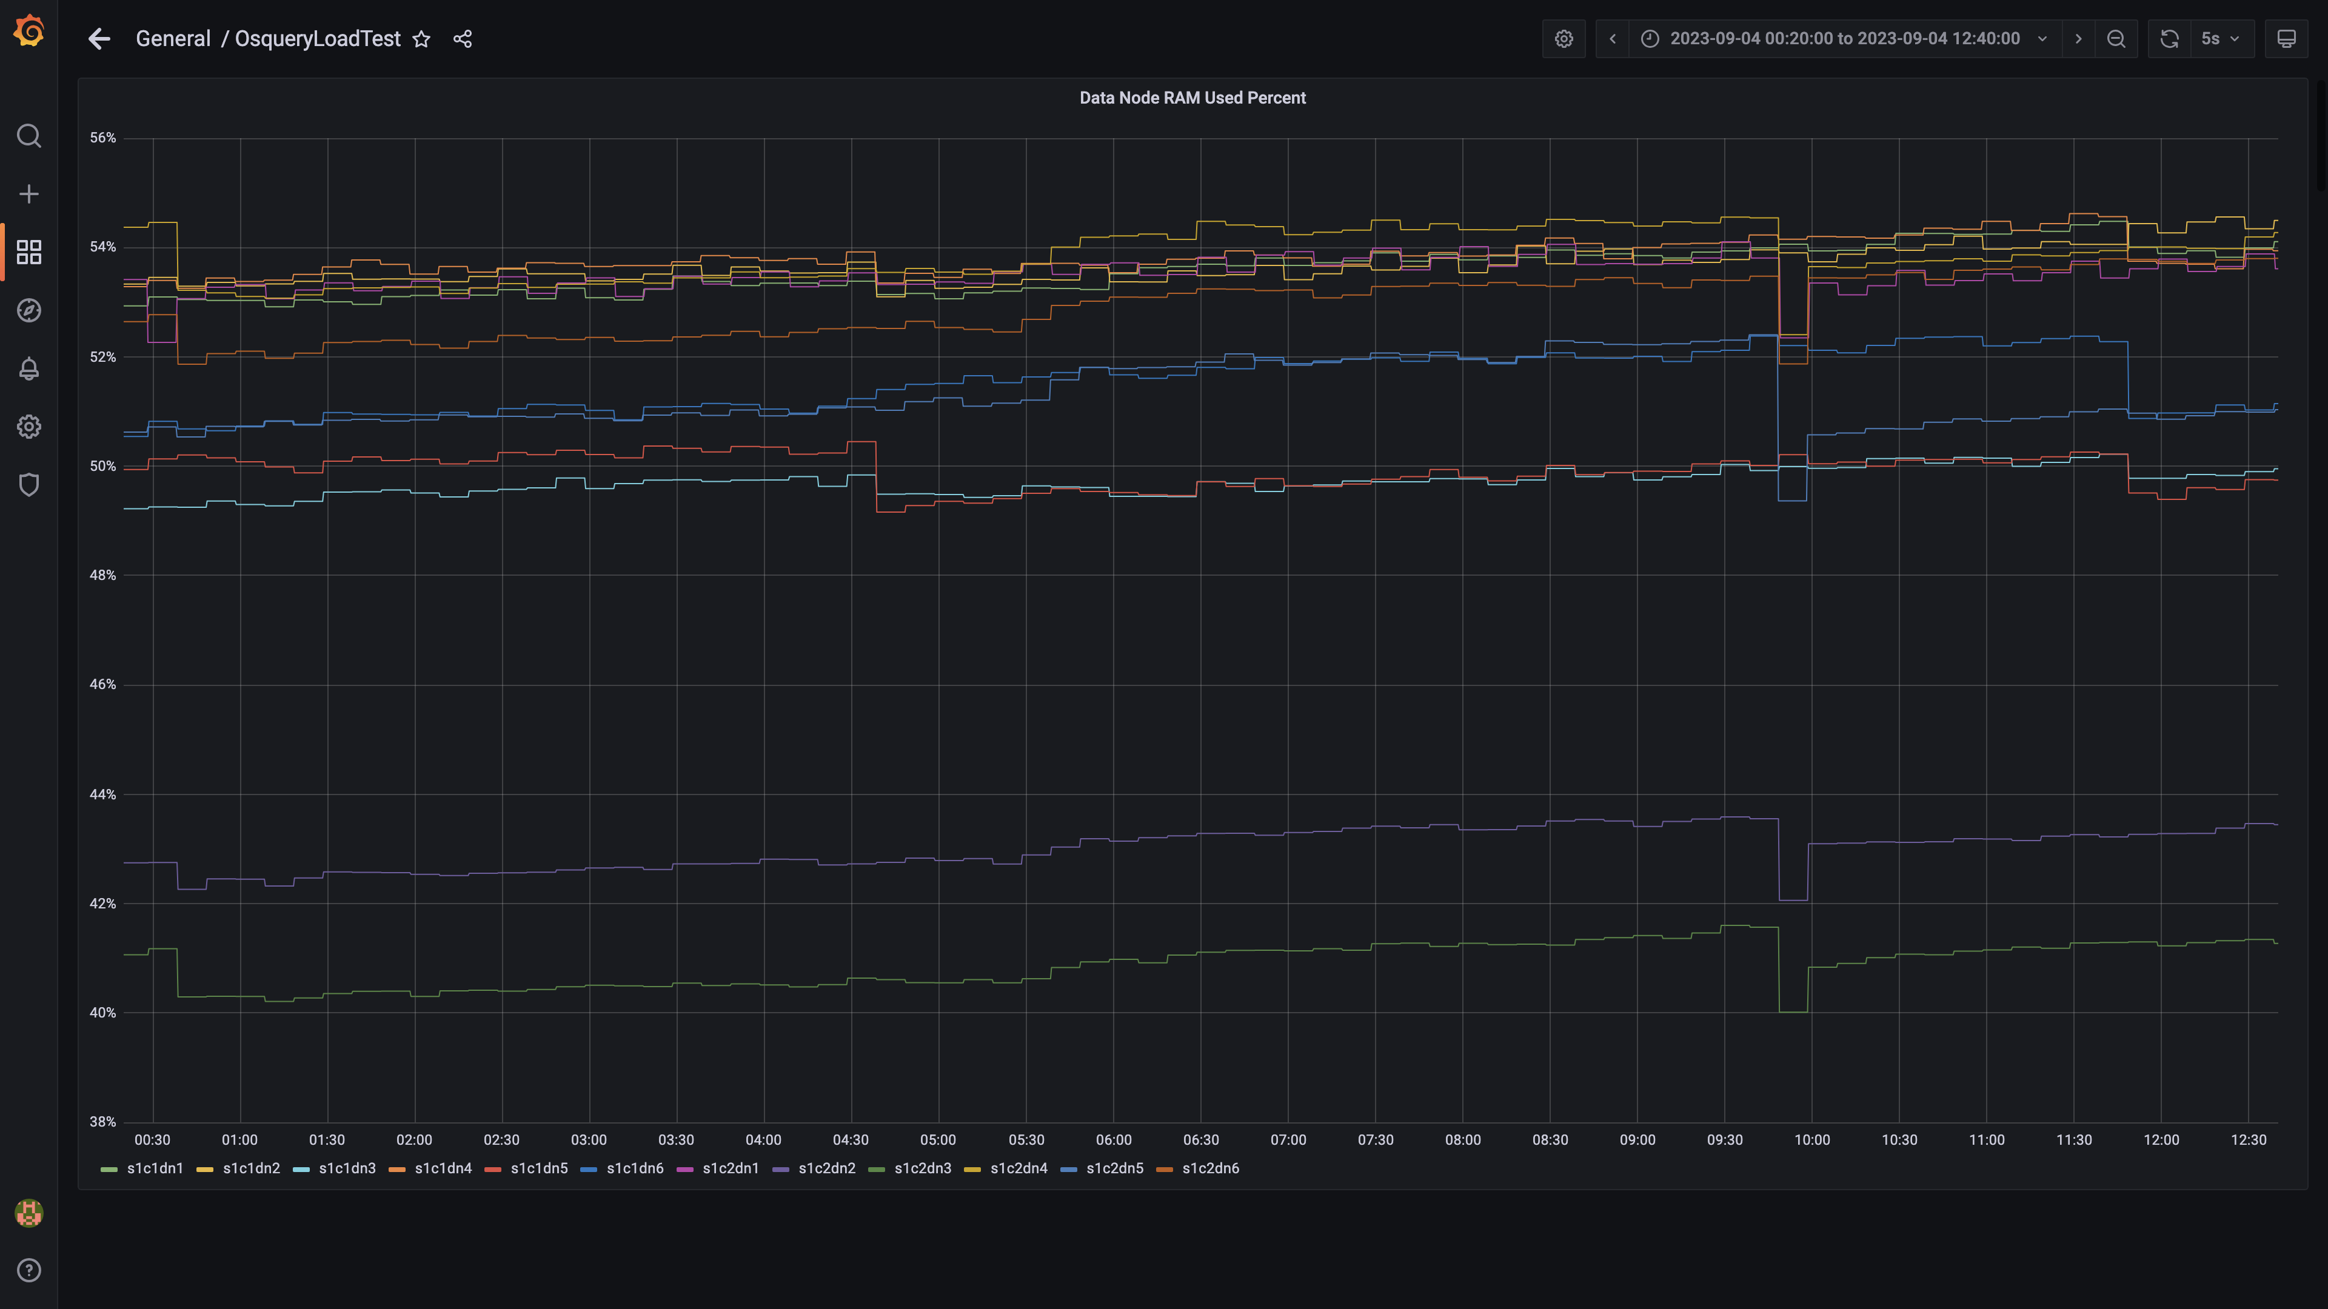

### Postgres node ram used percentage

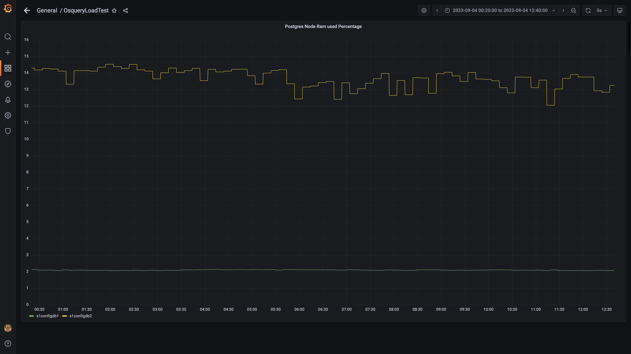

### Memory consumed by eventsdbingestion

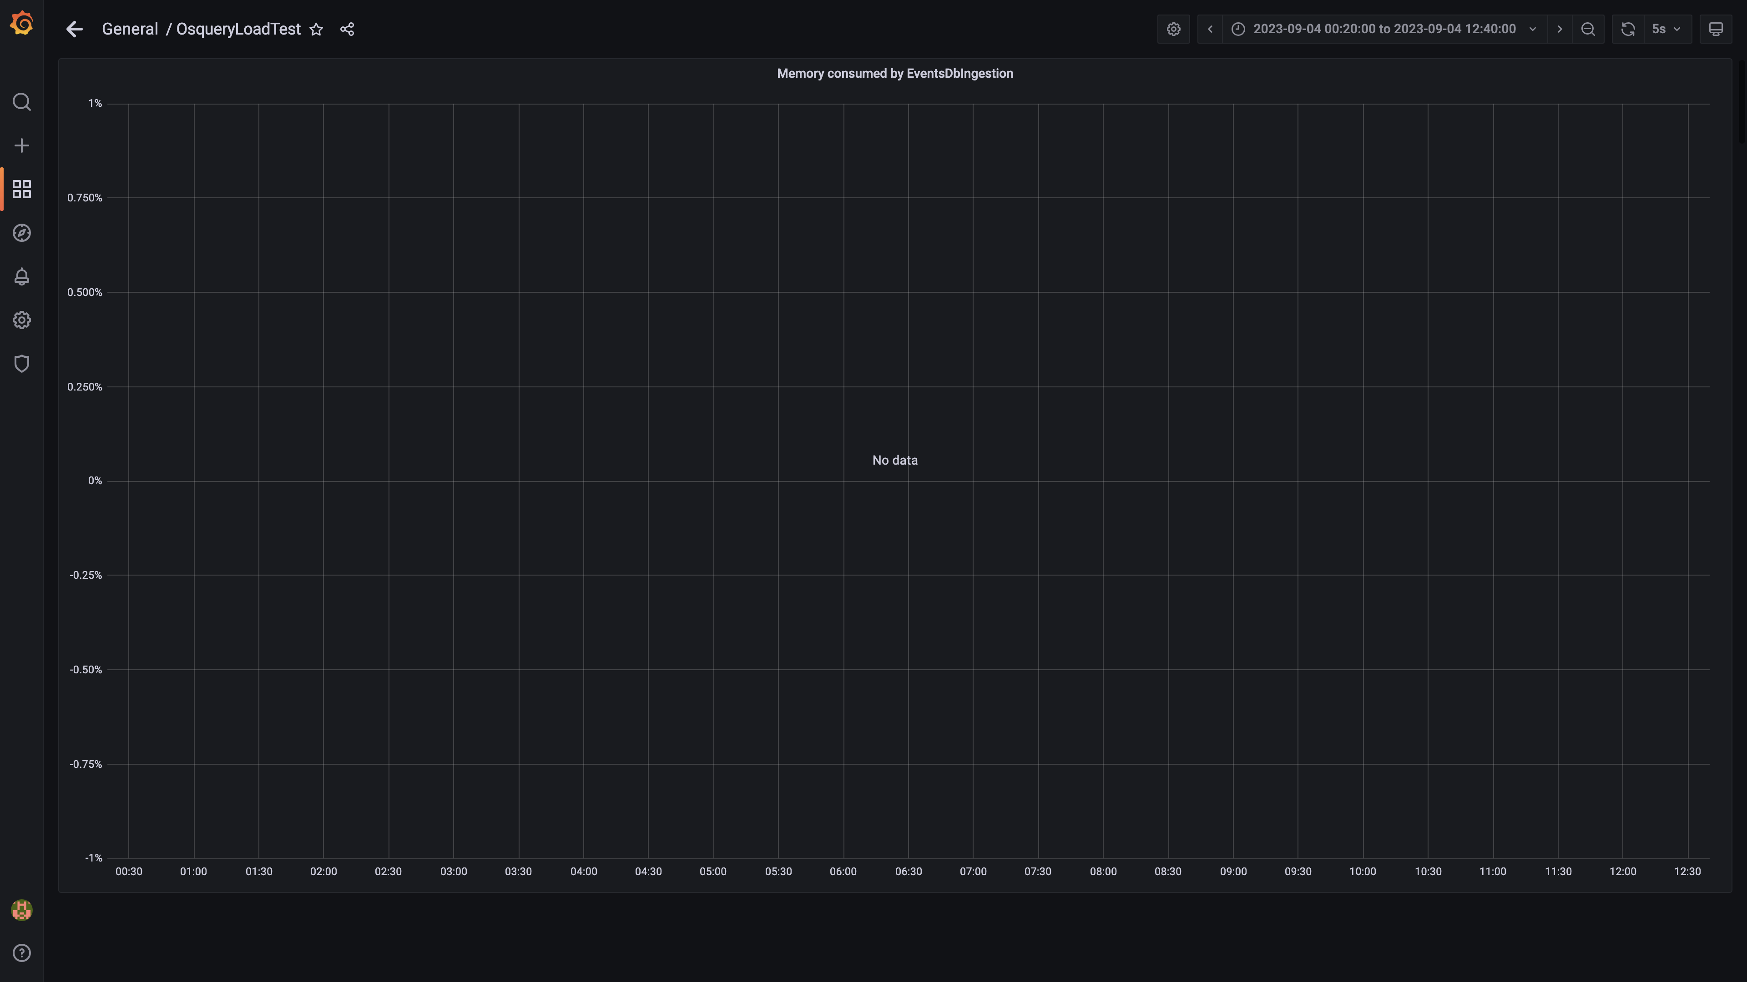

### Kafka disk used percentage

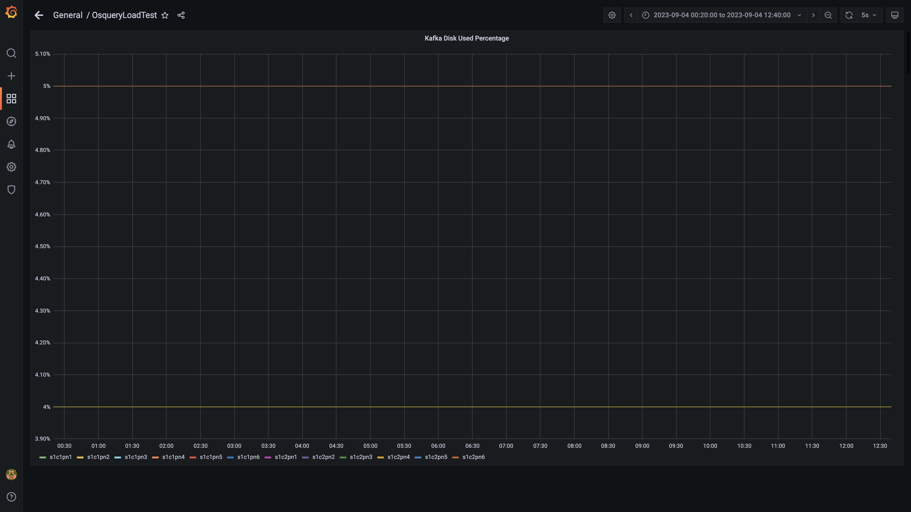

### Memory consumed by orc-compaction

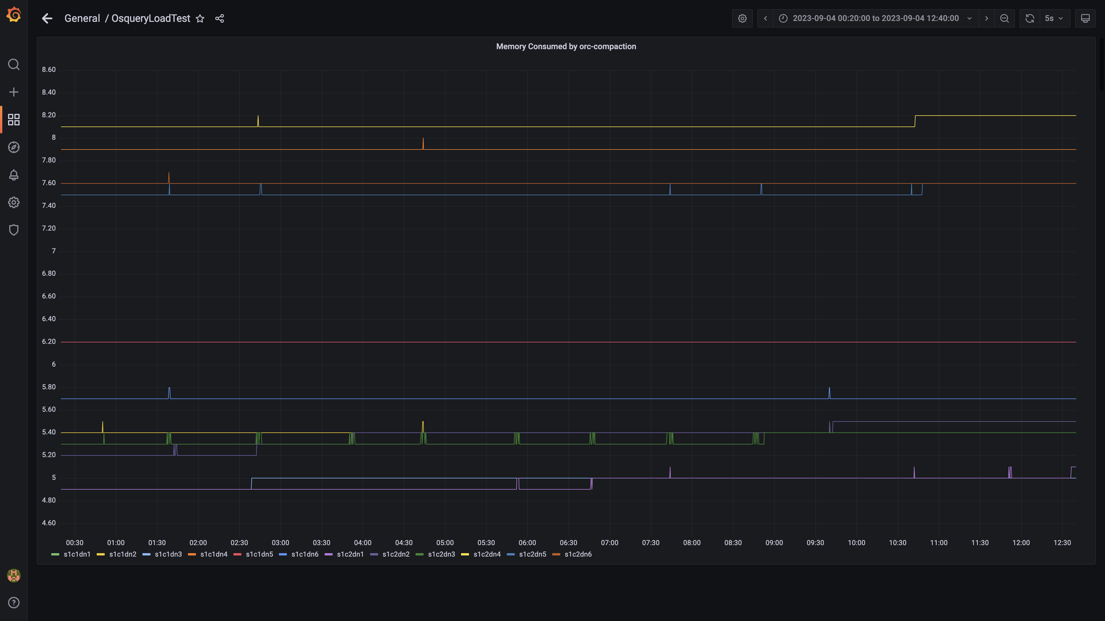

### Compliance summary consumer memory consumption

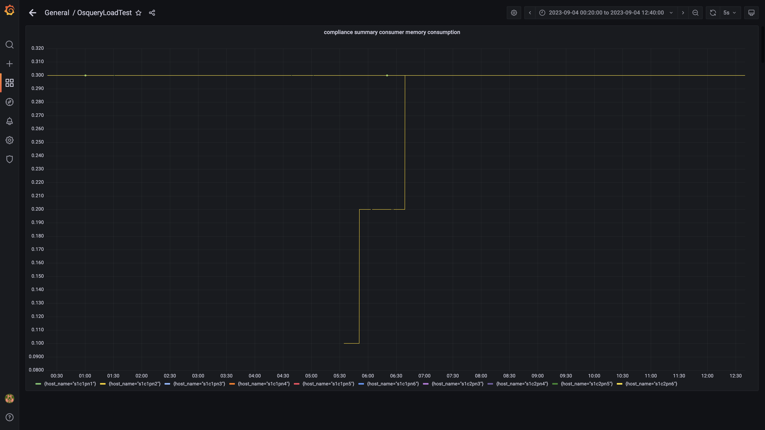

### Memory consumed by logger

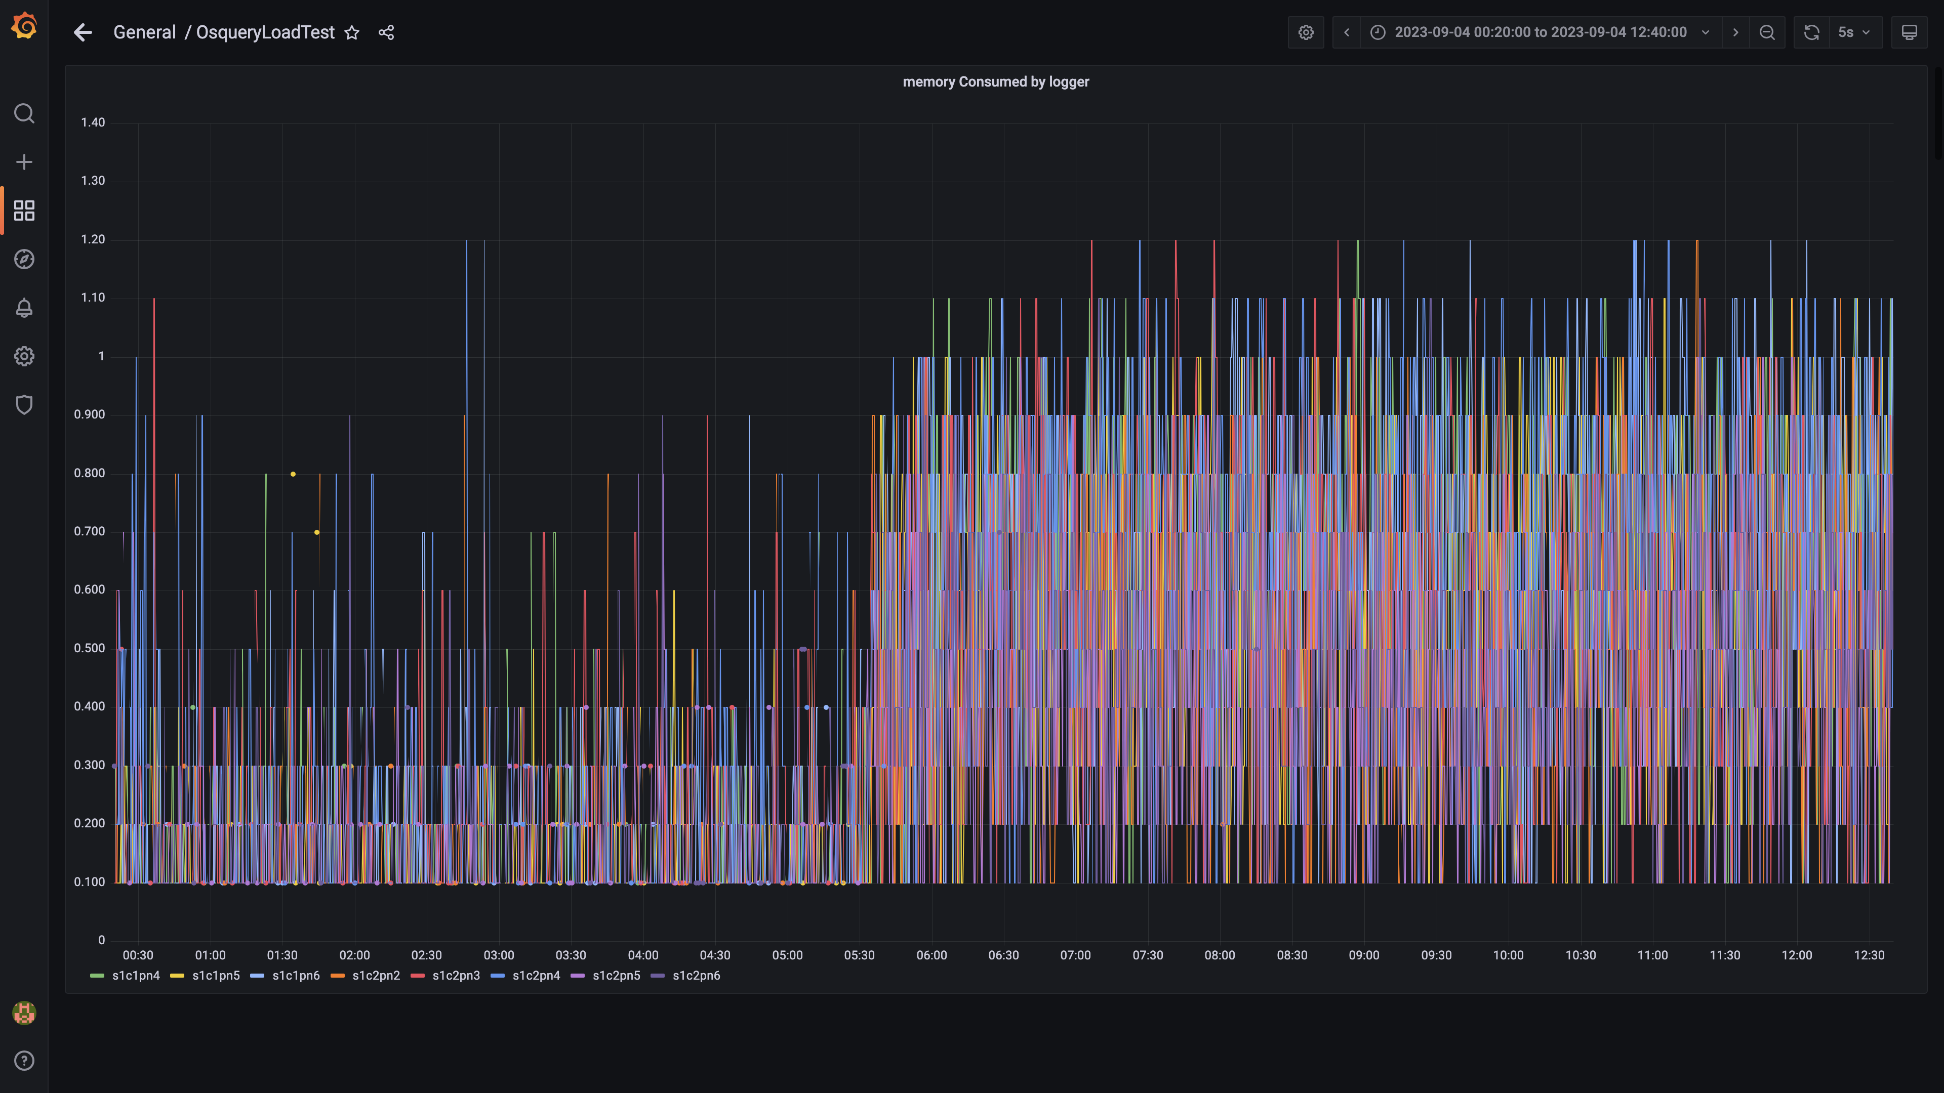

### Kafka memory used percentage

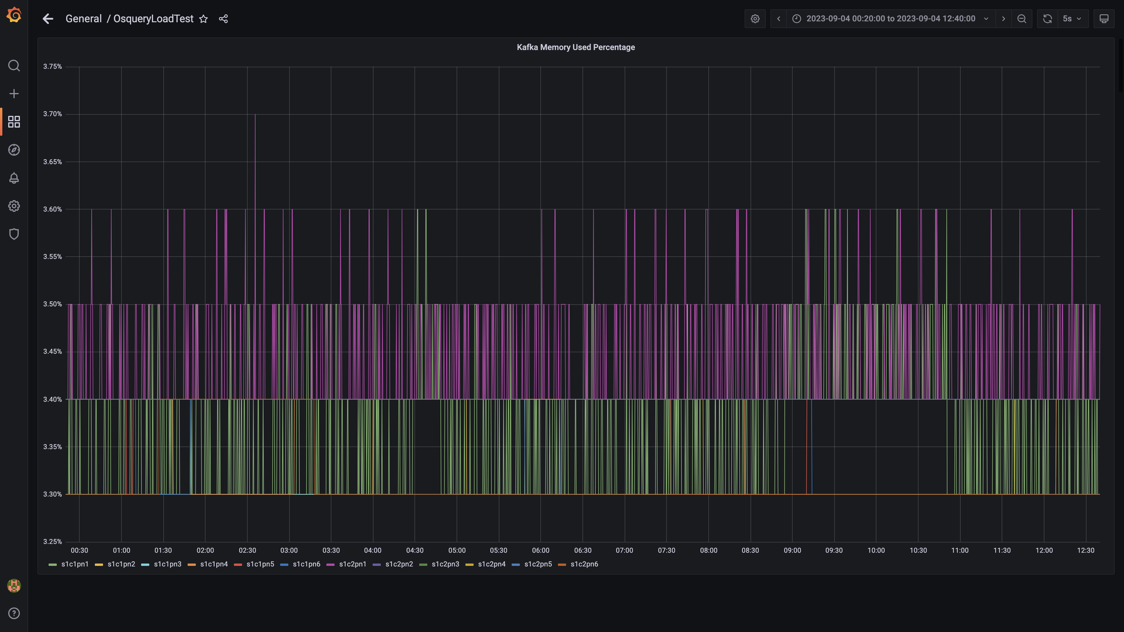

### Memory consumed by trino

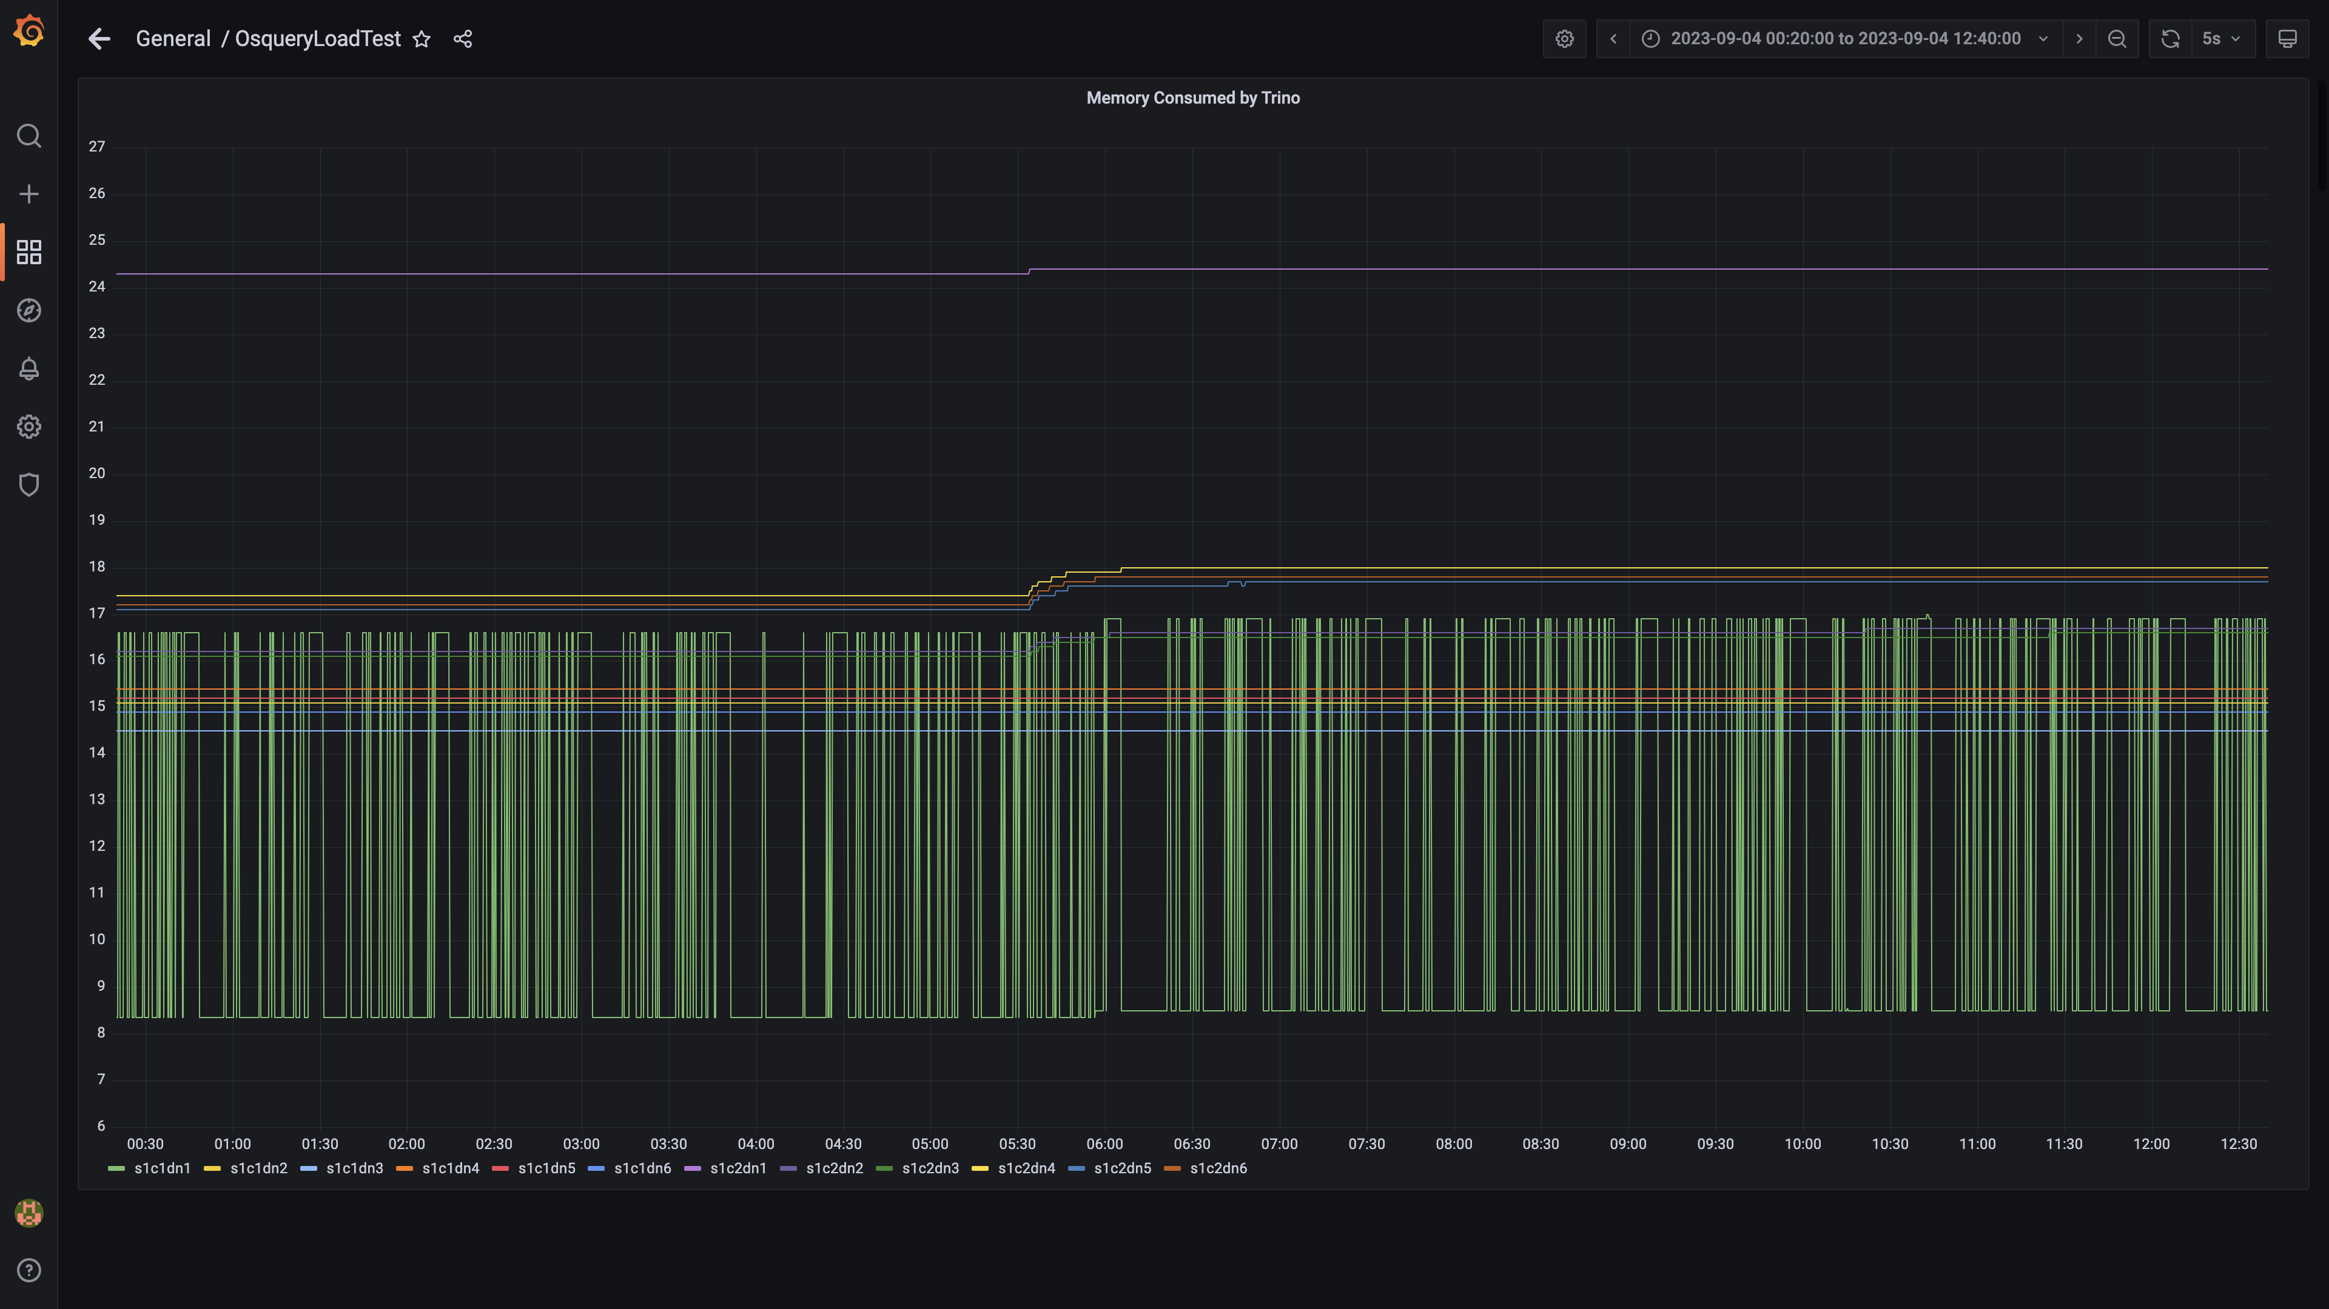

### Memory consumed by osqueryingestion

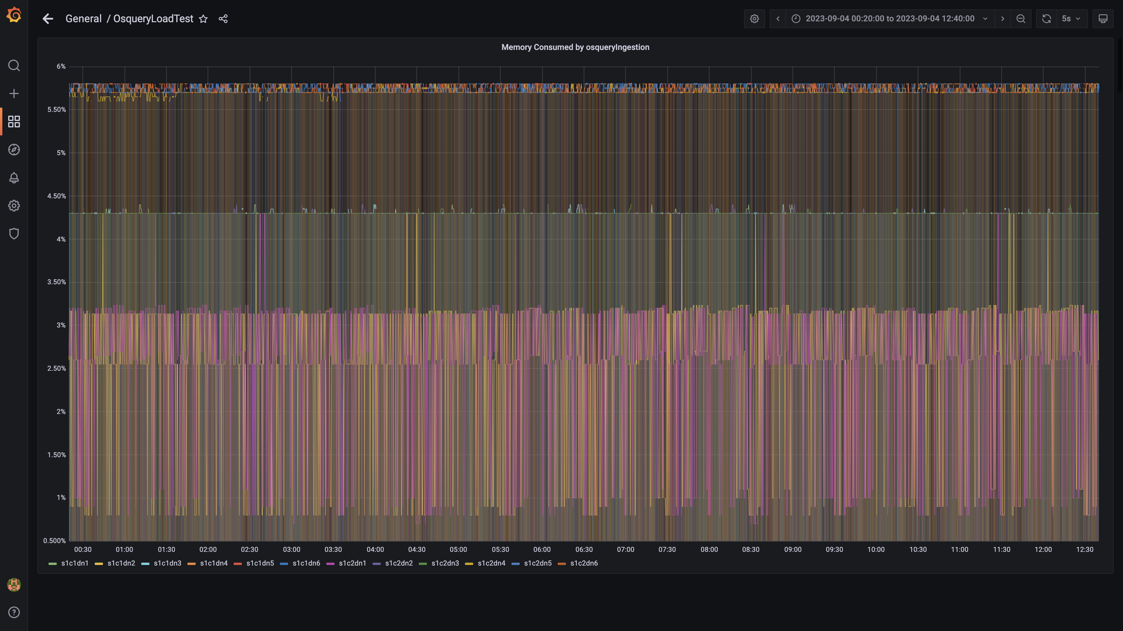

### Memory consumed by spark-worker

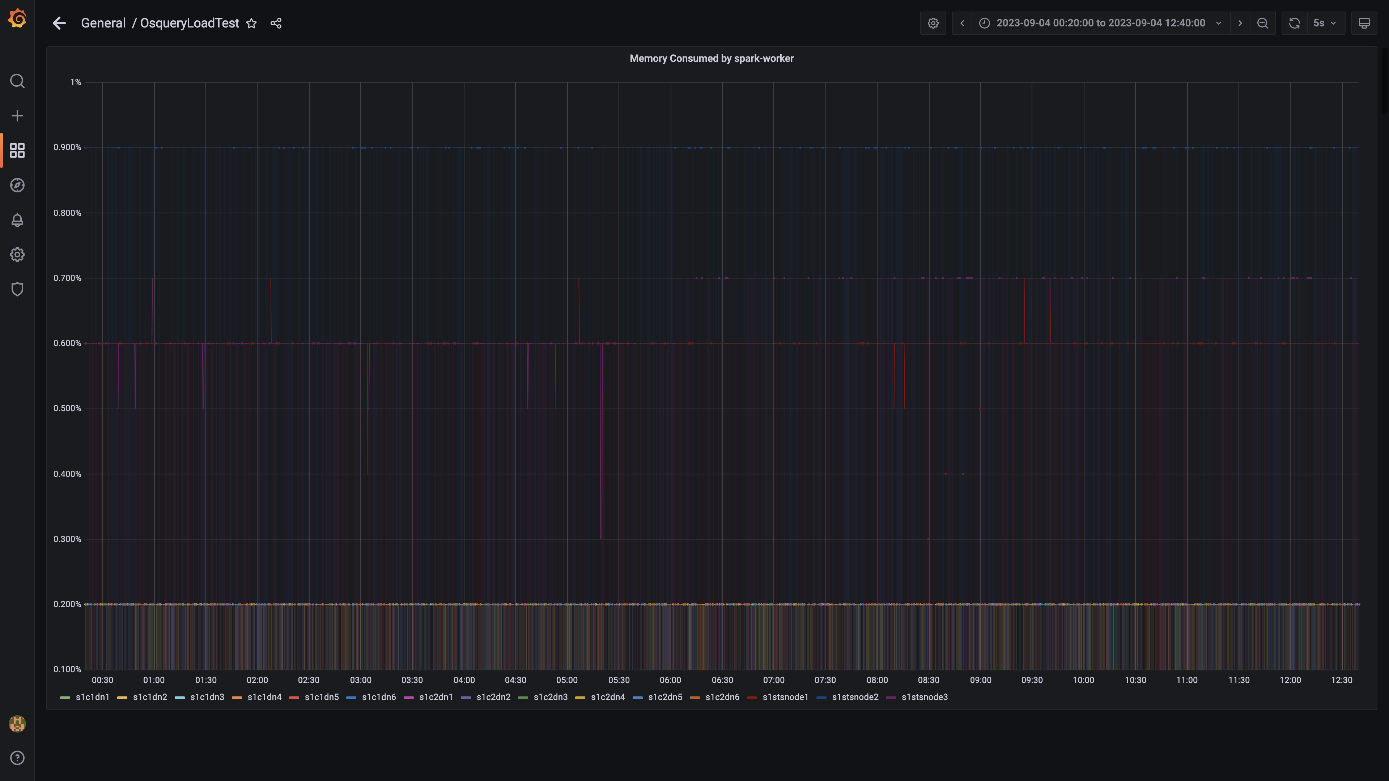

### Memory consumed by ruleengine

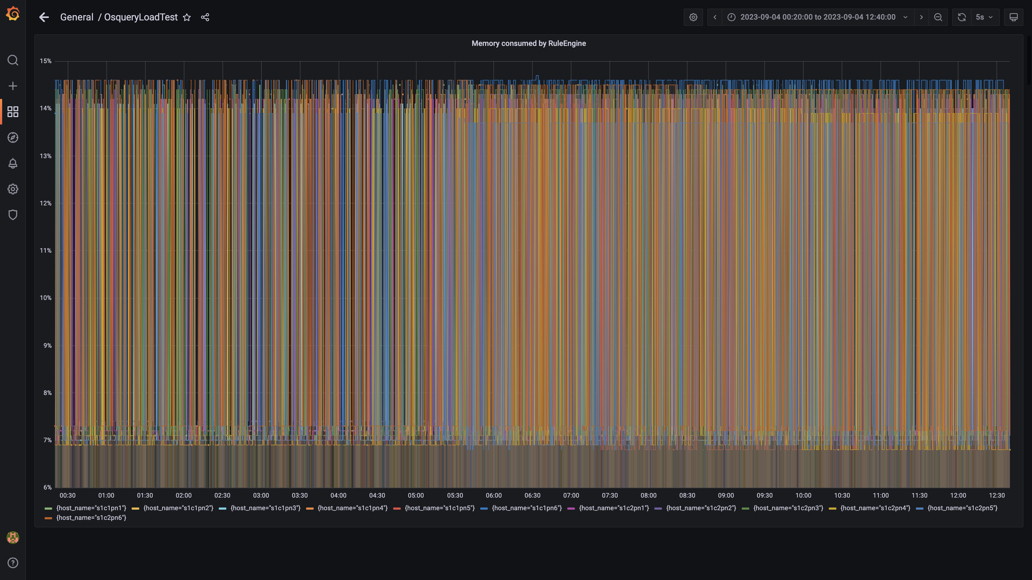

### Memory consumed by configdb

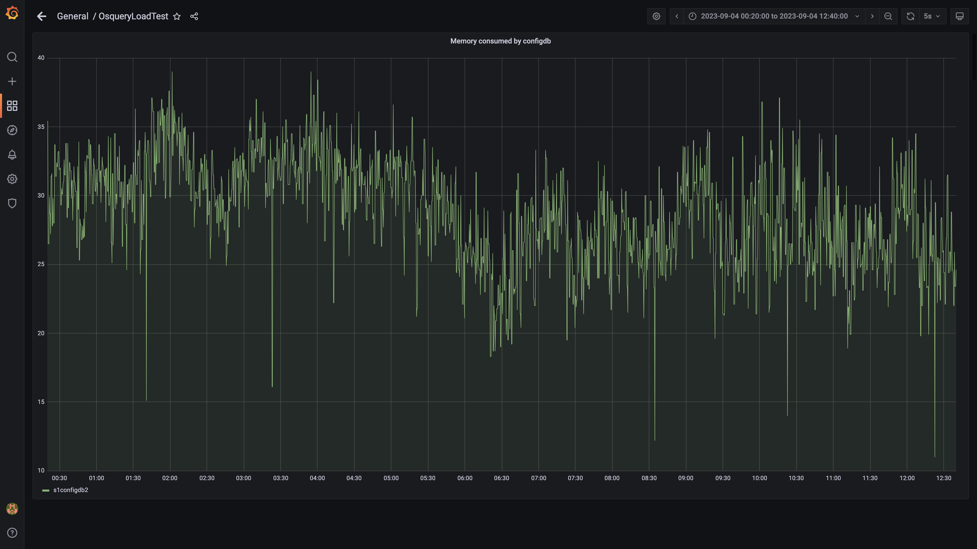

### Memory consumed by data archival

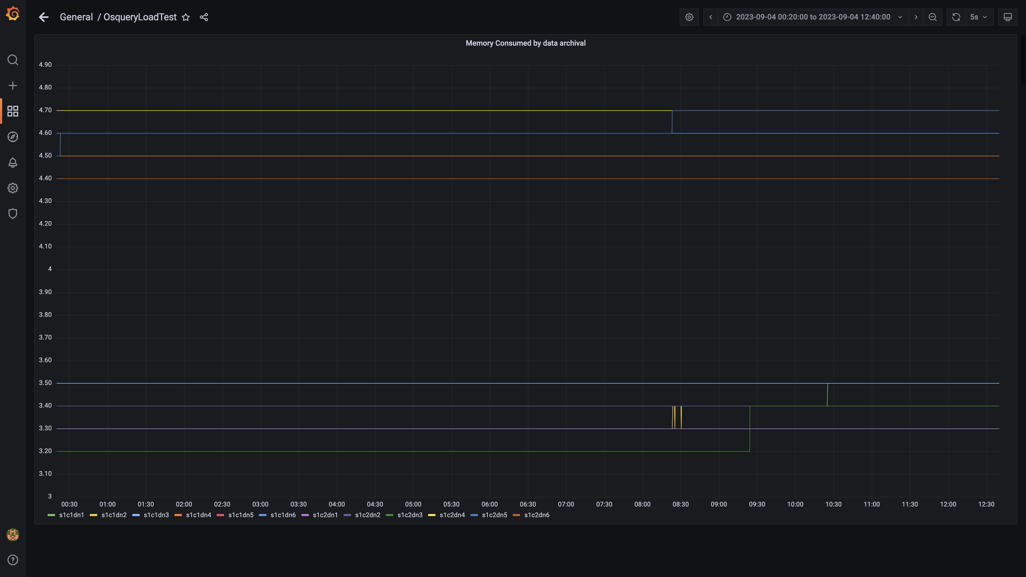

### Debezium memory usage

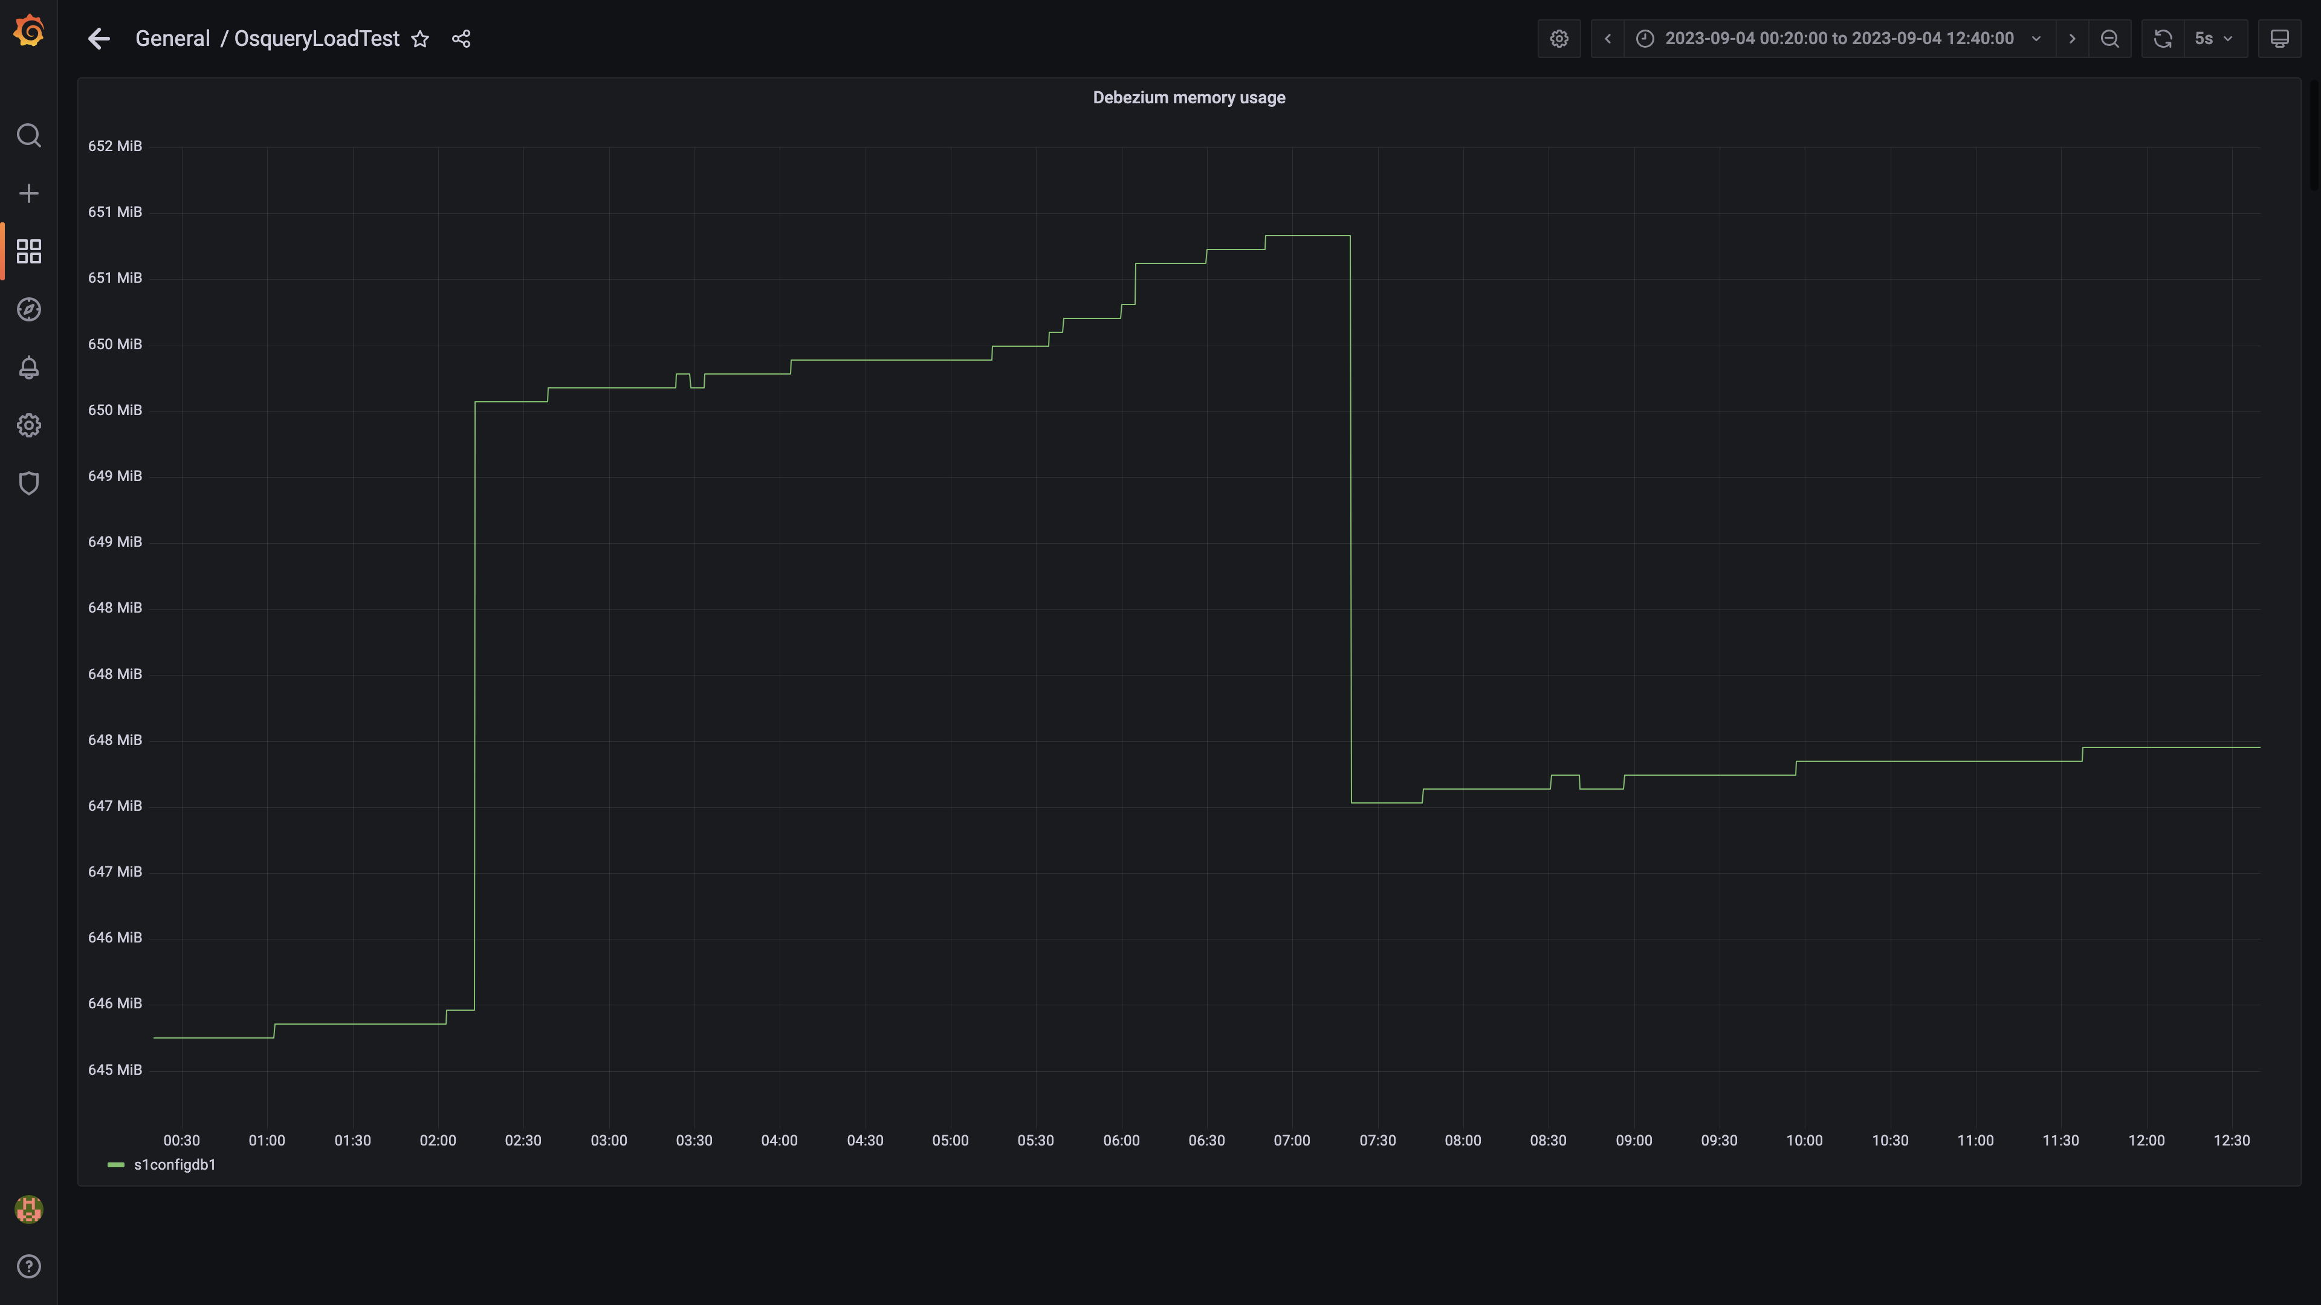

### Memory consumed by redis server

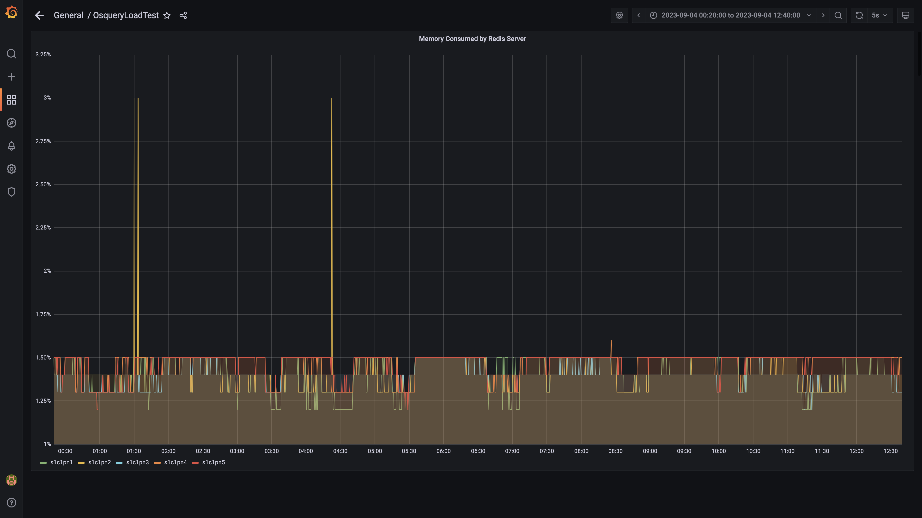

### Memory consumed by tls

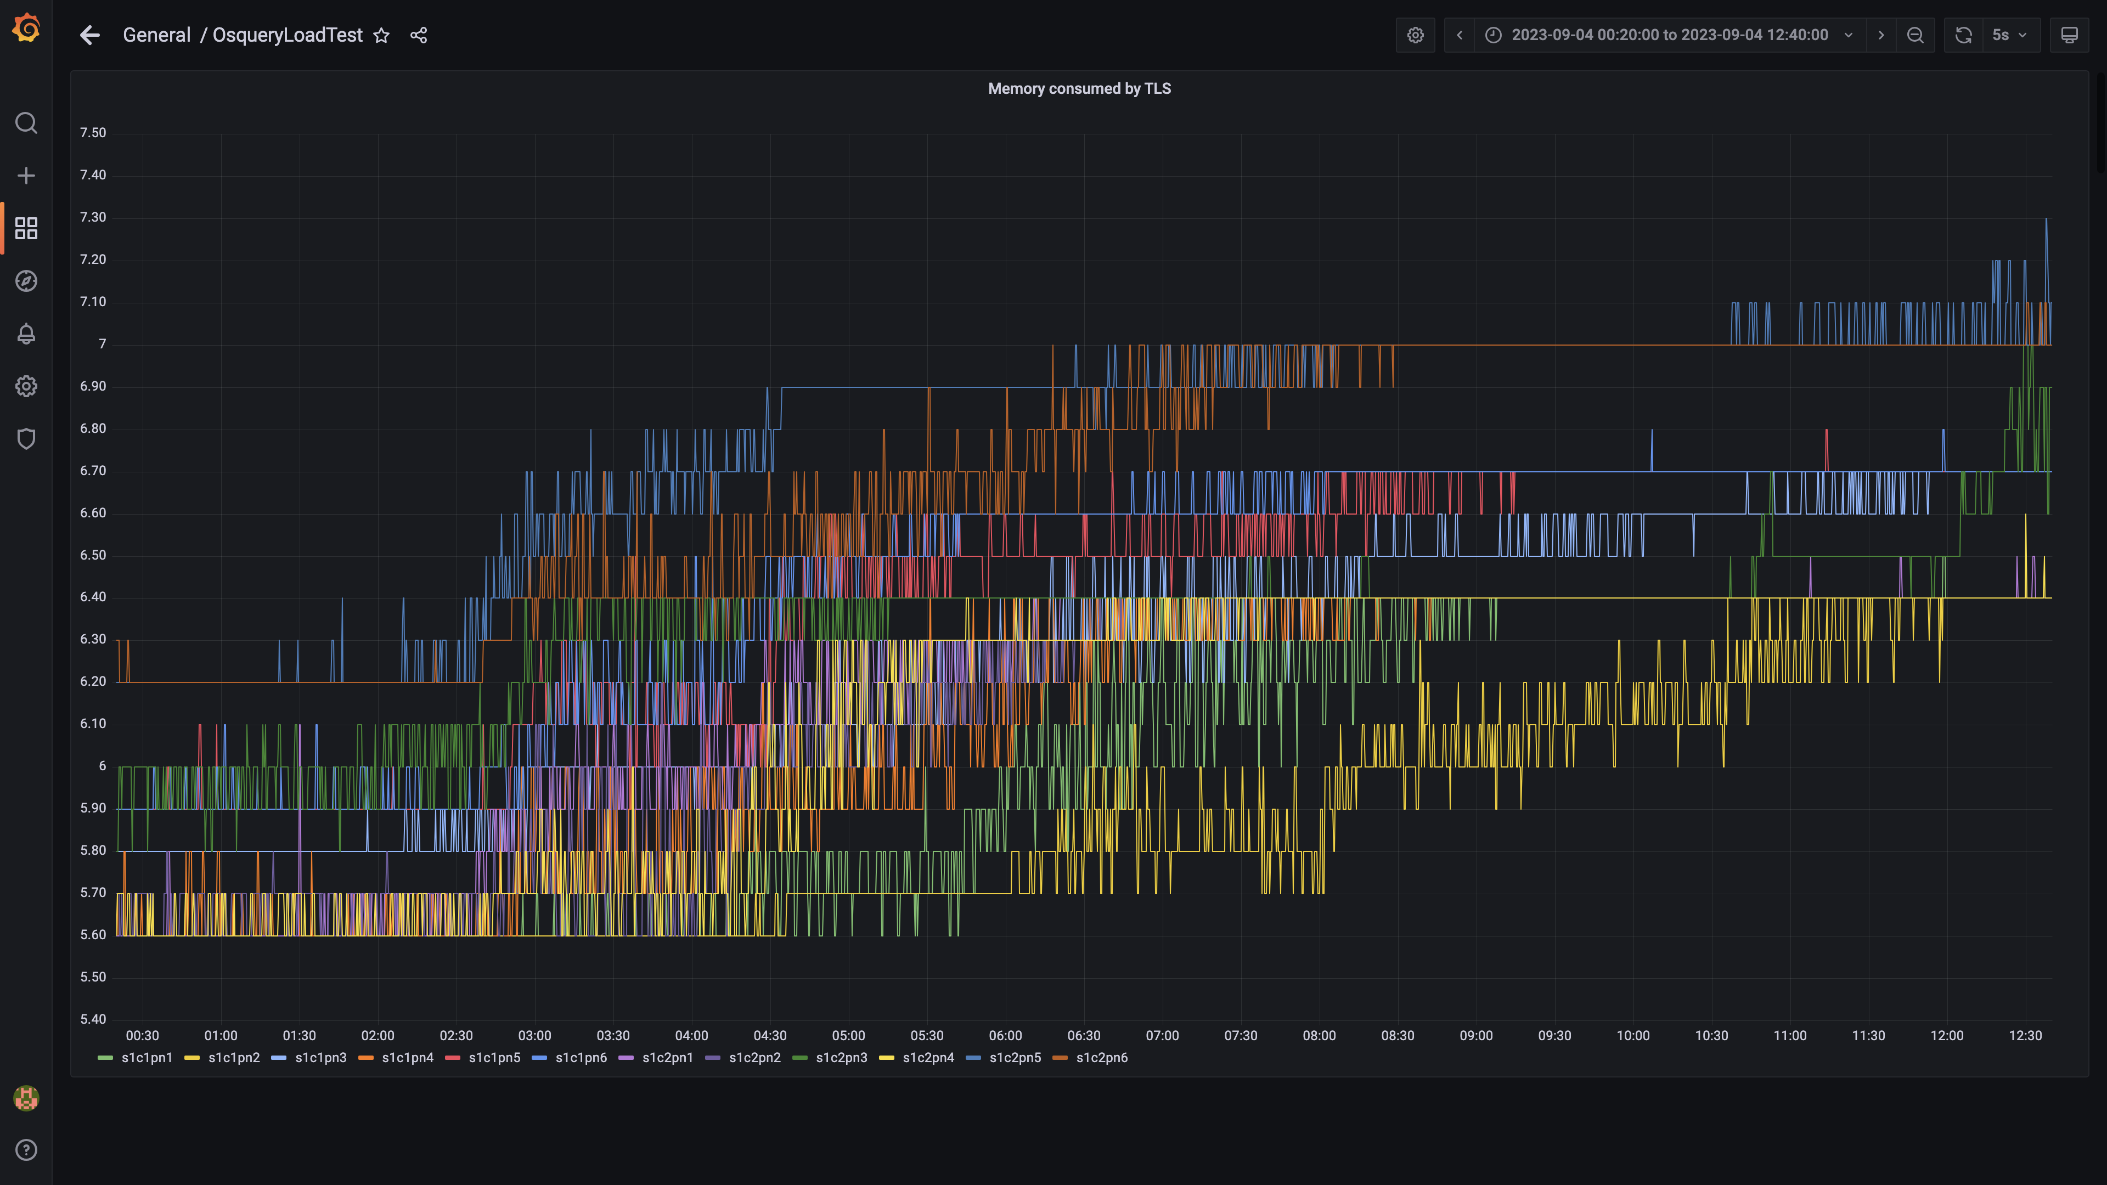

### Airflow memory usage

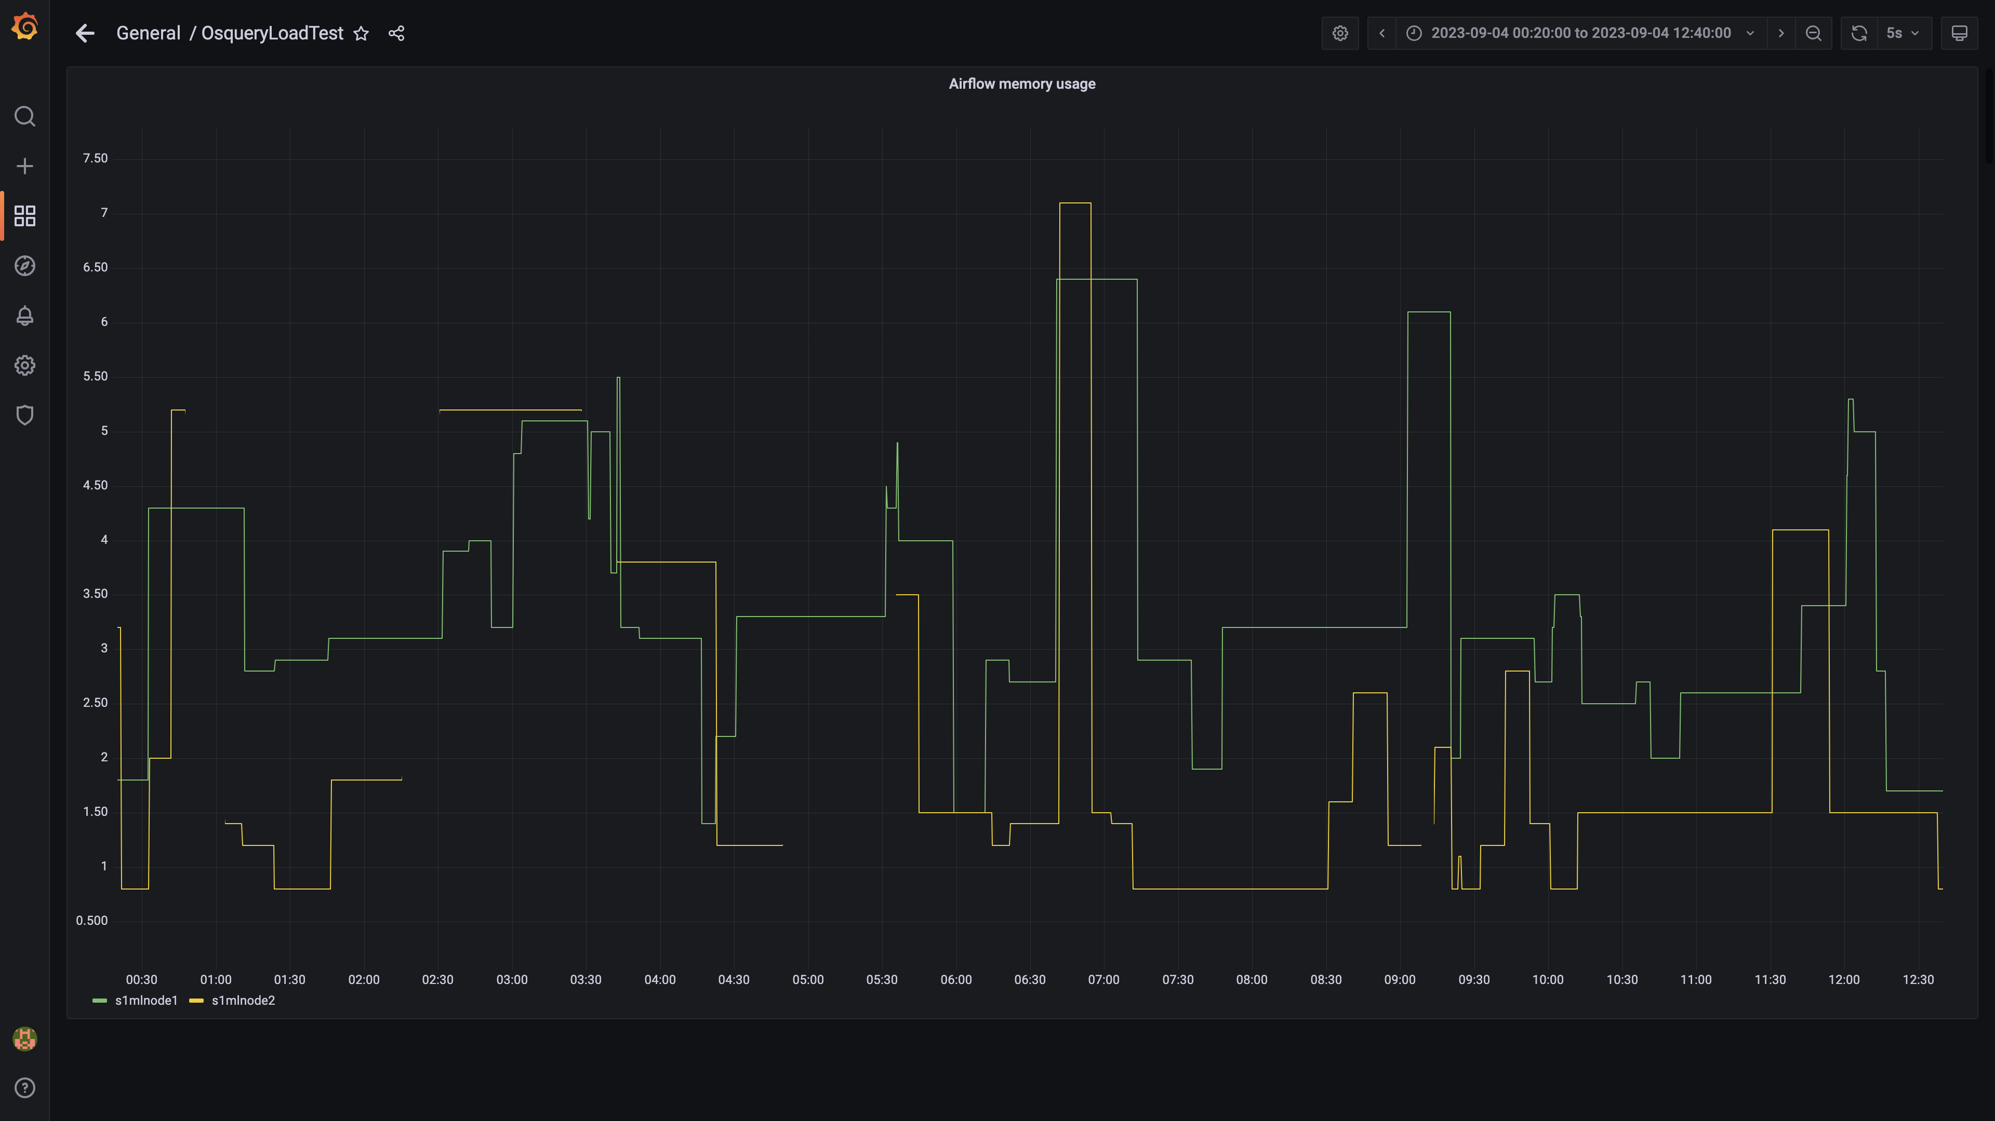

### Postgres node cpu busy percent

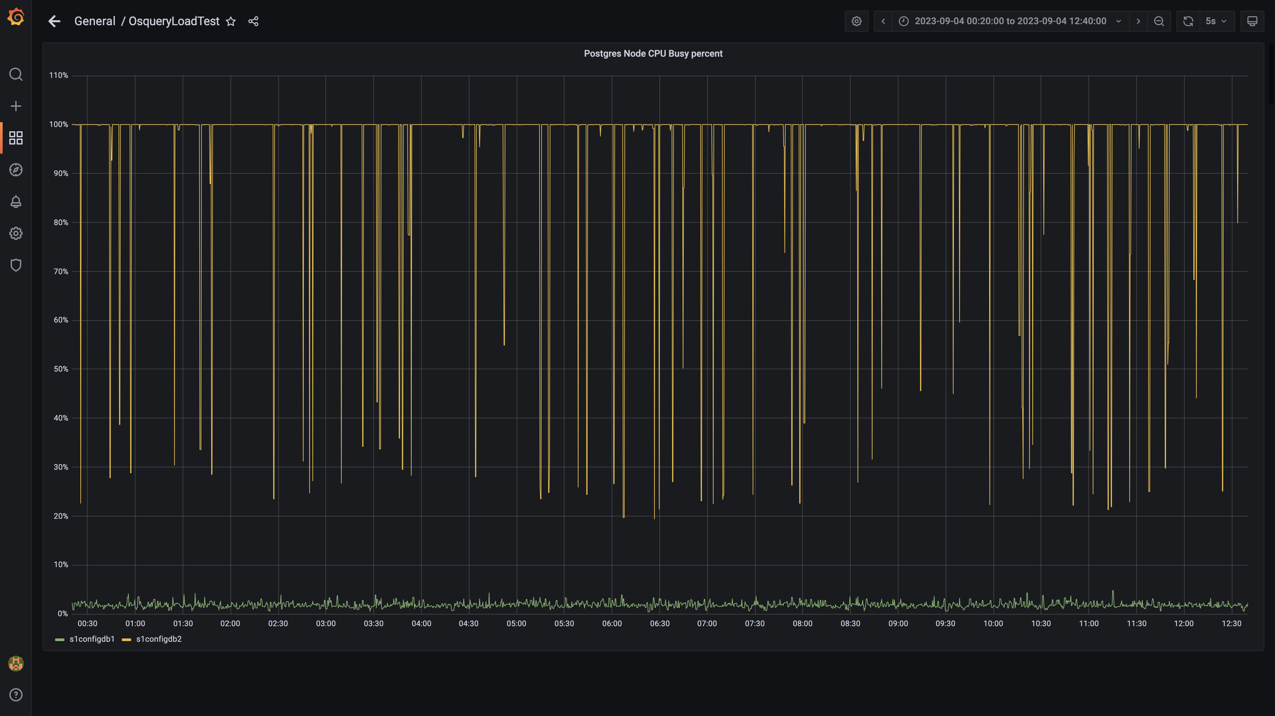

### Process node cpu busy percent

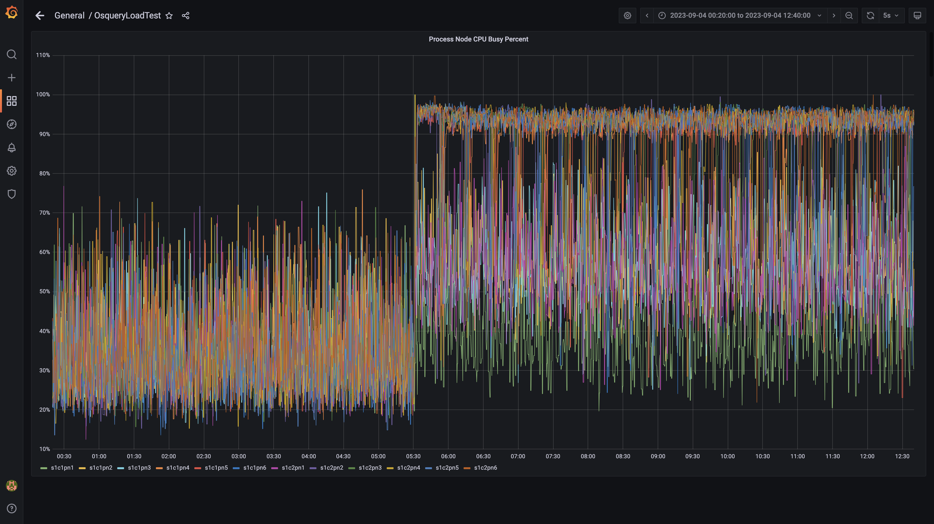

### Data node cpu busy percent

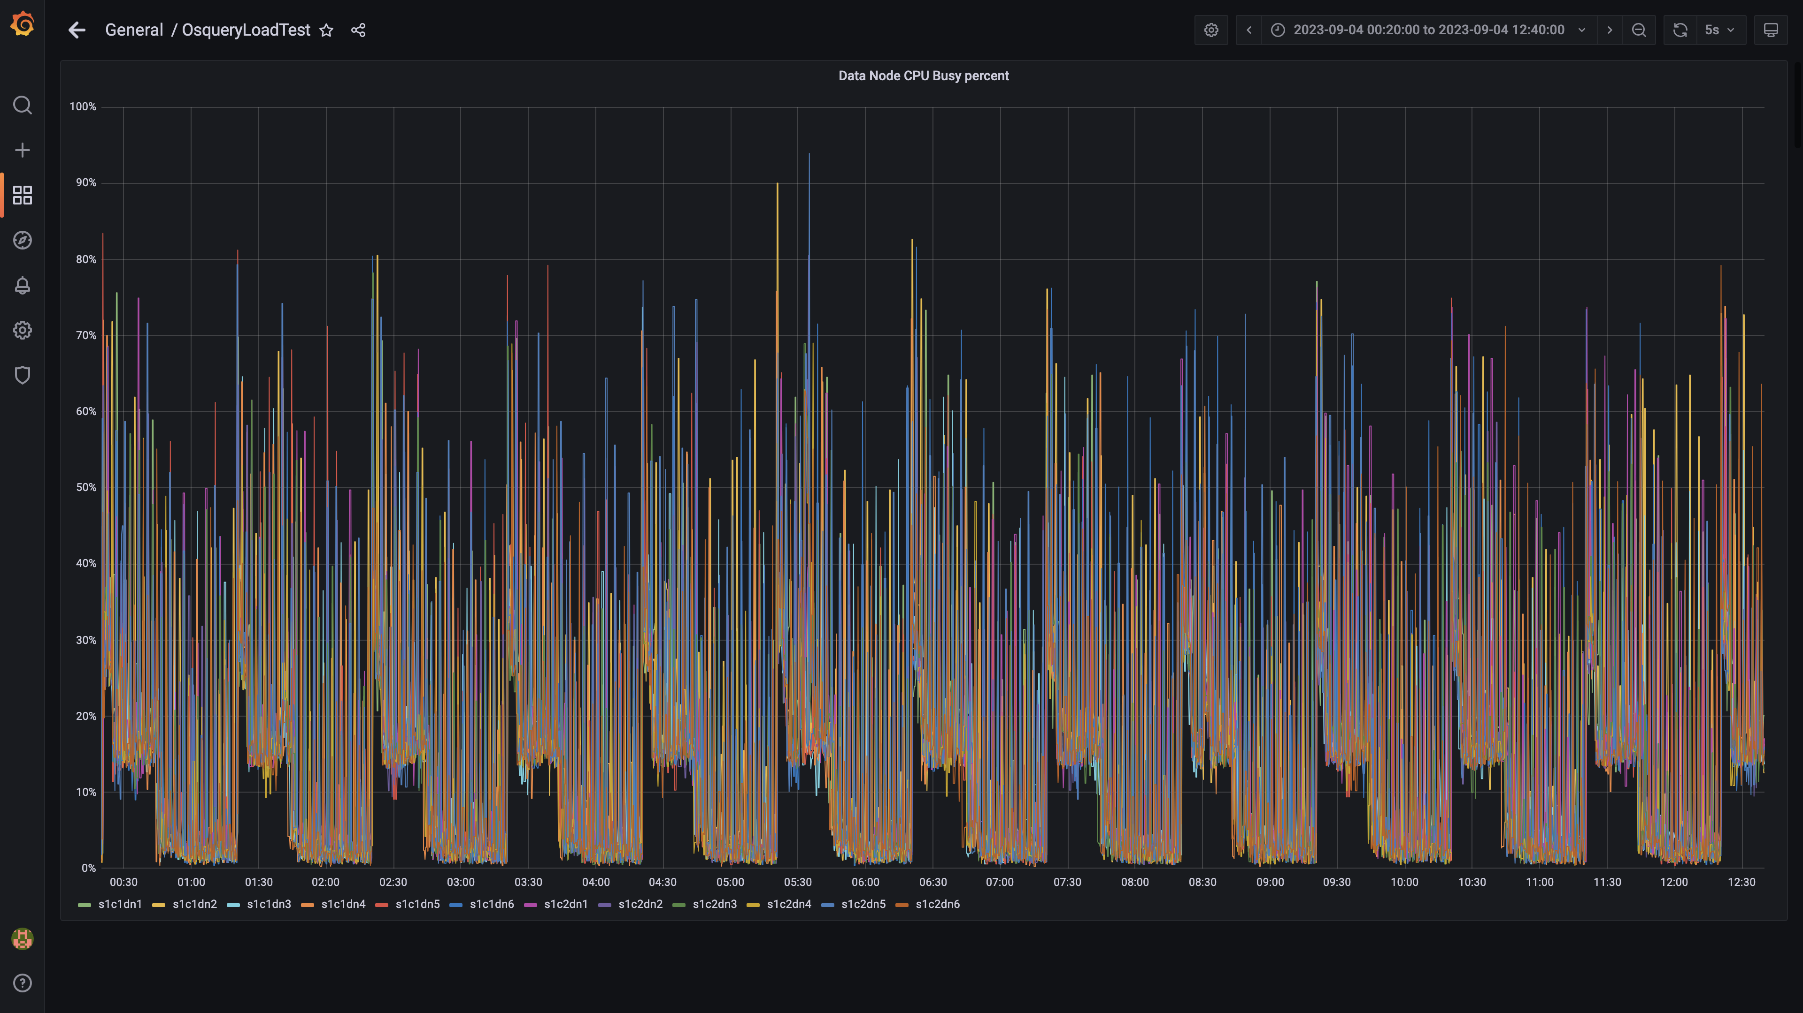

### Postgres-configdb cpu used percentage

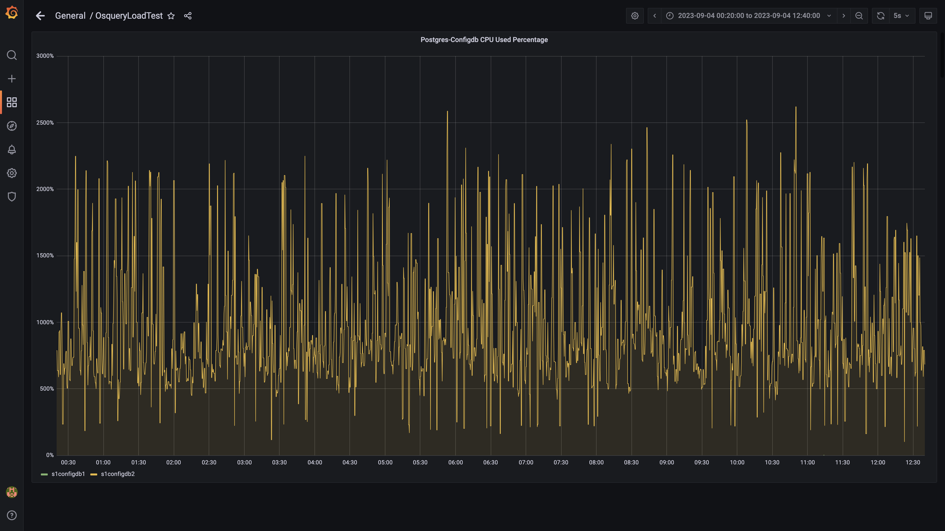

### Pgbouncer cpu used percentage

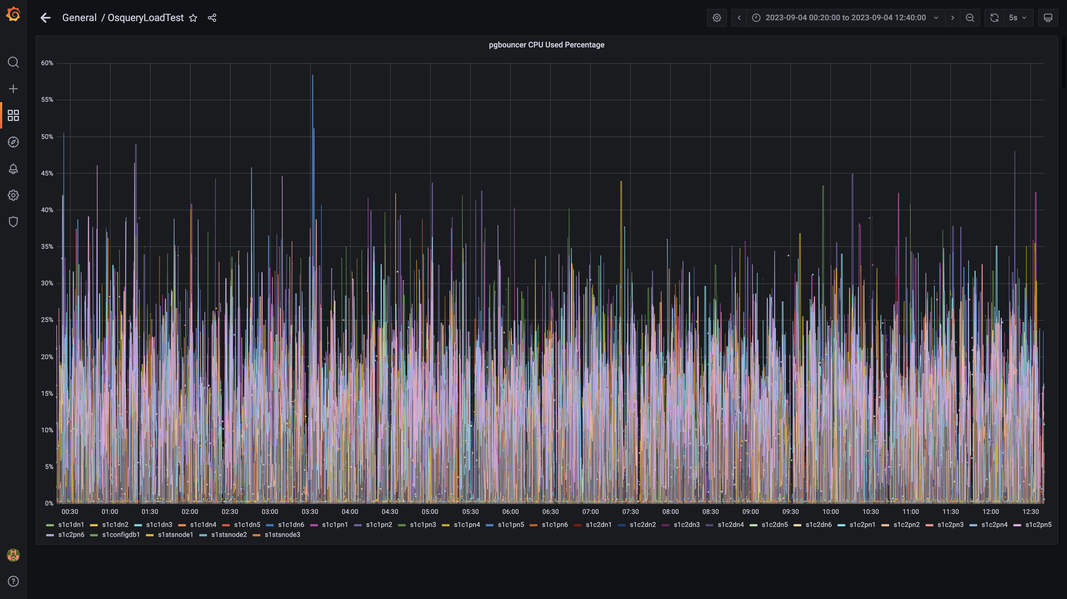

### Cpu consumed by eventsdbingestion

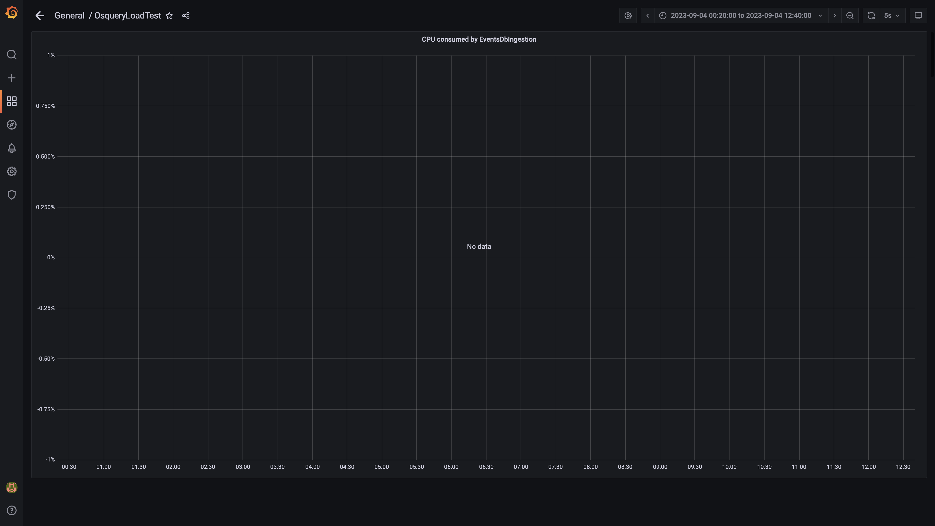

### Cpu consumed by pushgateway

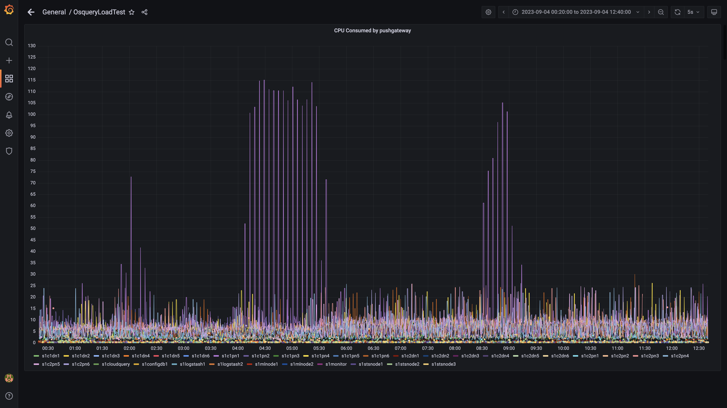

### Cpu consumed by ruleengine

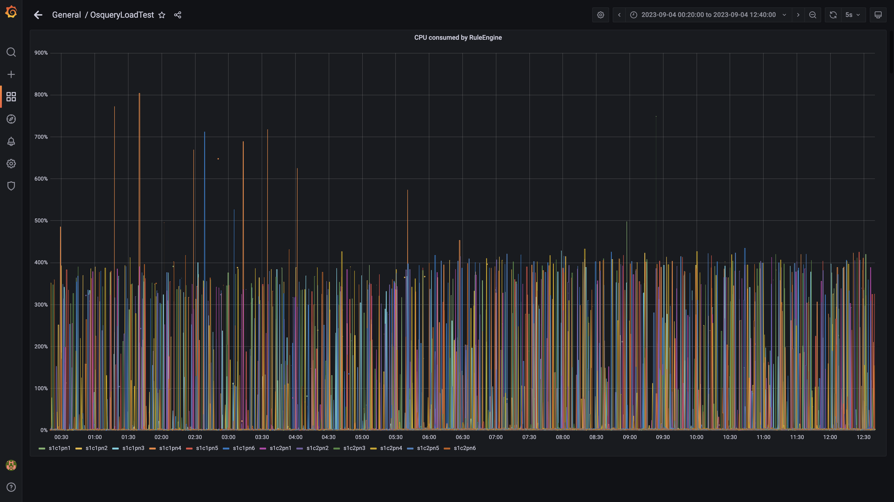

### Kafka cpu used percentage

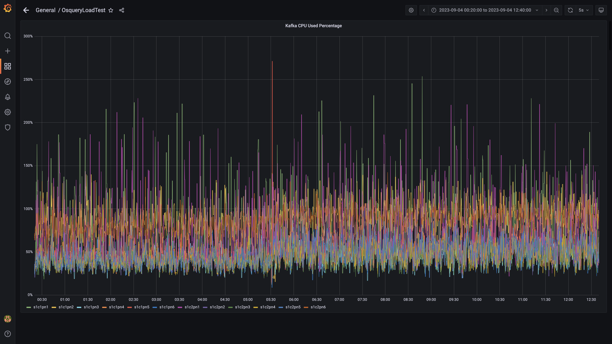

### Cpu used by data-archival

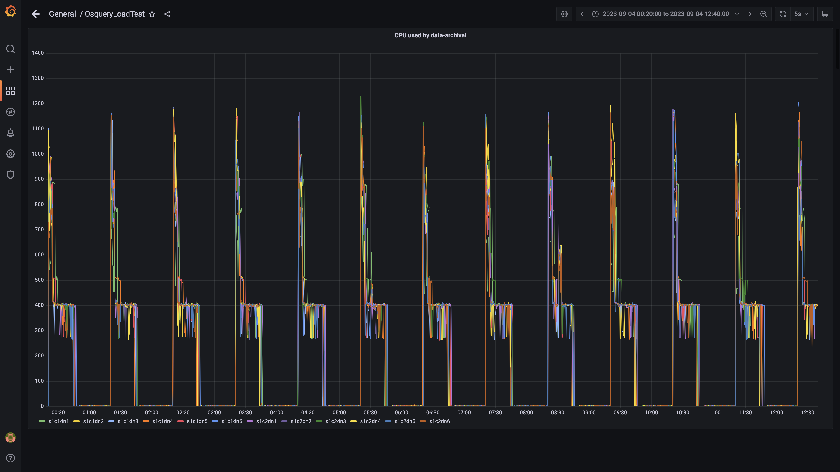

### Cpu consumed by osqueryingestion

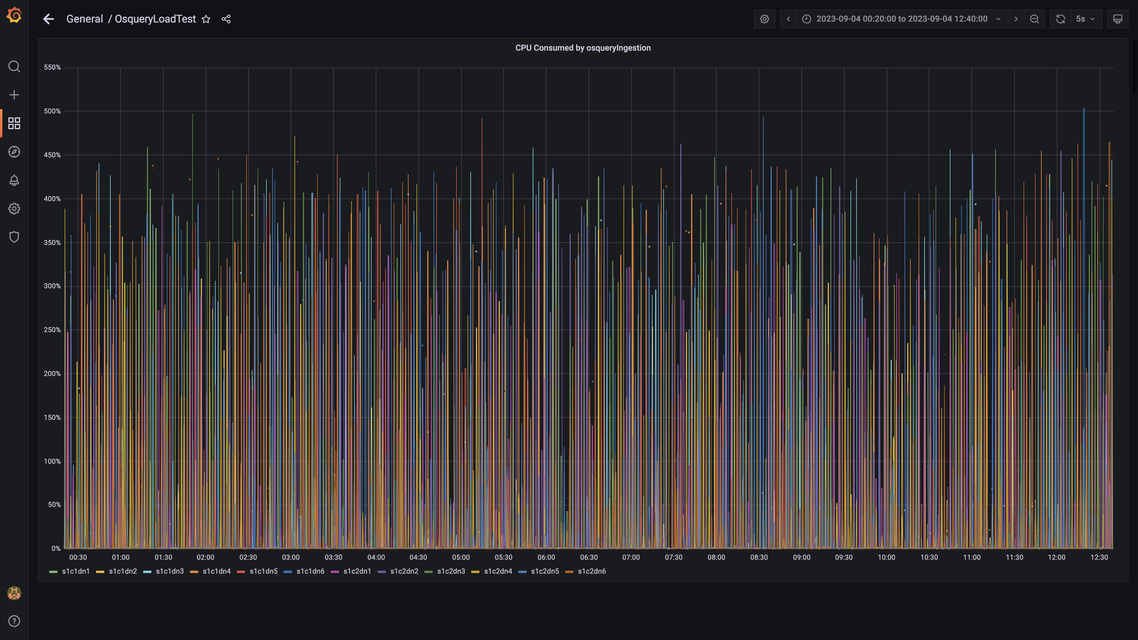

### Cpu consumed by redis server

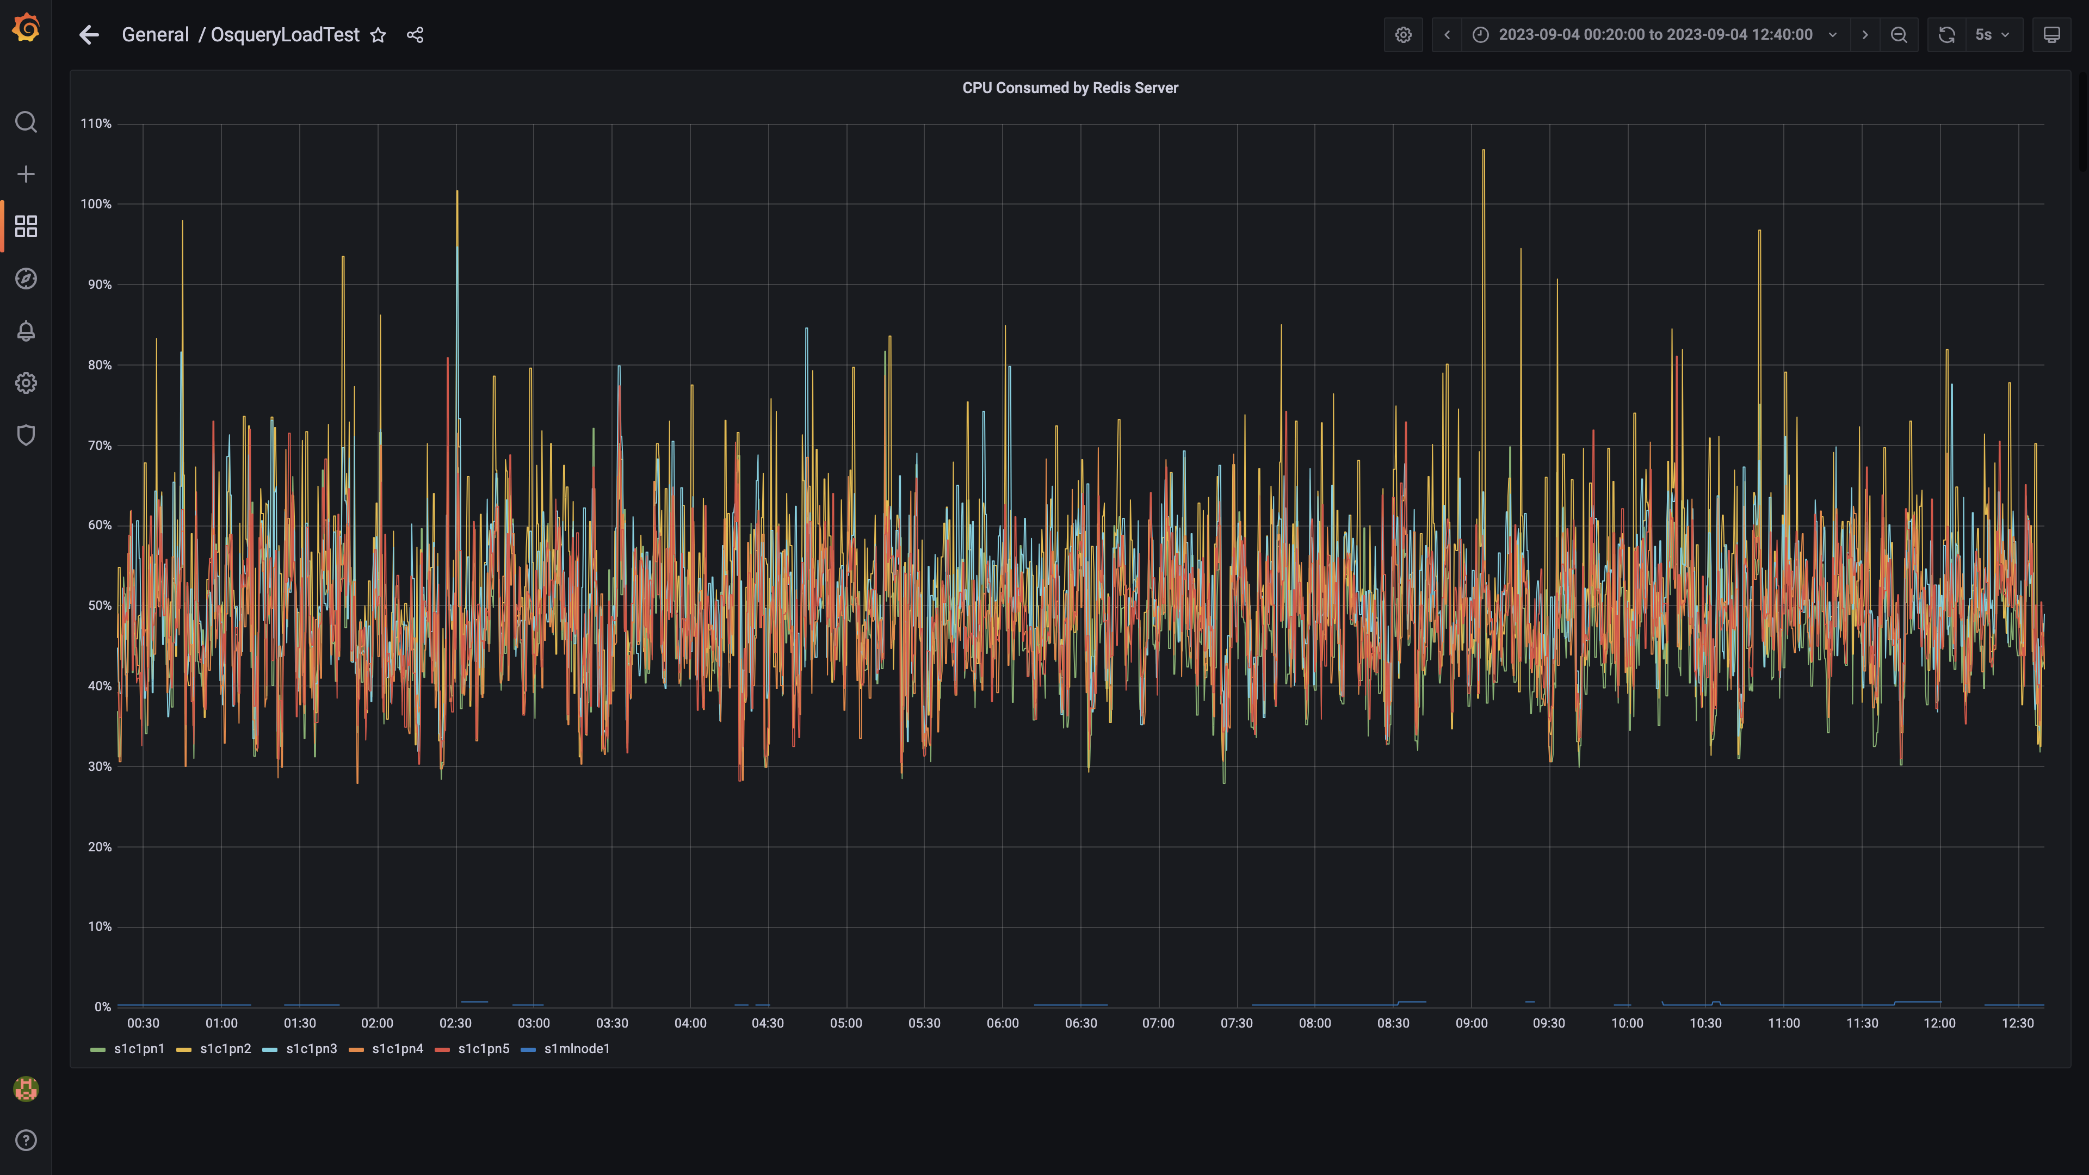

### Cpu consumed by orc-compaction

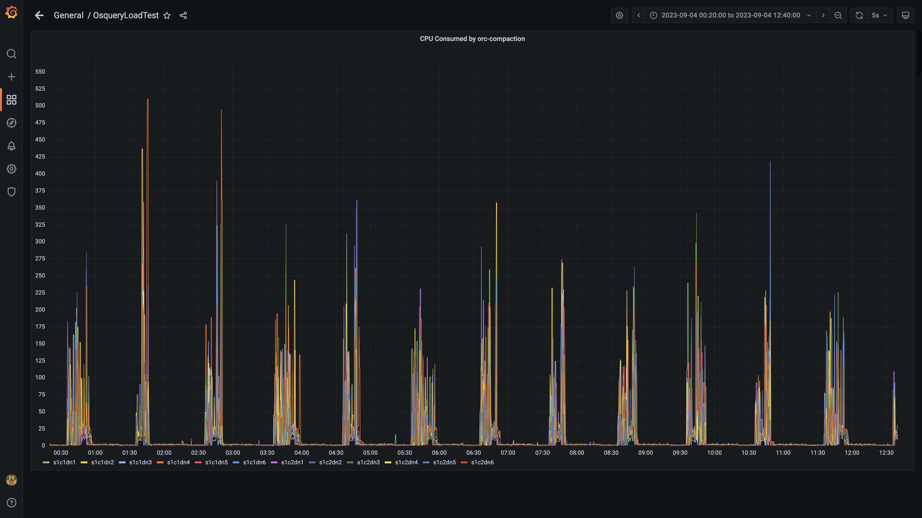

### Cpu consumed by spark-worker

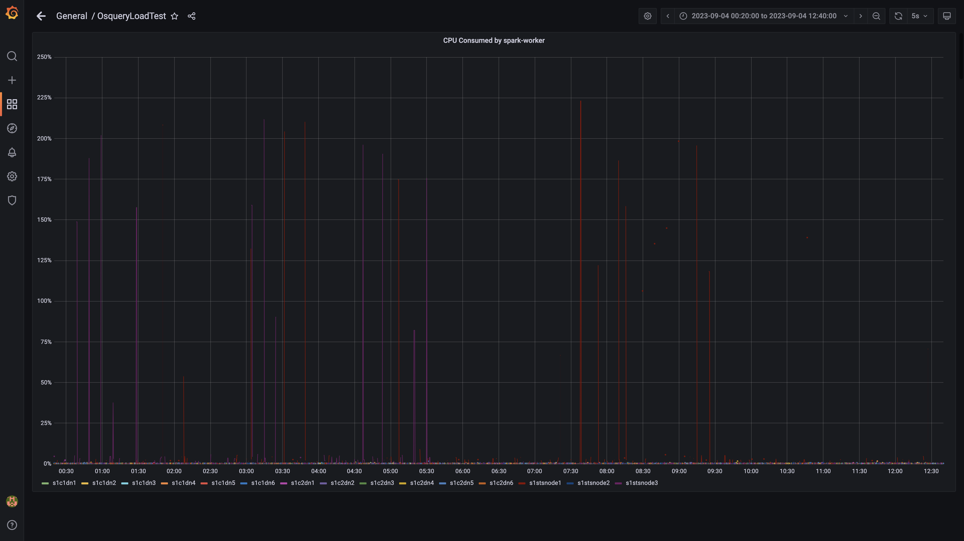

### Cpu consumed by logger

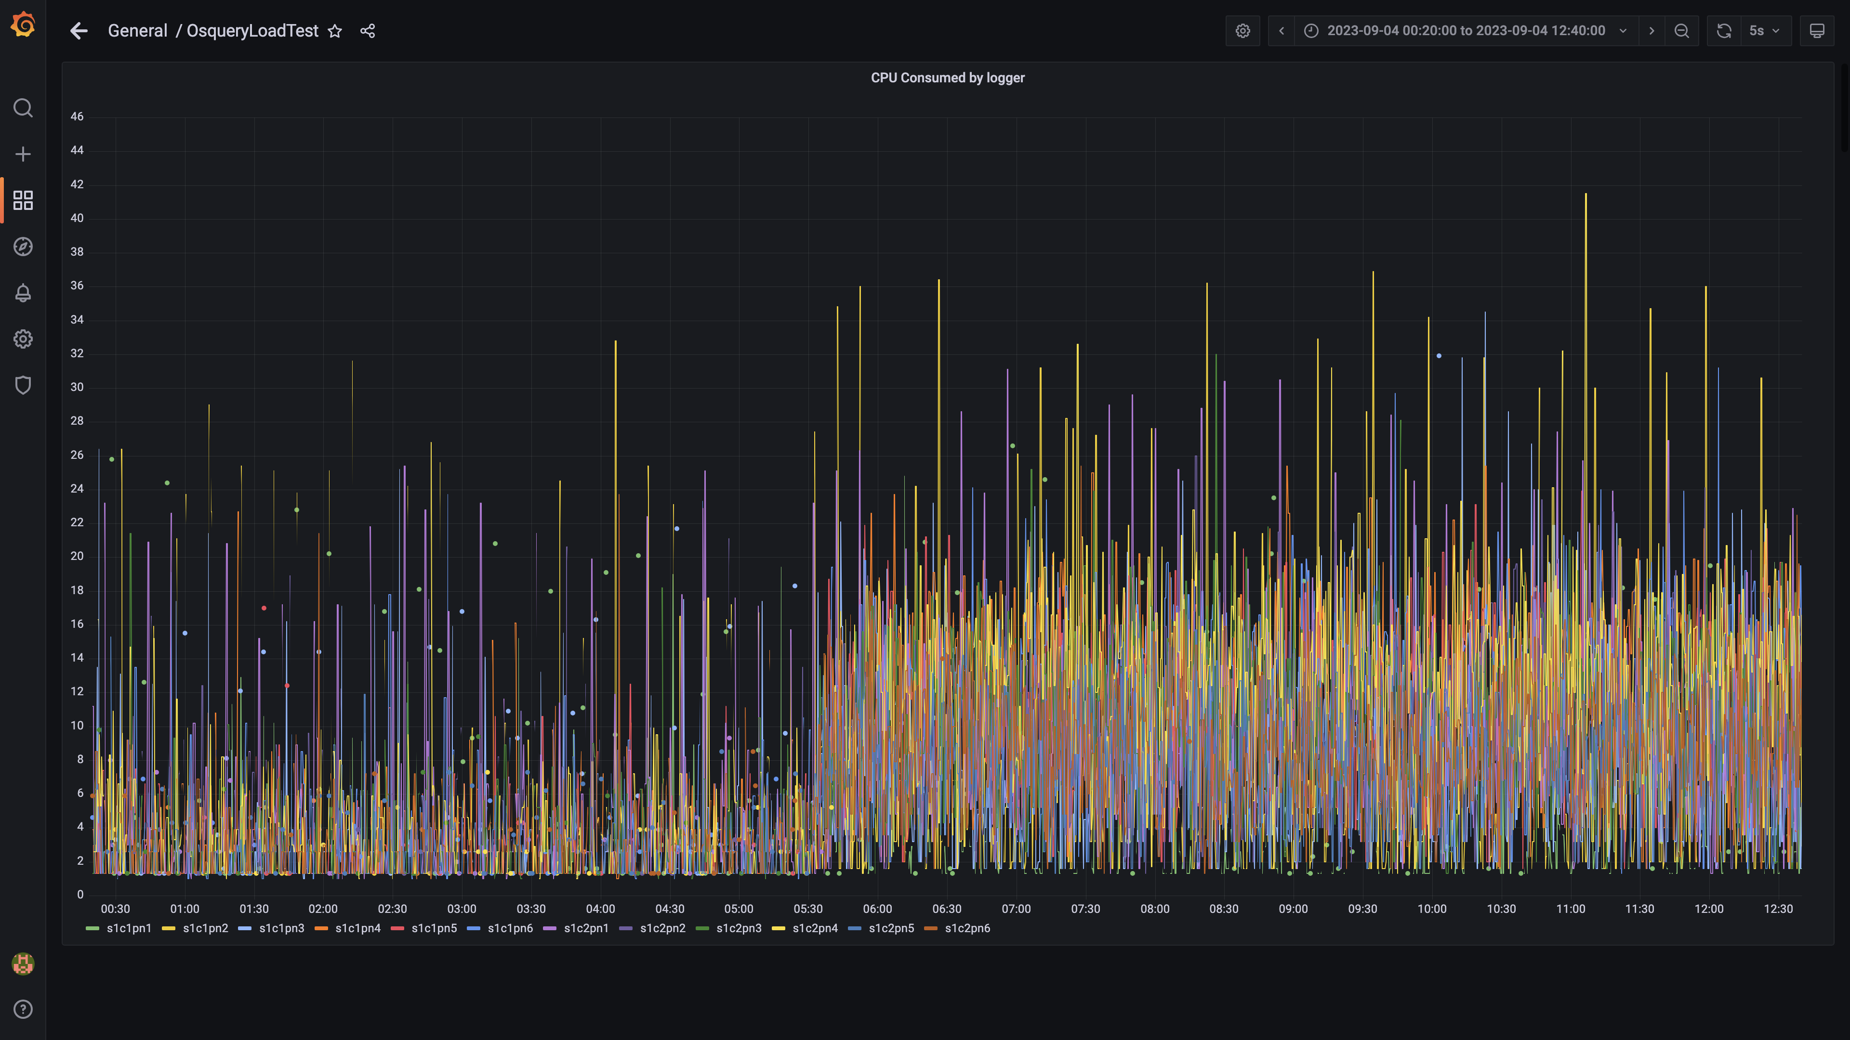

### Compliance summary consumer cpu consumption

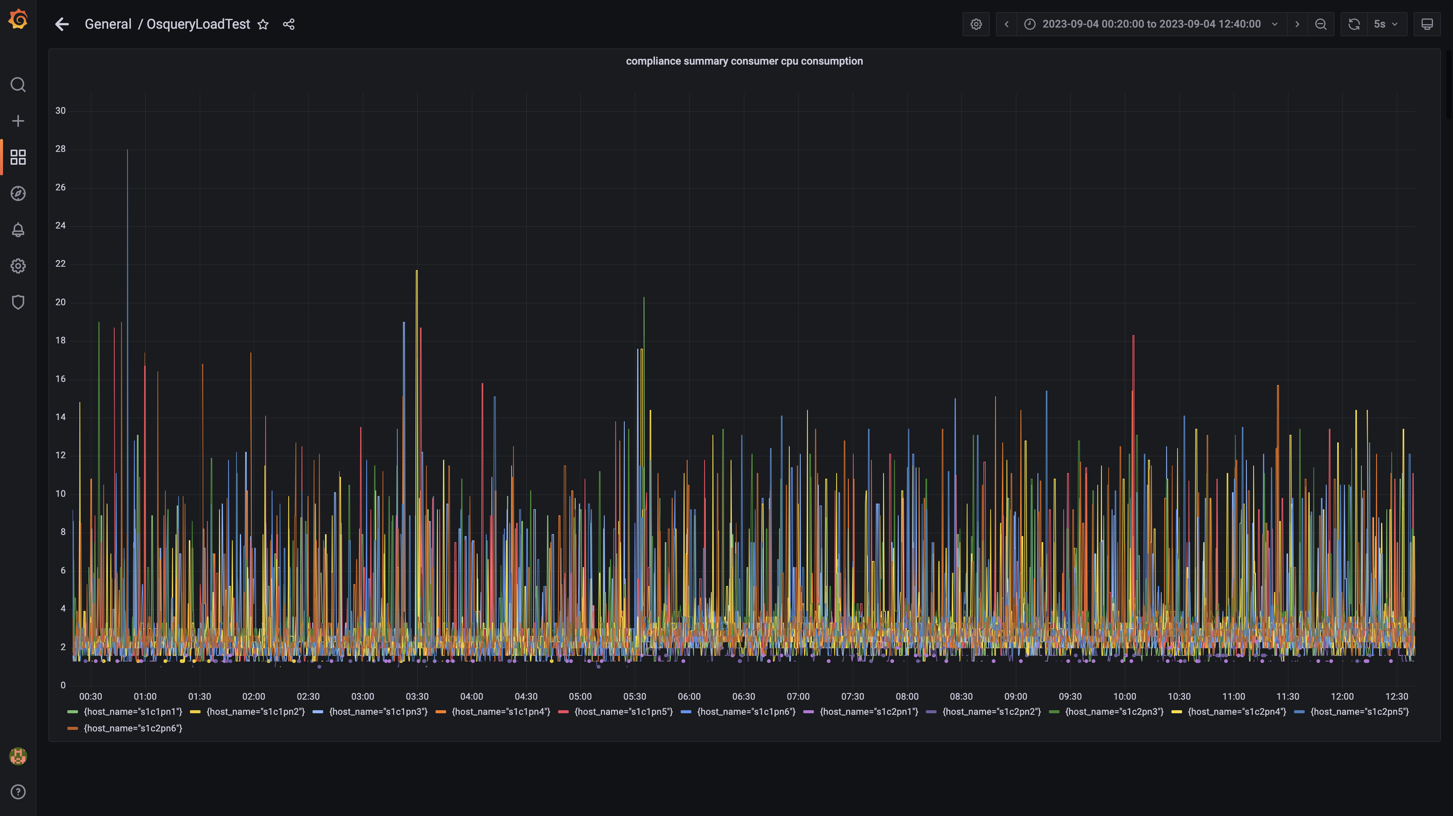

### Cpu consumed by trino

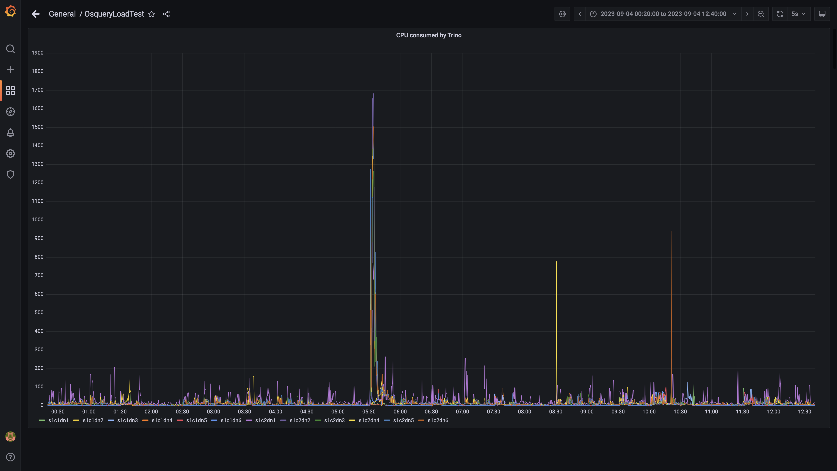

### Debezium cpu usage

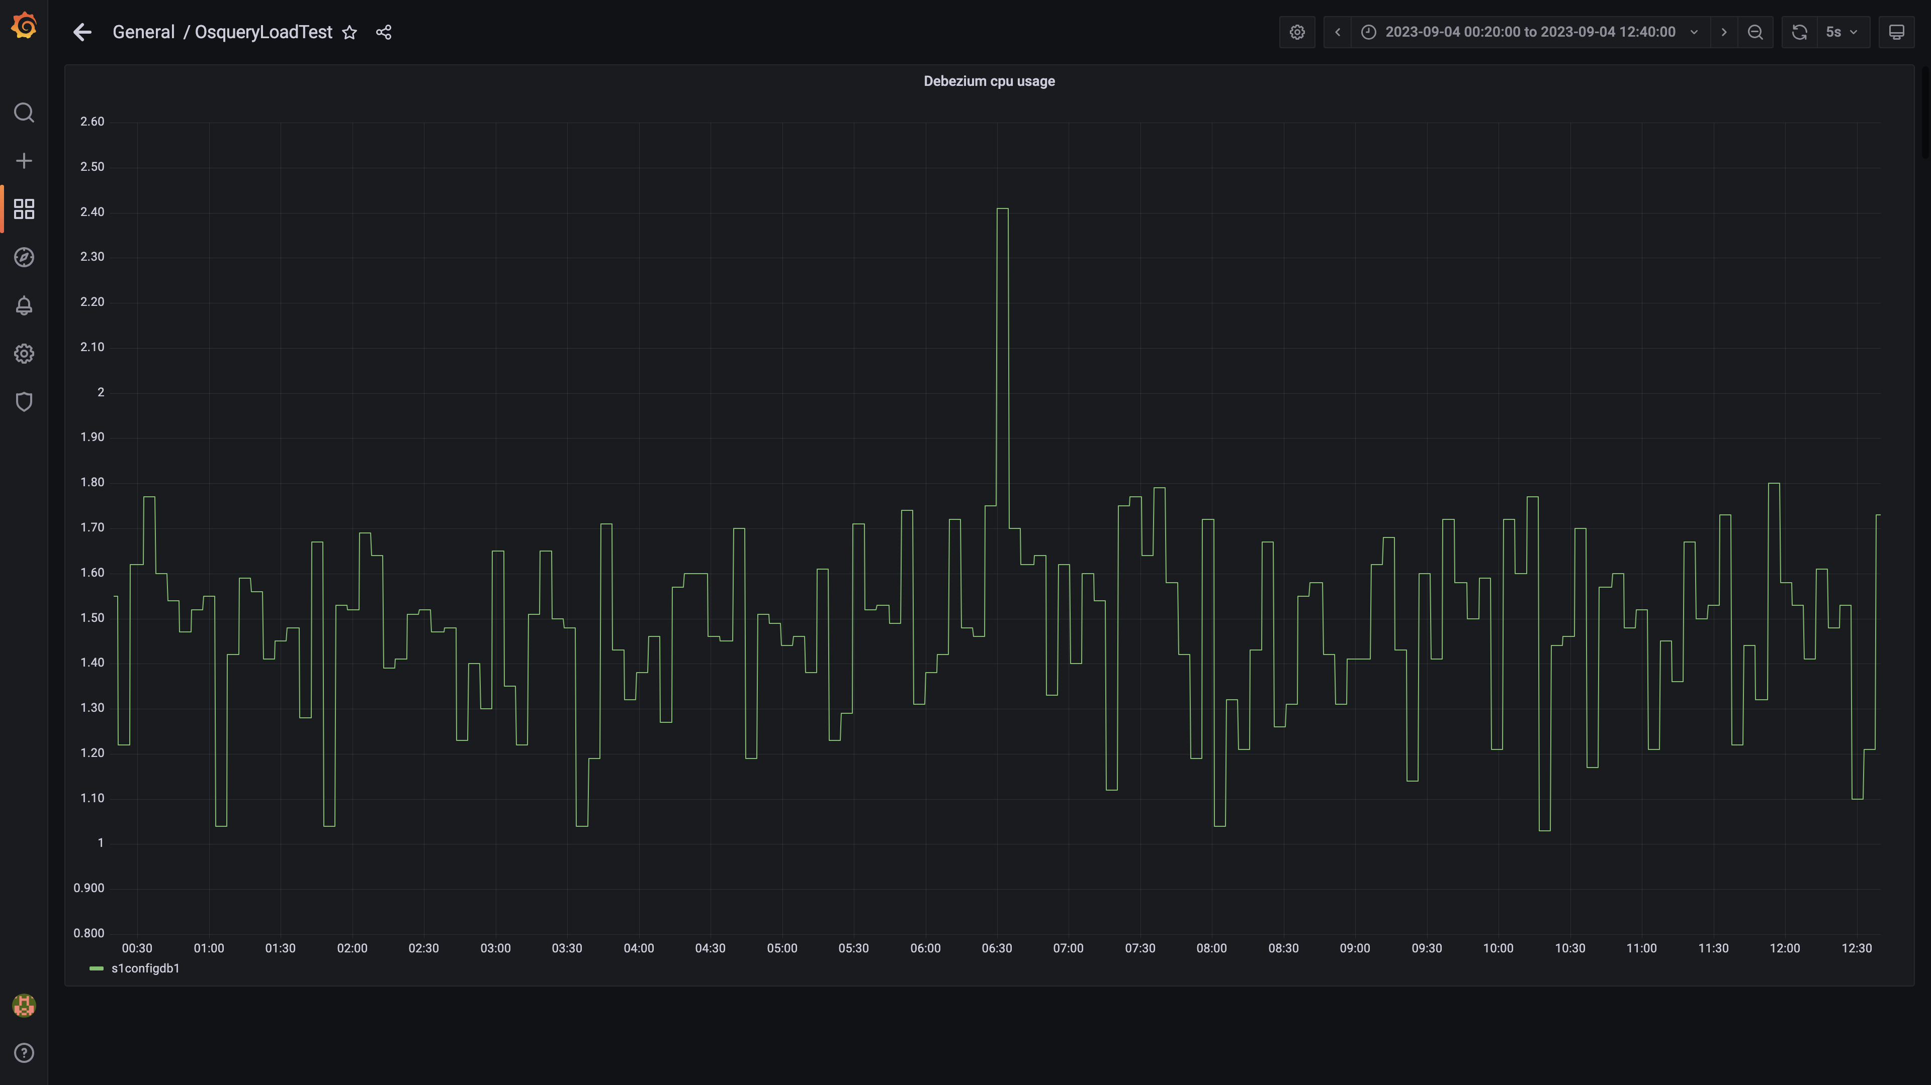

### Cpu consumed by spark-master

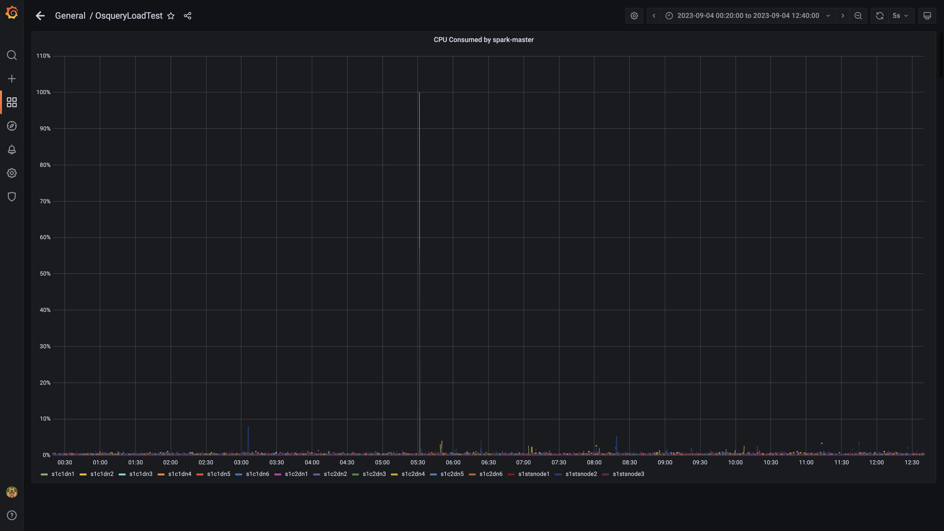

### Cpu consumed by tls

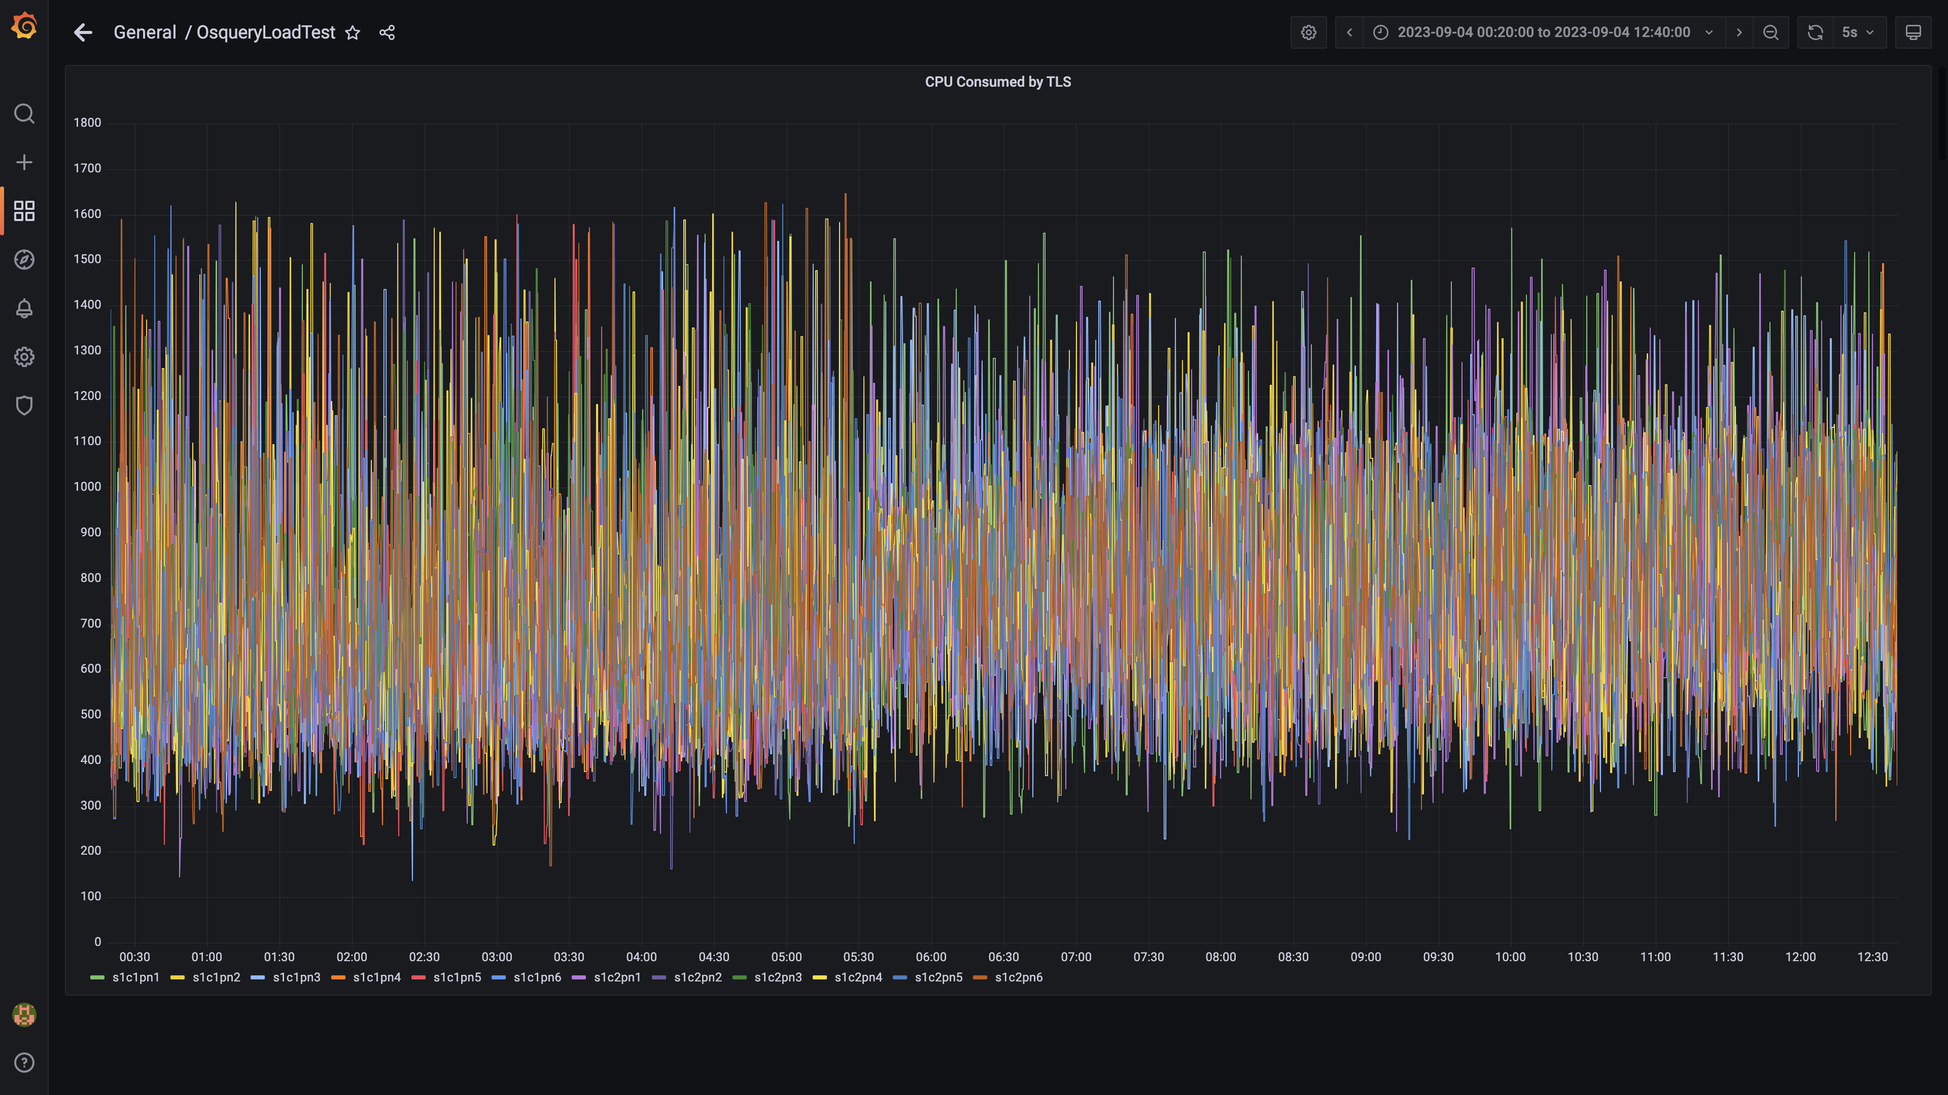

### Airflow cpu usage

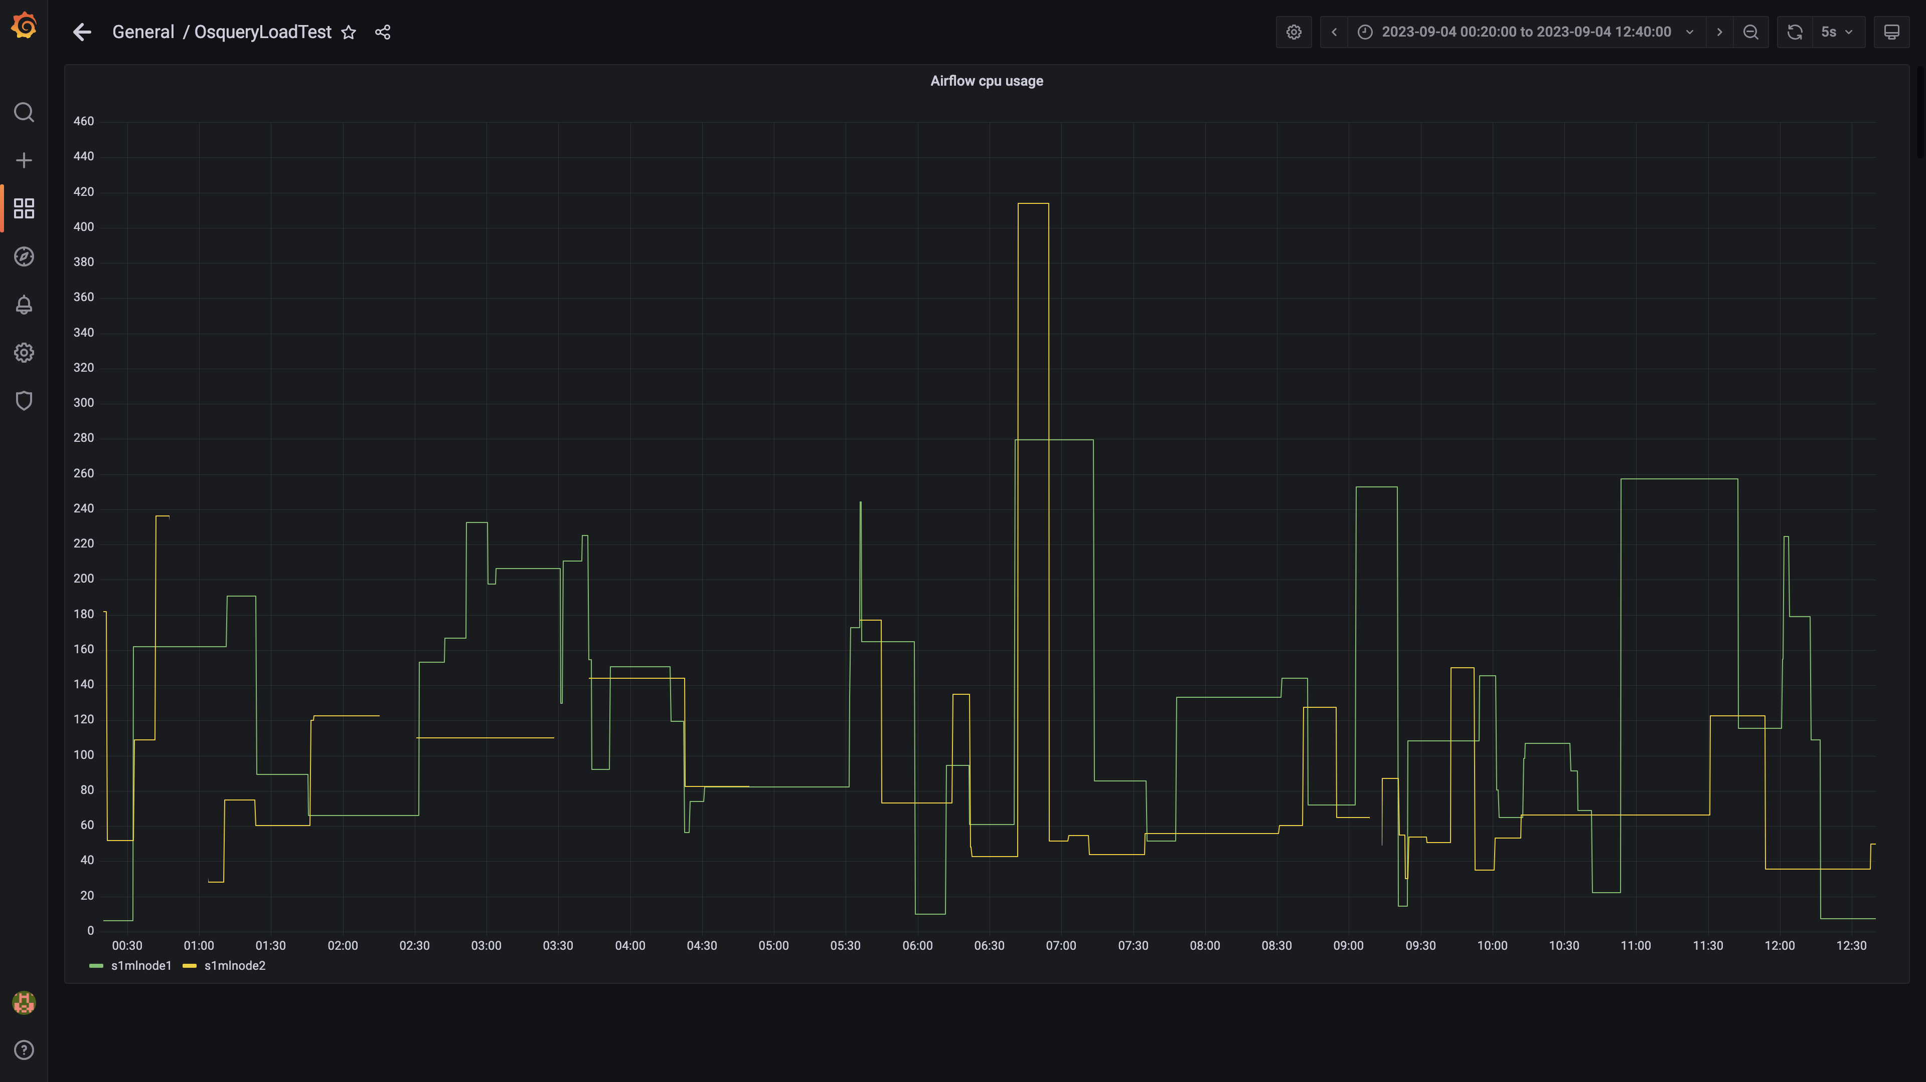

### Spark inject and drain rate agent osquery

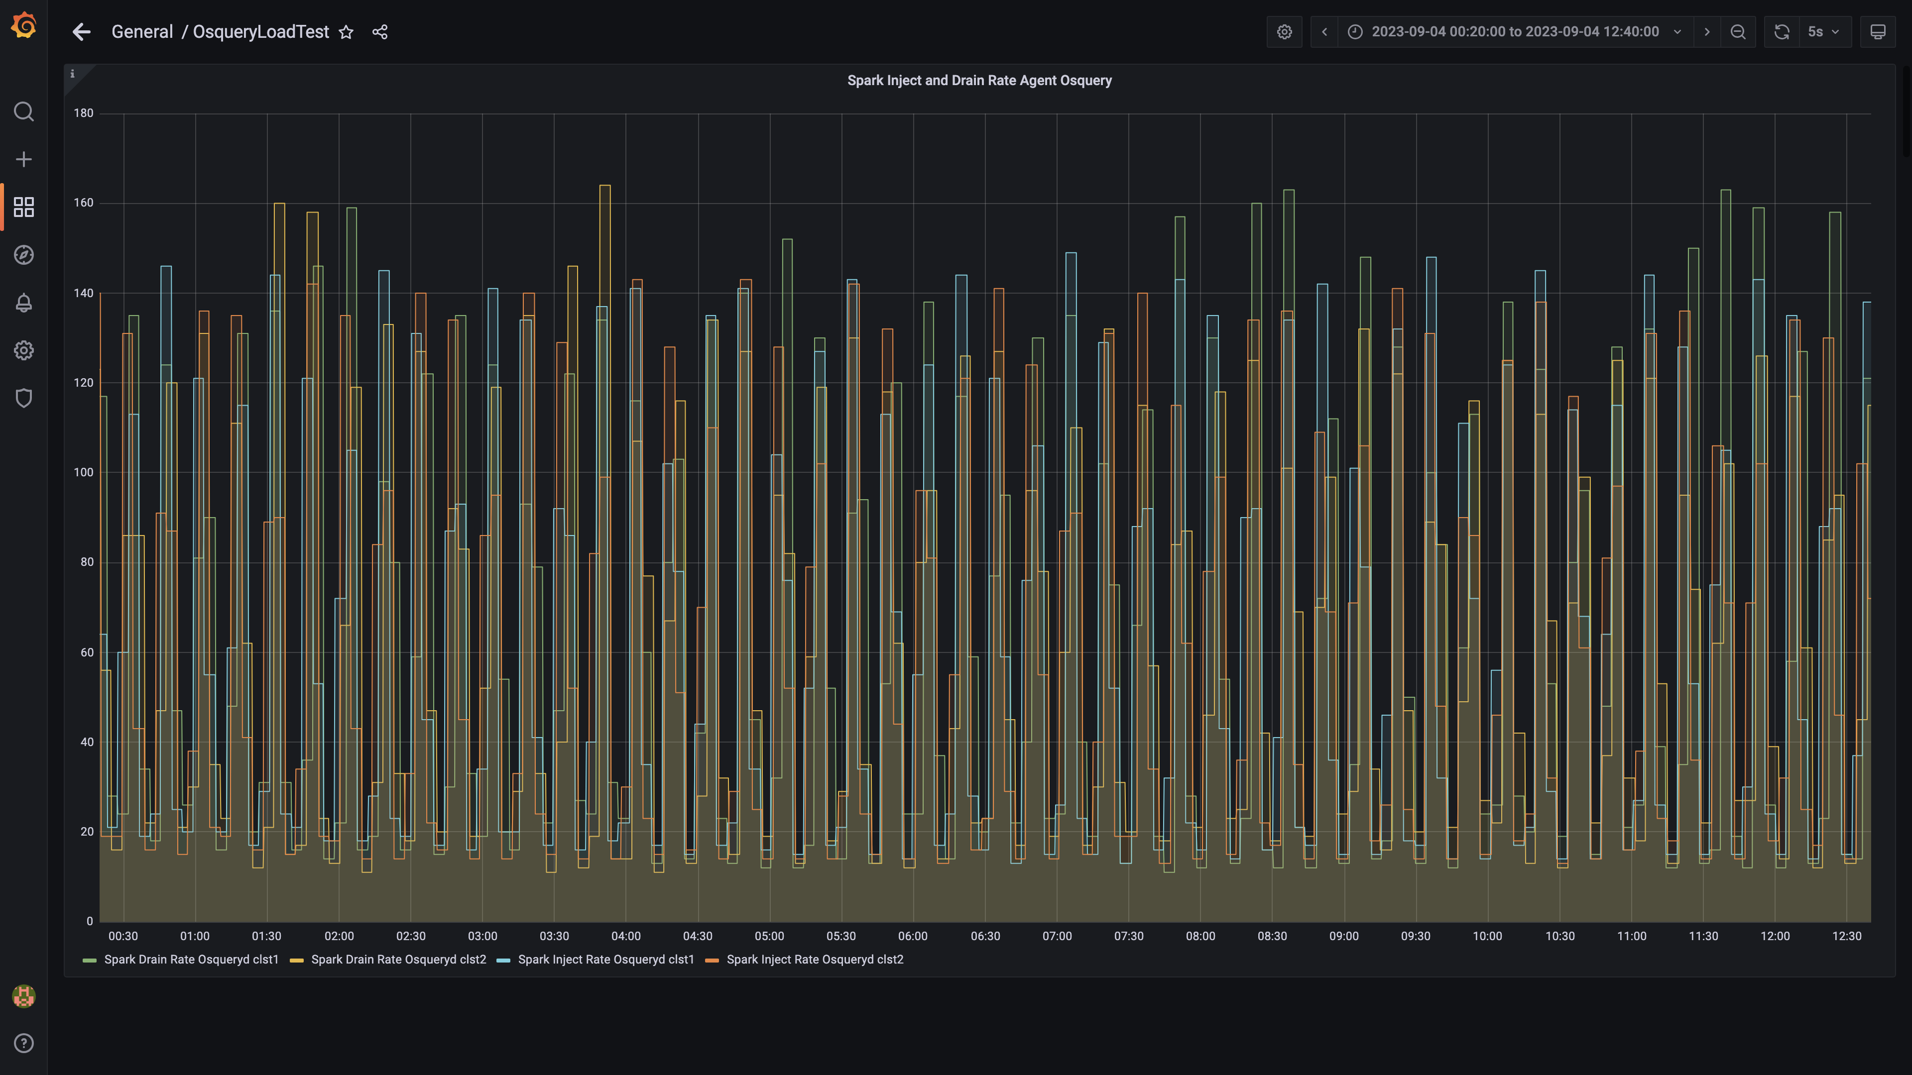

### Spark lag for agent osquery

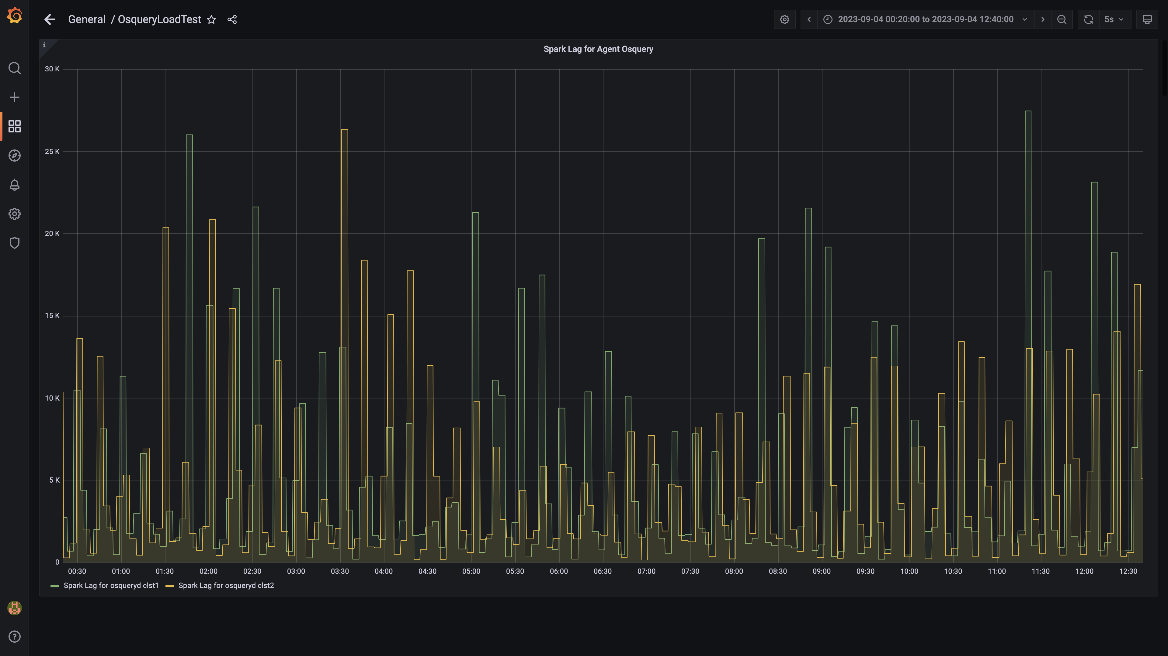

### Spark inject and drain rate events

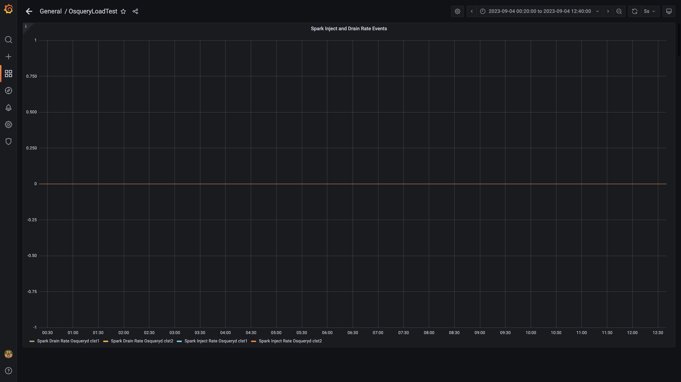

### Spark lag for events

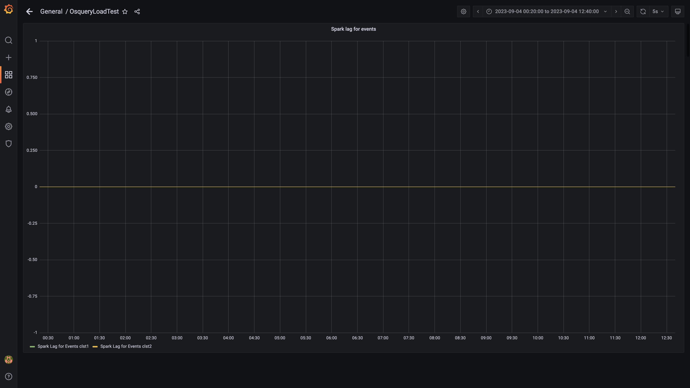

### Inject and drain rate db-alerts group

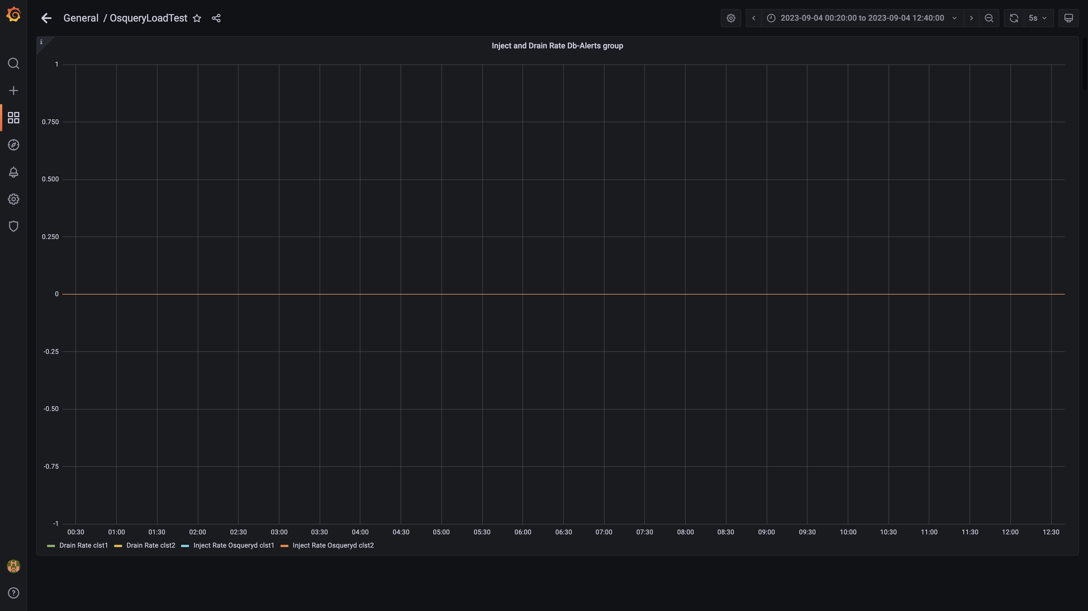

### Kafka lag for db-alerts group

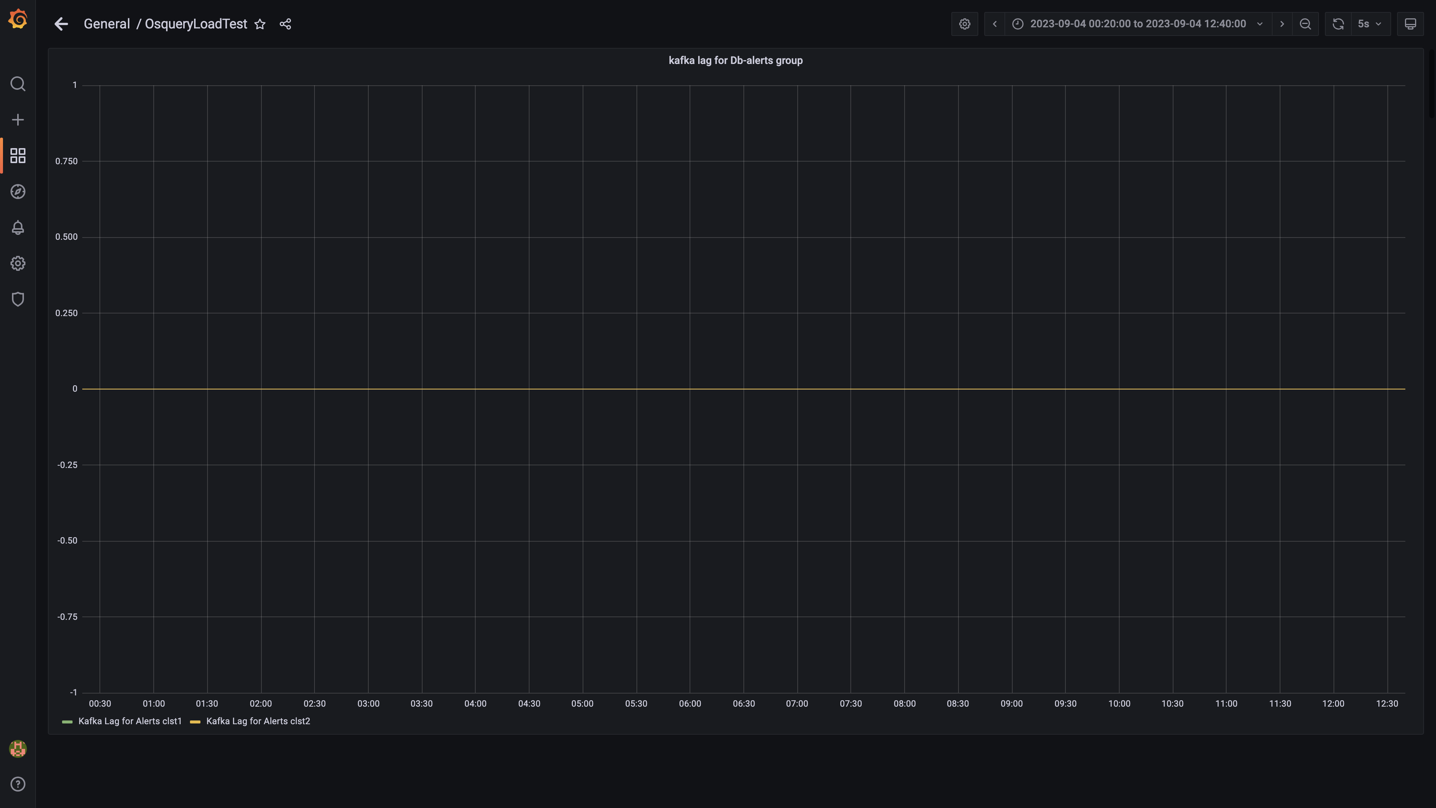

### Inject drain rates for ruleengine group

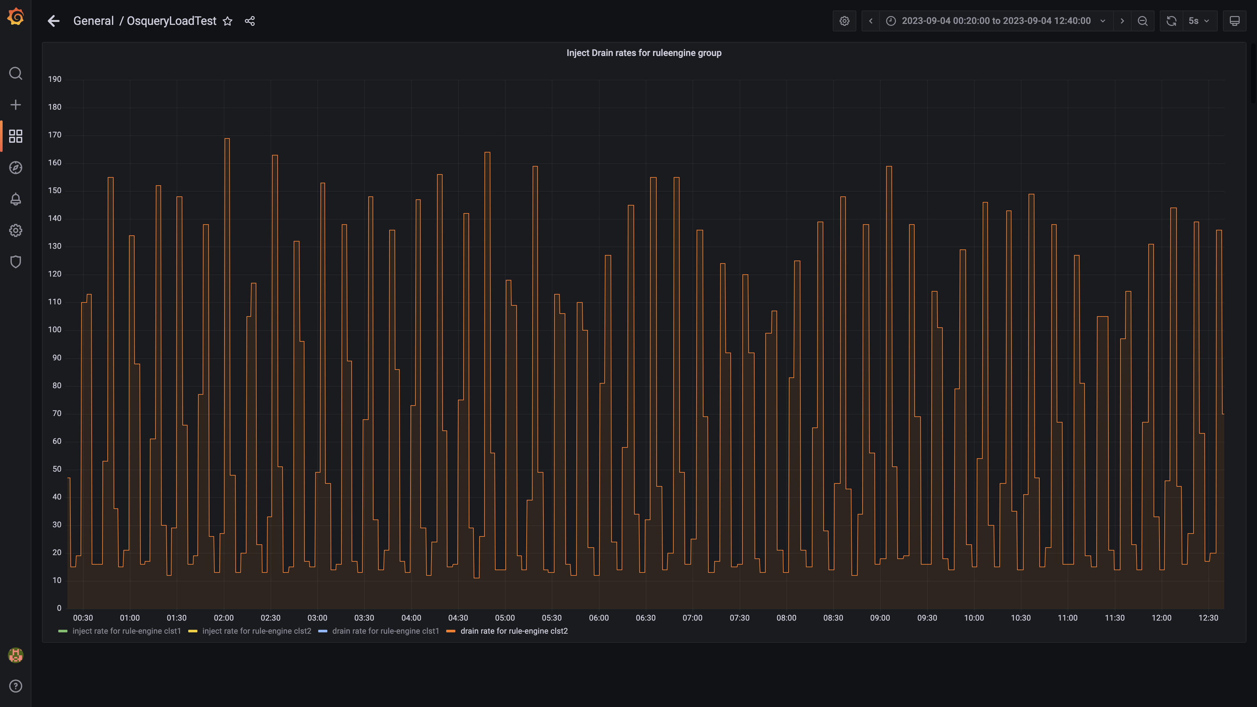

### Kafka lag for ruleengine group

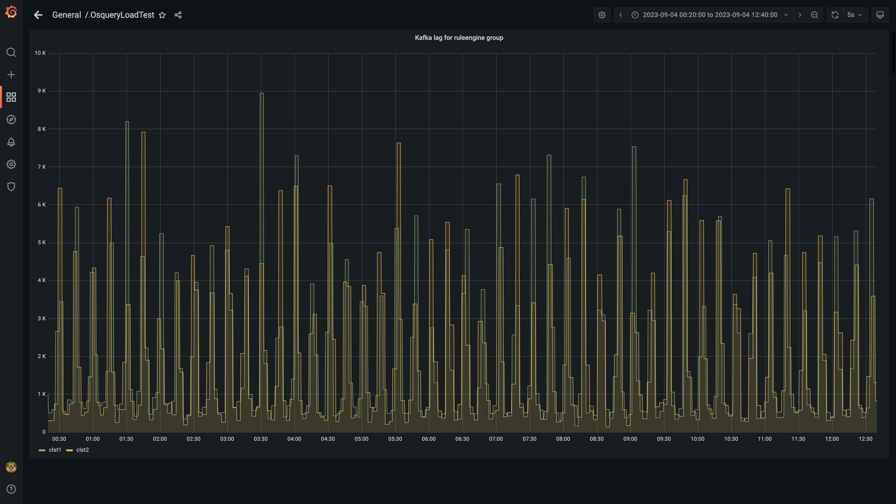

### Kafka inject and drain rates for debezium group

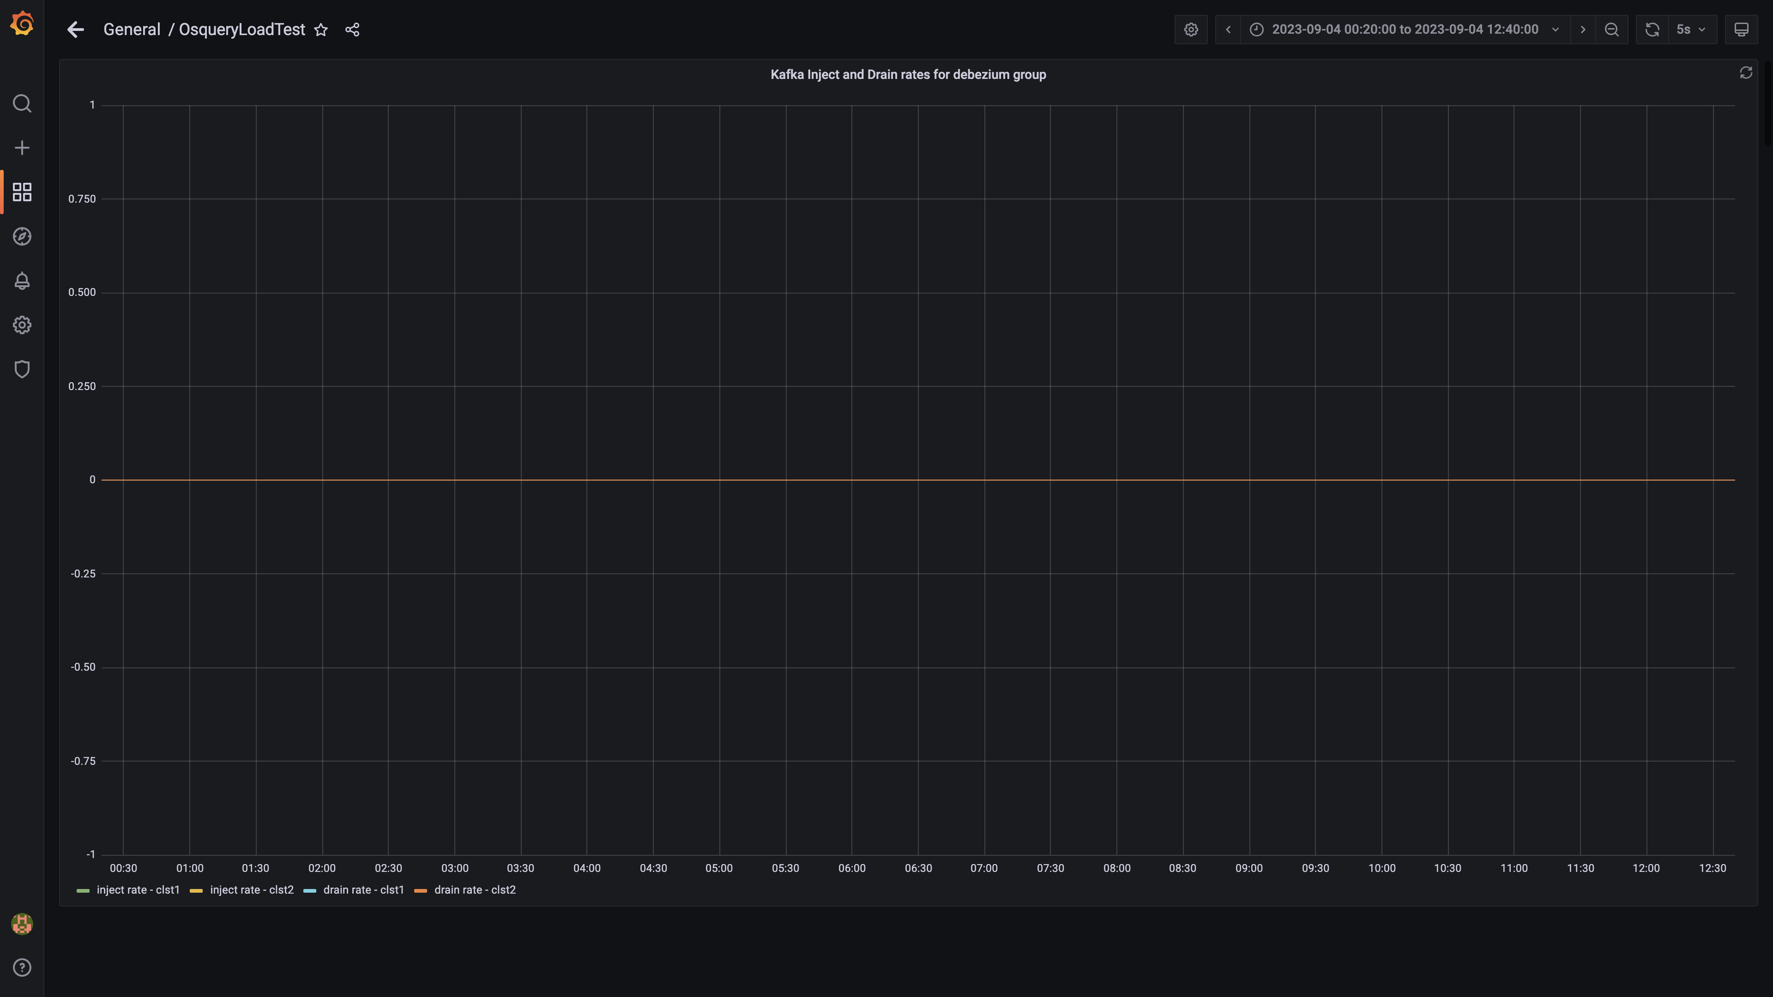

### Aggregate lag

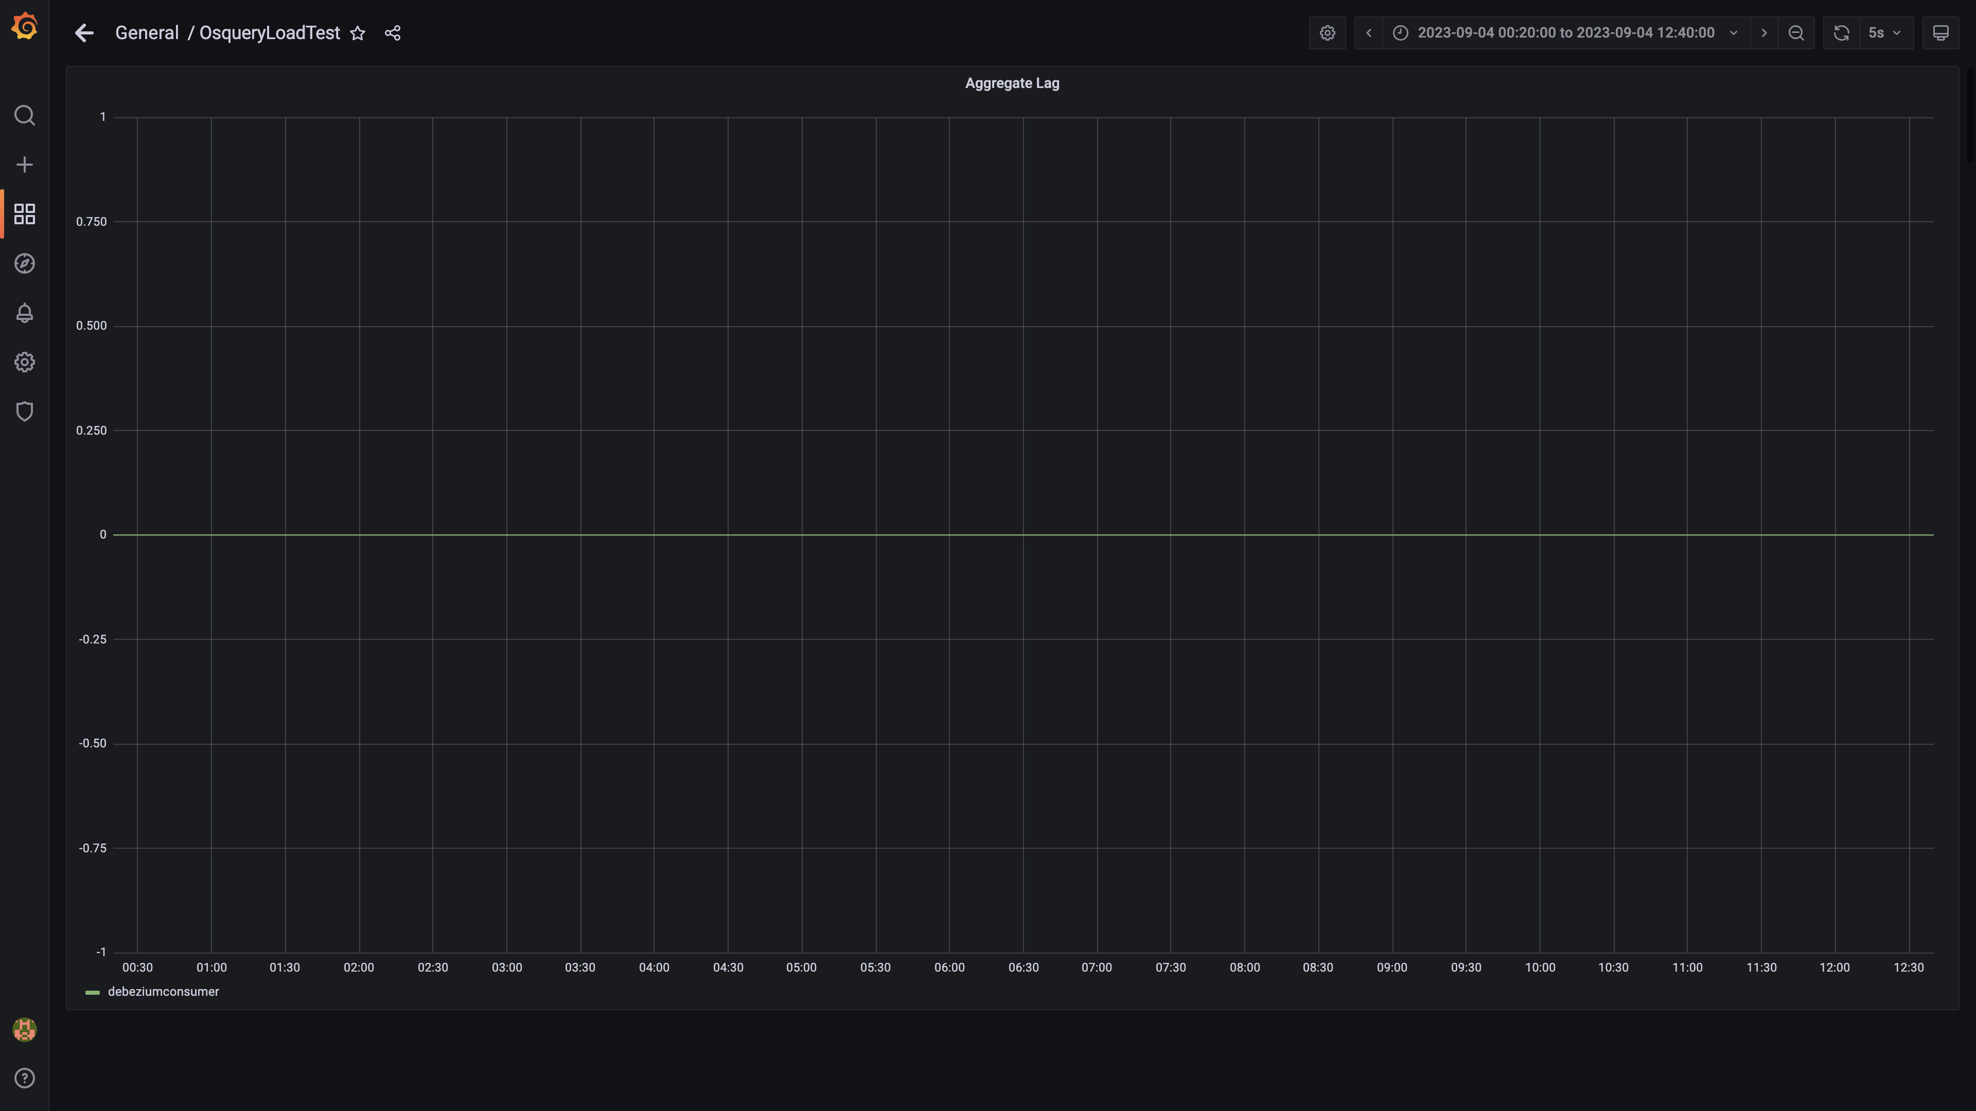

### Debezium replication lag

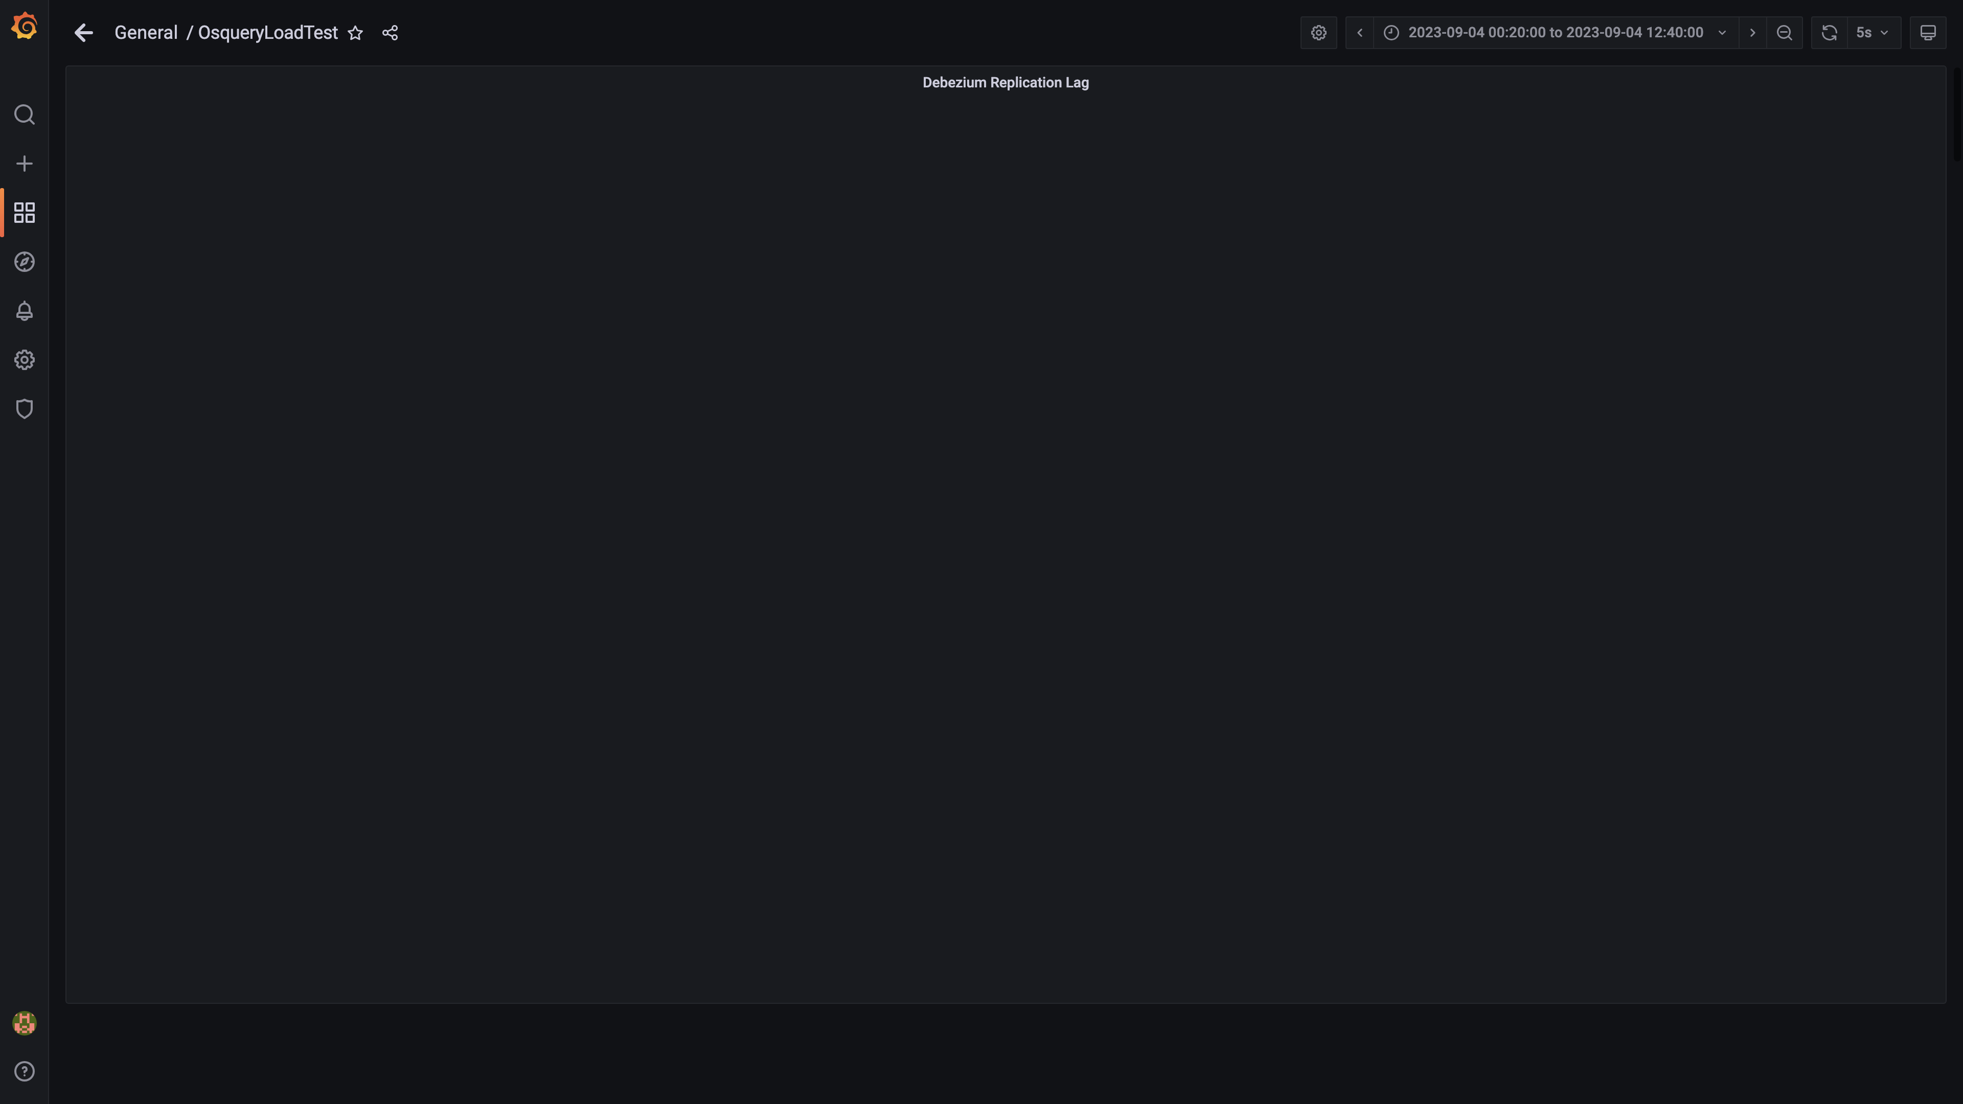

### Panel 132 not loaded in given time

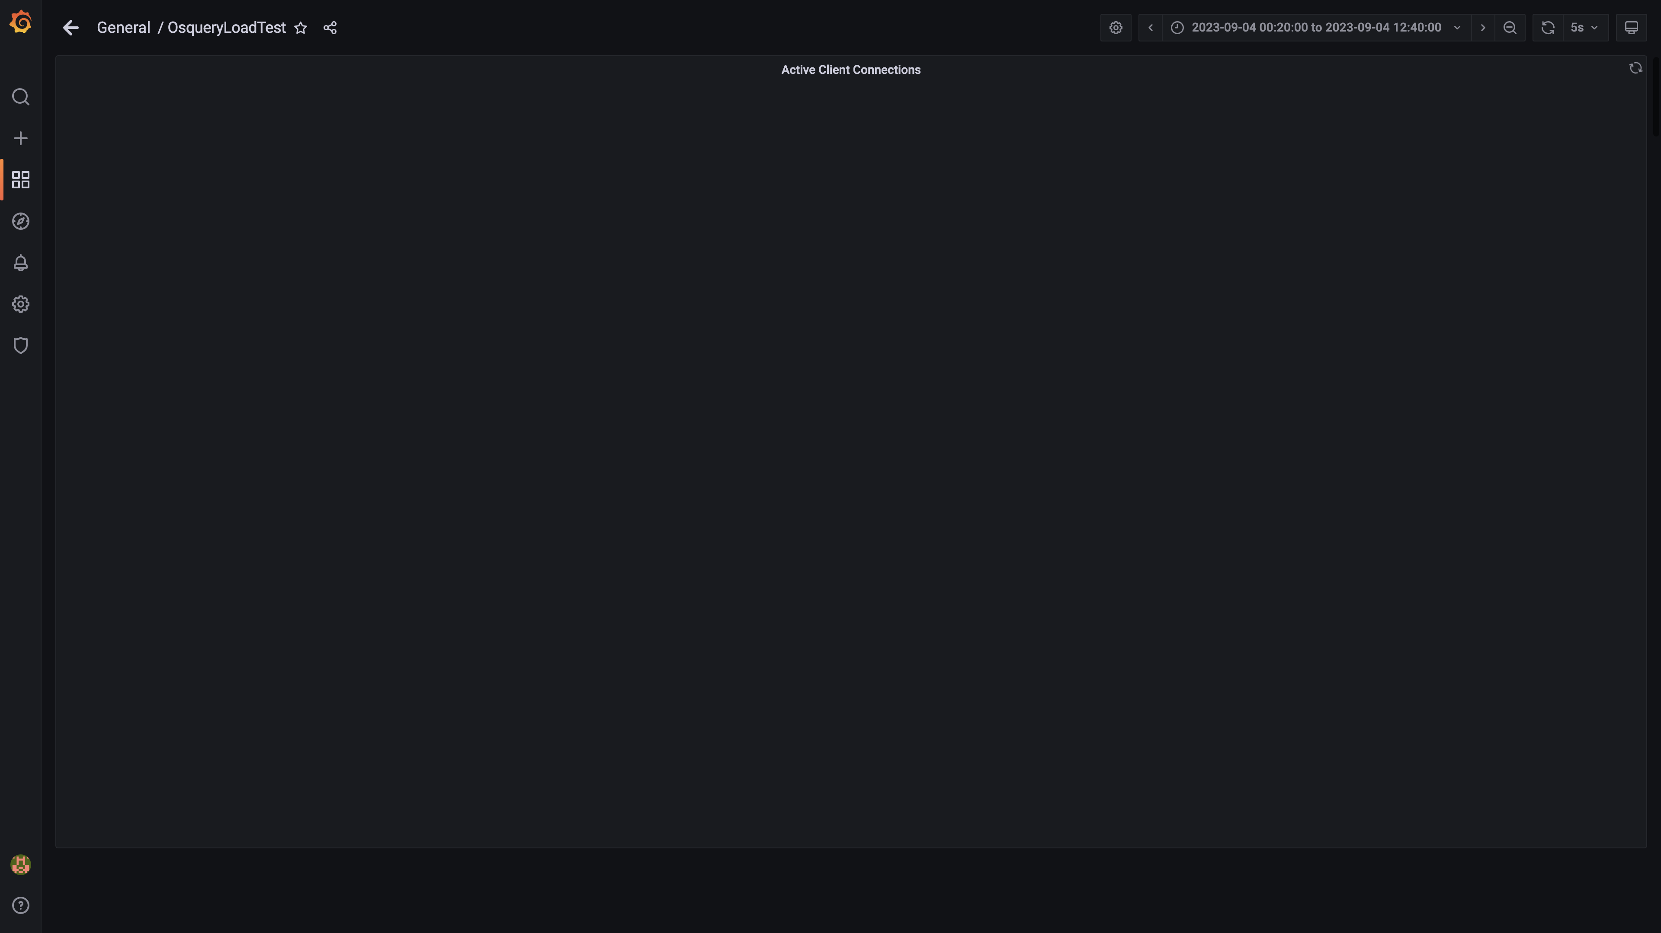

### Panel 130 not loaded in given time

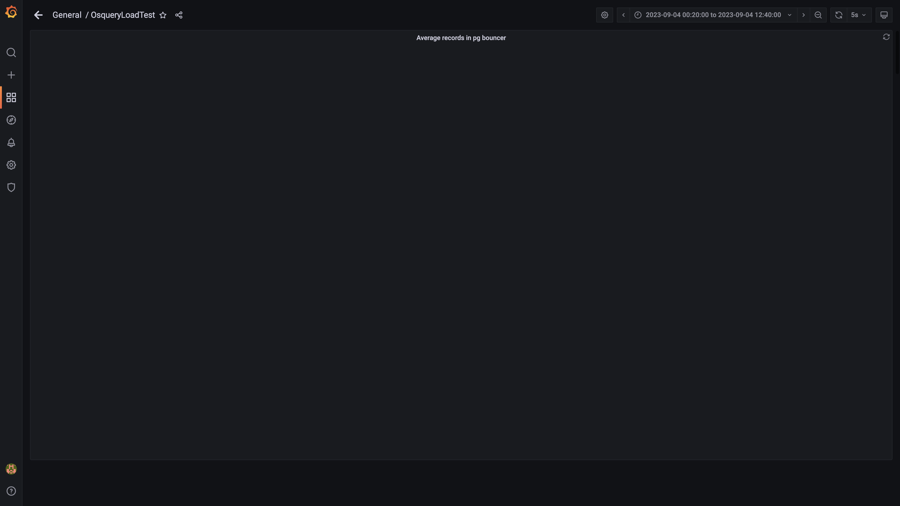

### Panel 128 not loaded in given time

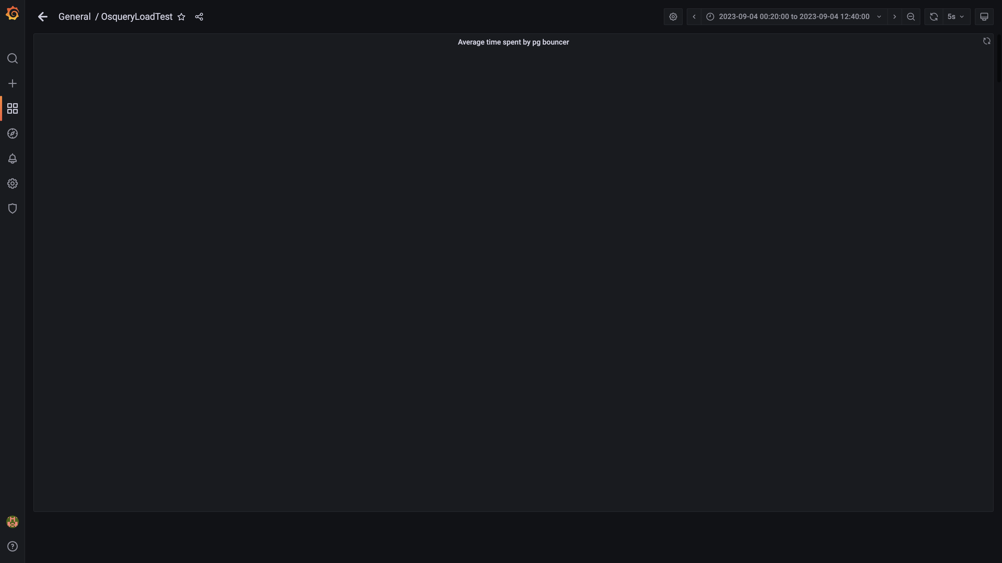

### Redis client connections for tls

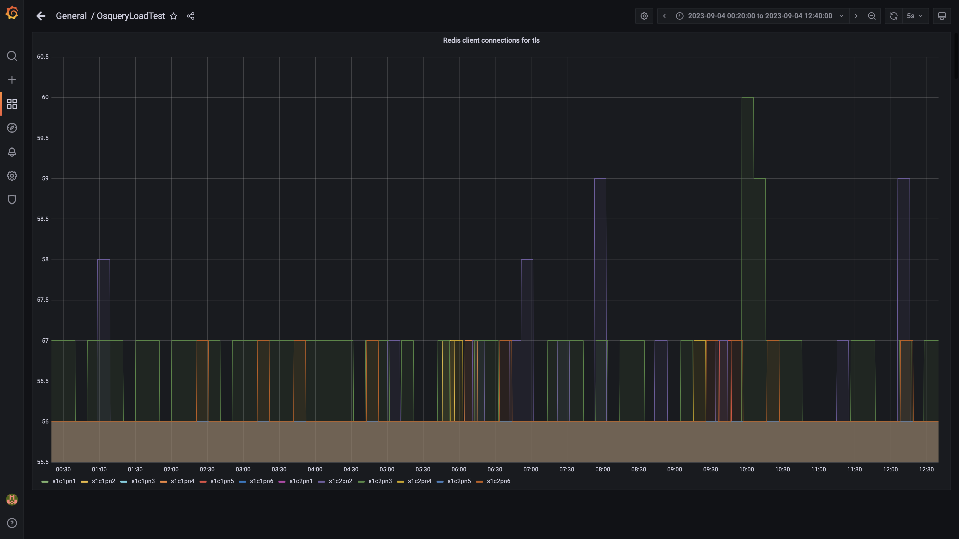

### Configdb pg wal folder size

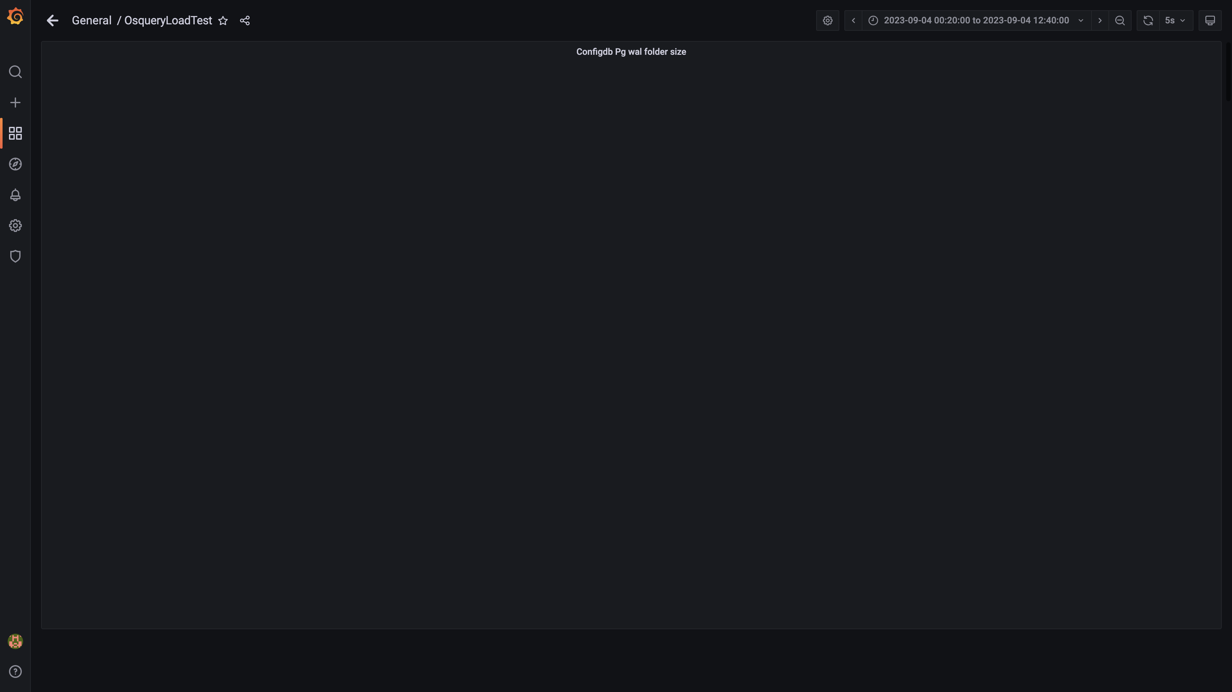

### Configdb number of wal files

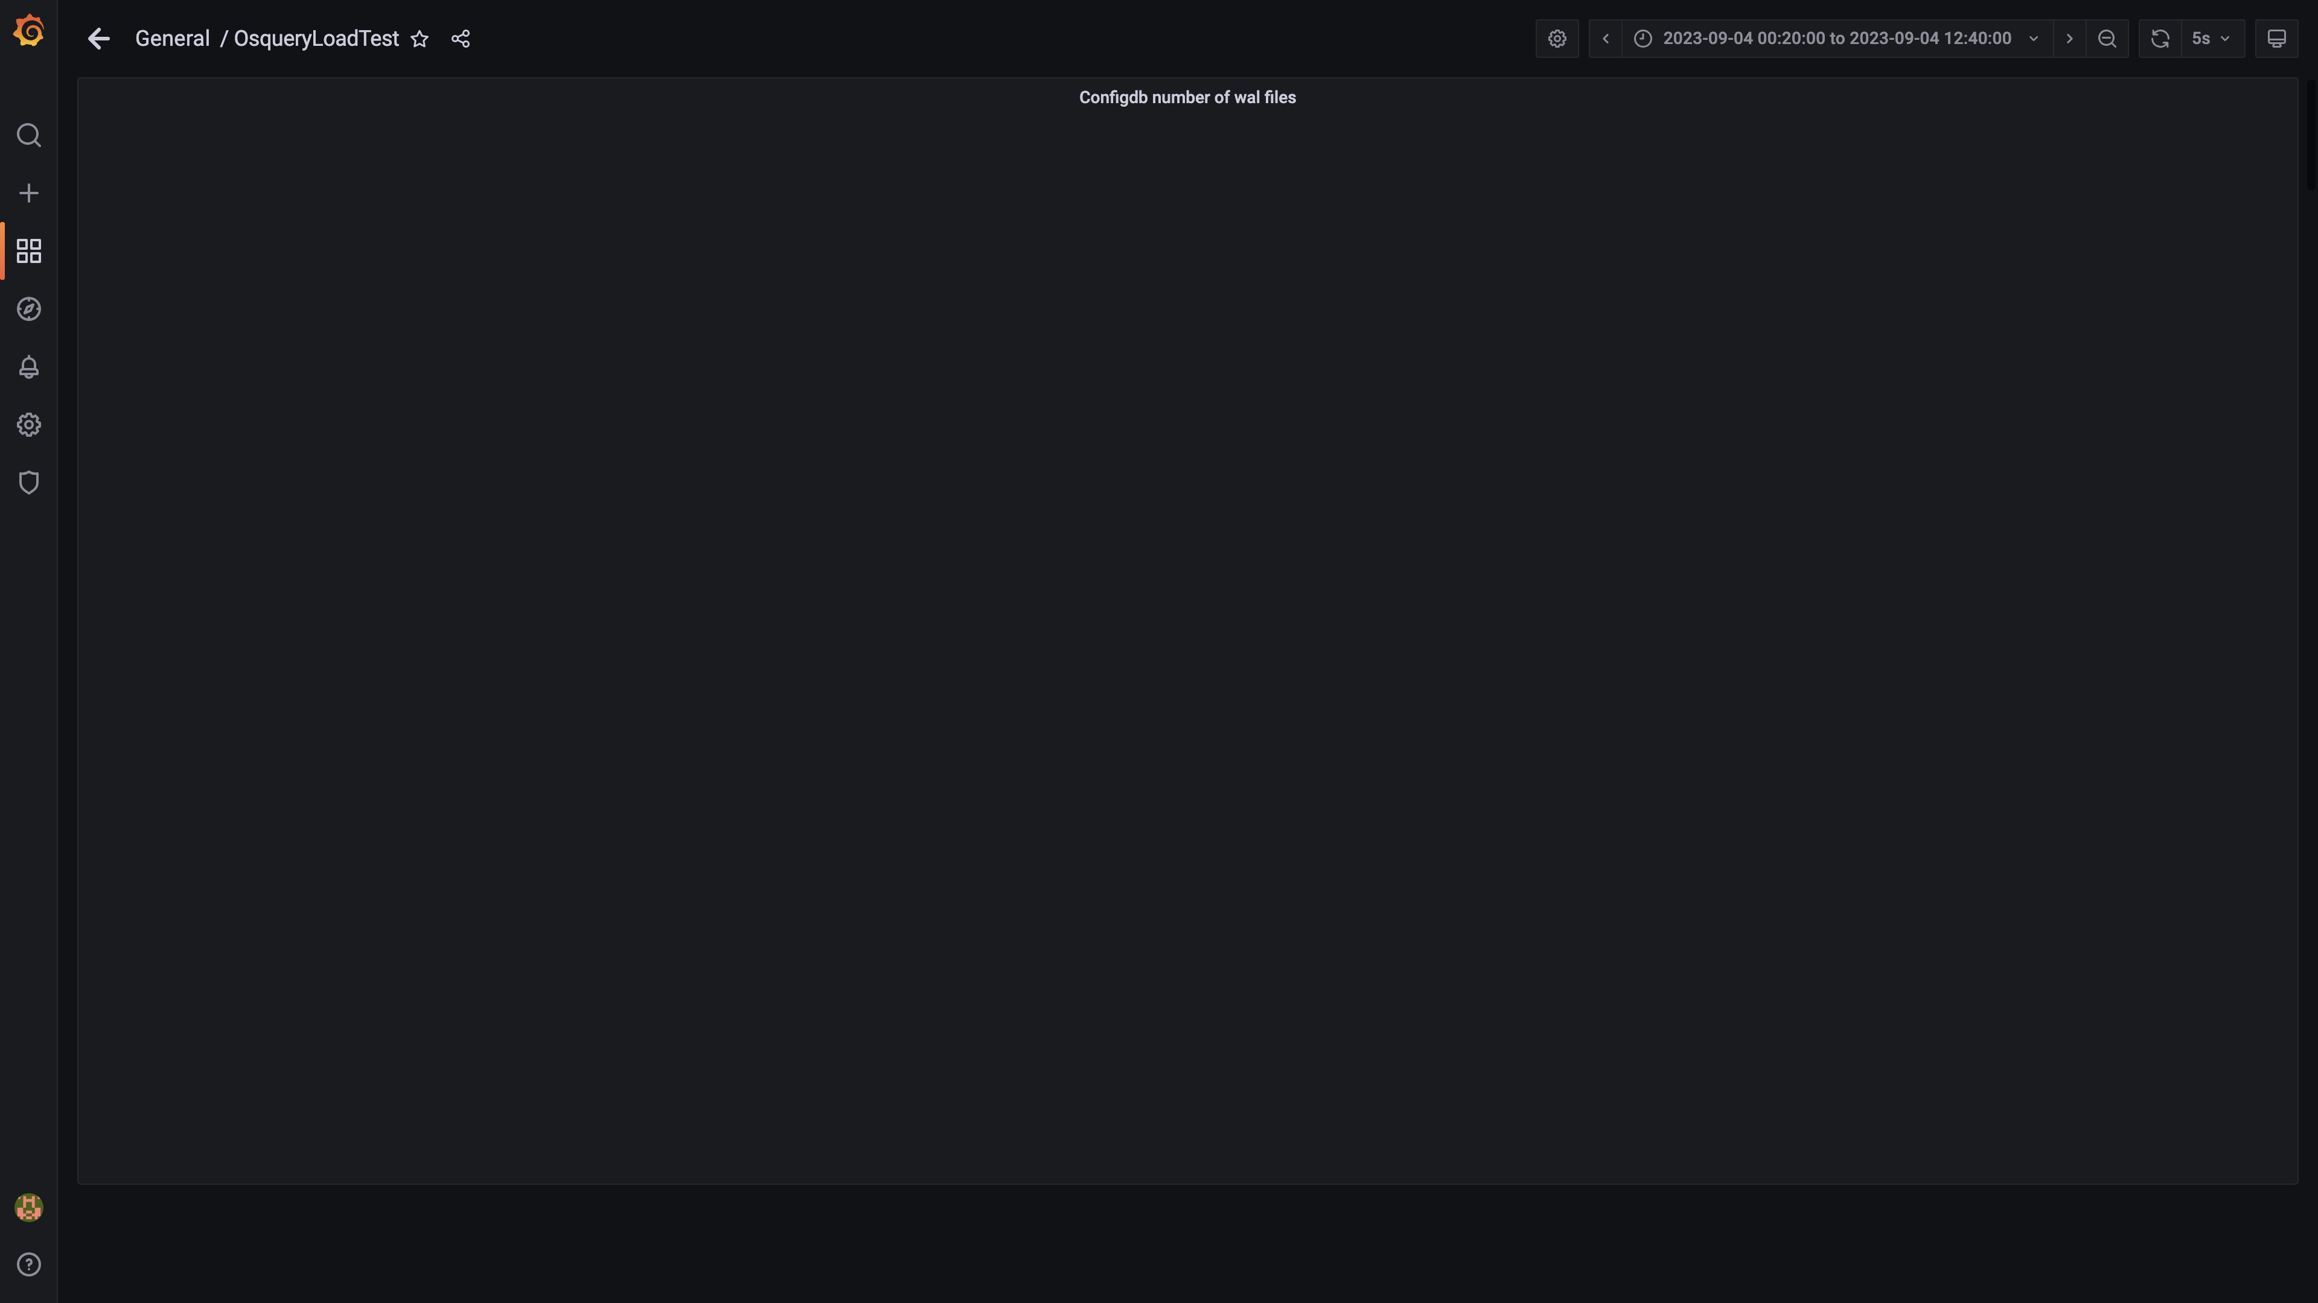

### Top 10 redis client connections by app

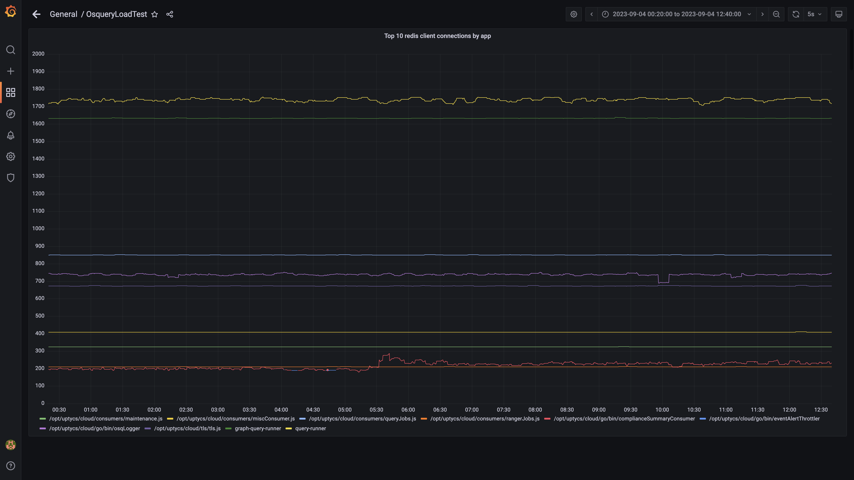

### Configdb folder size

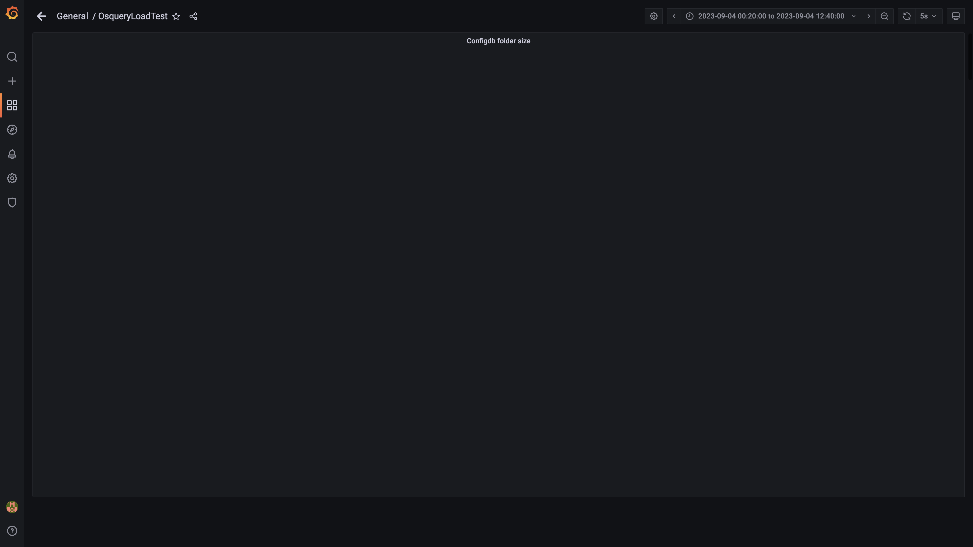

### Cpu and memory usages

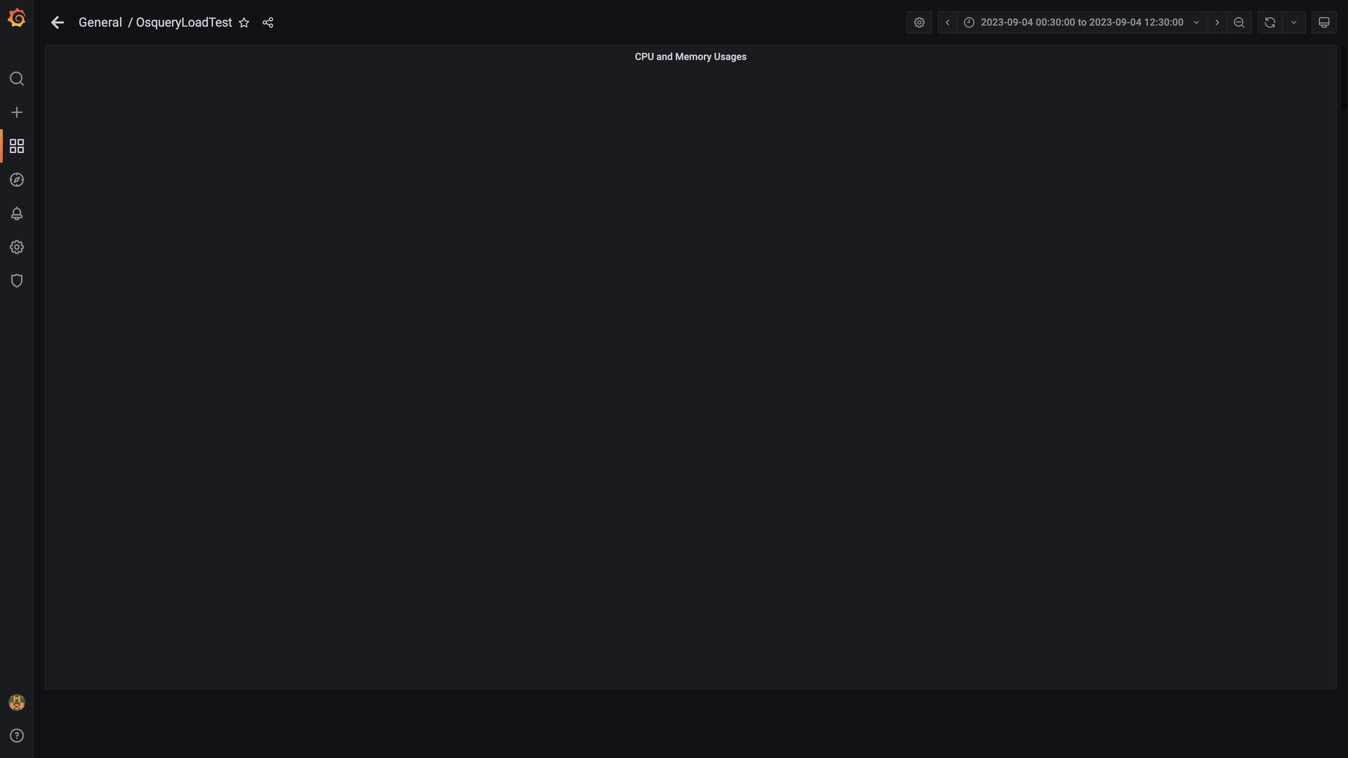

### Overall container memory and cpu usage

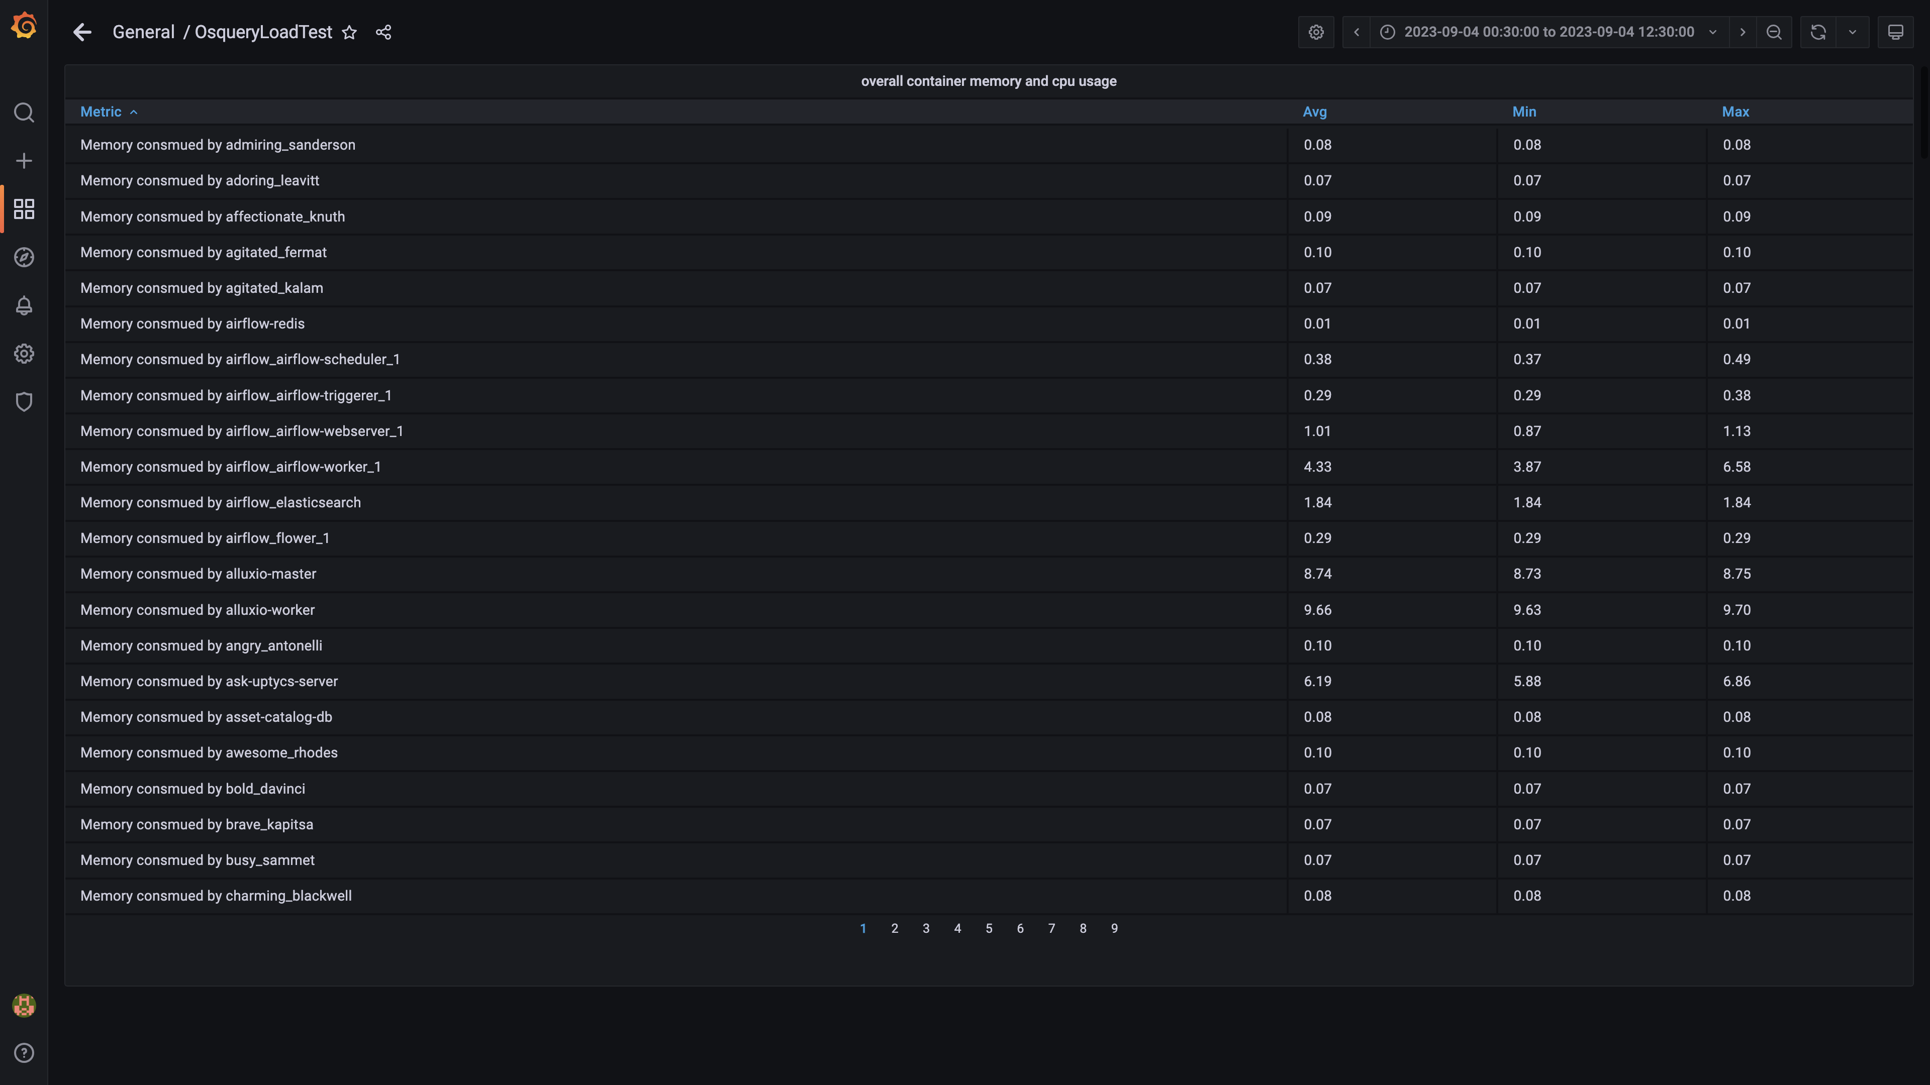

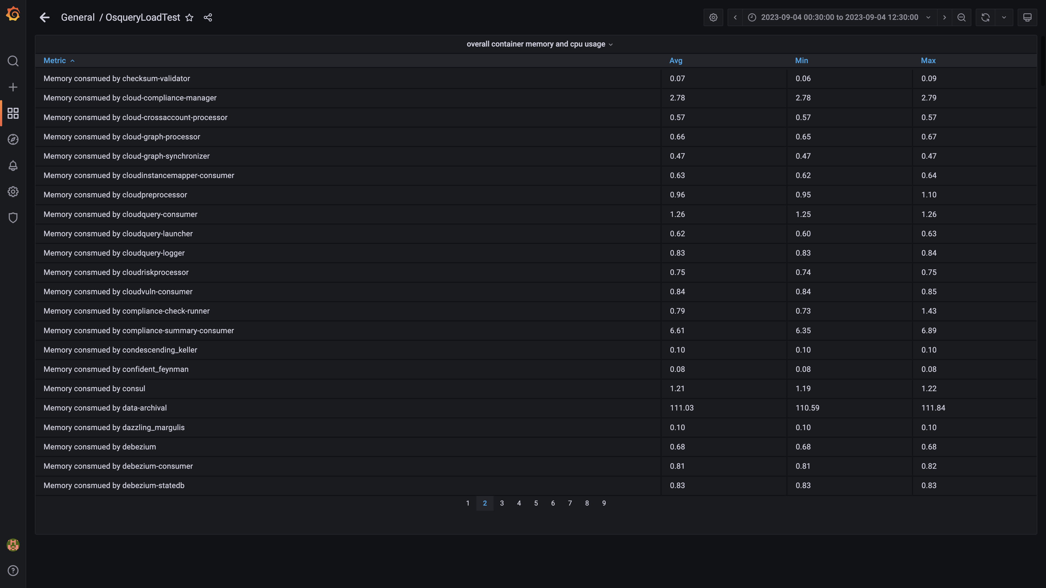

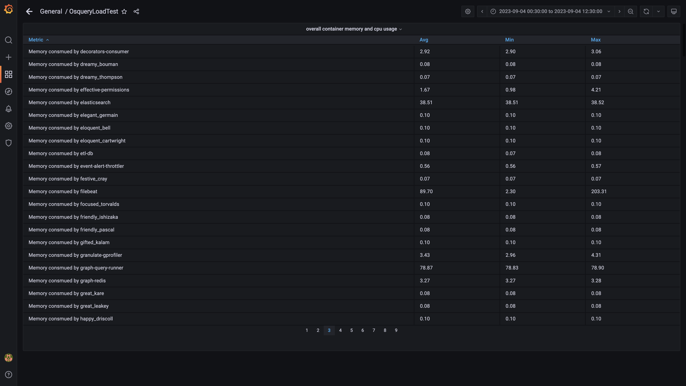

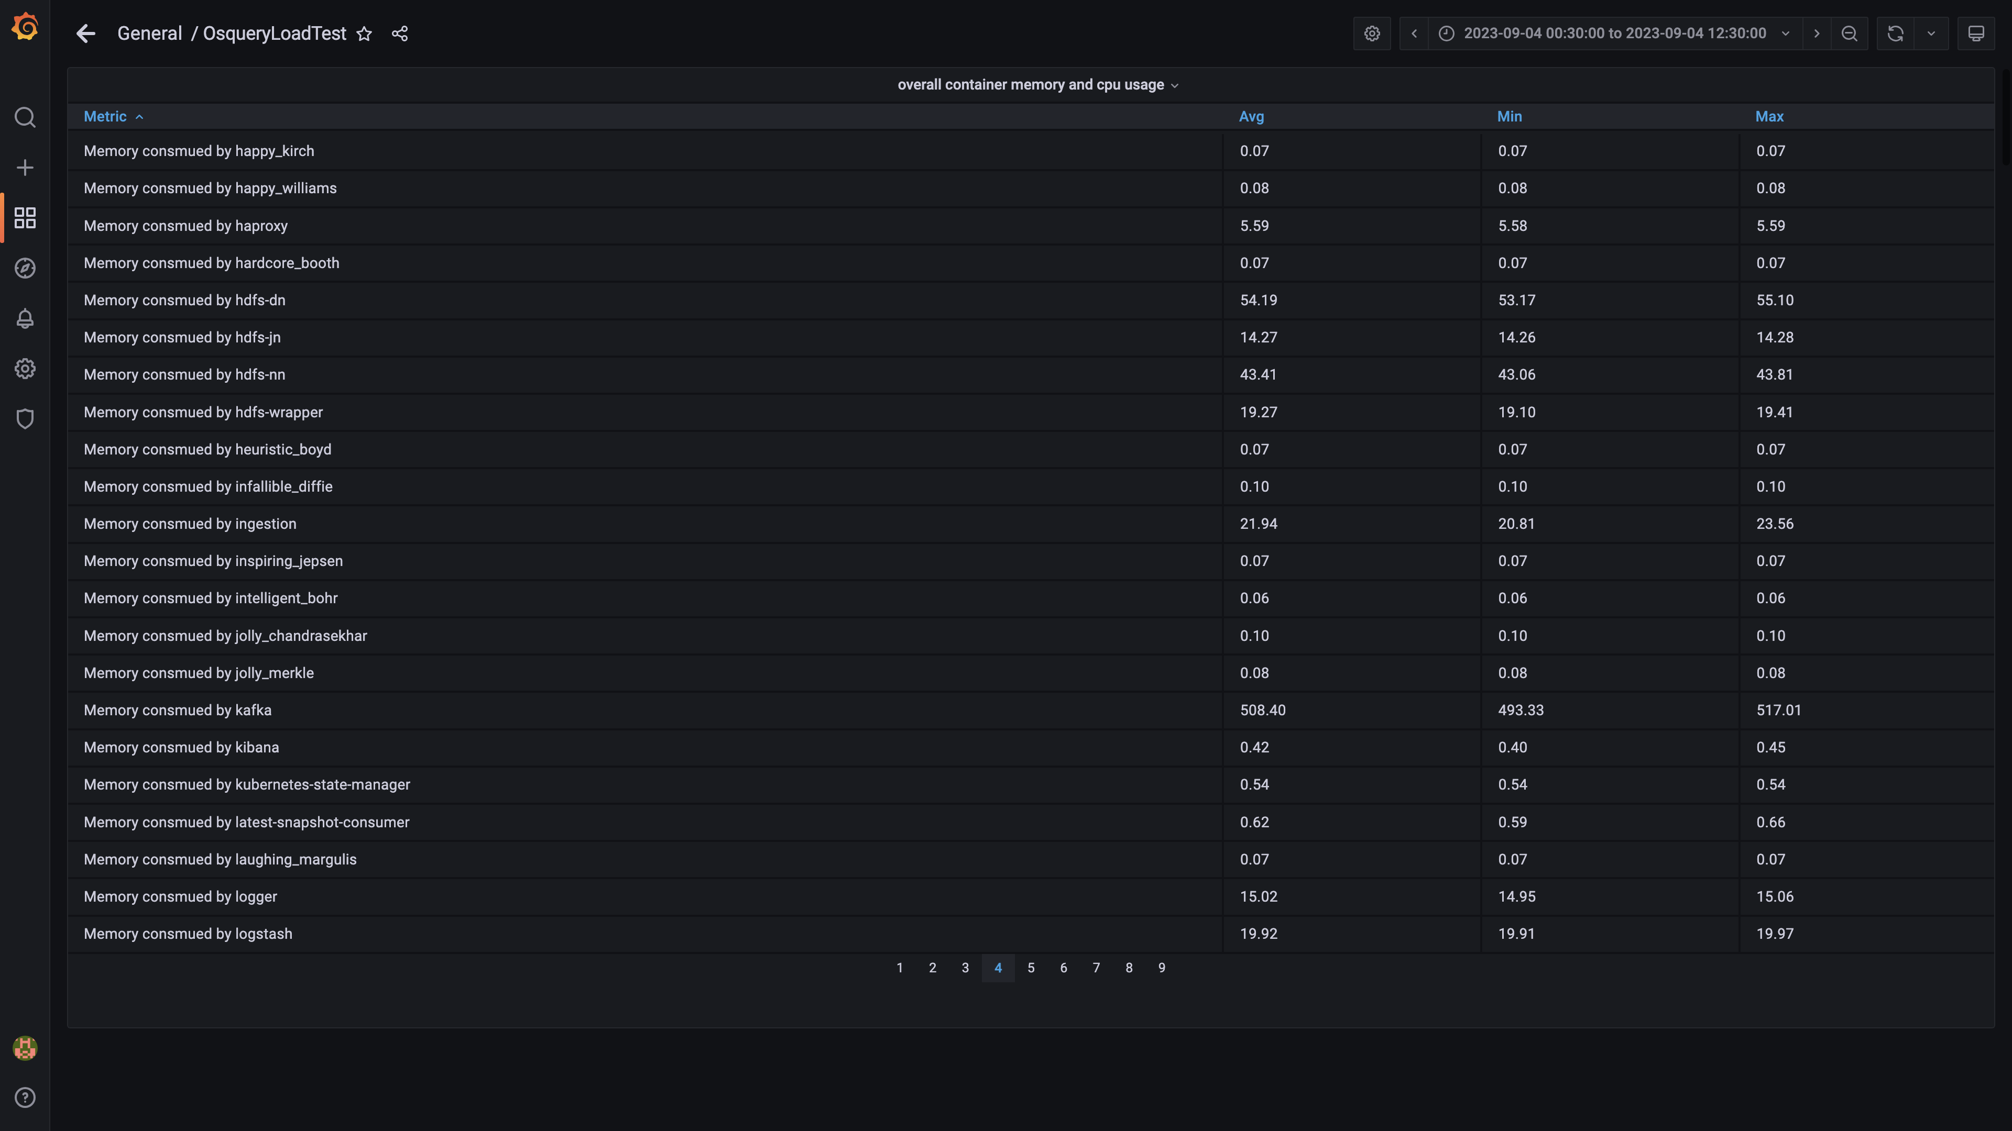

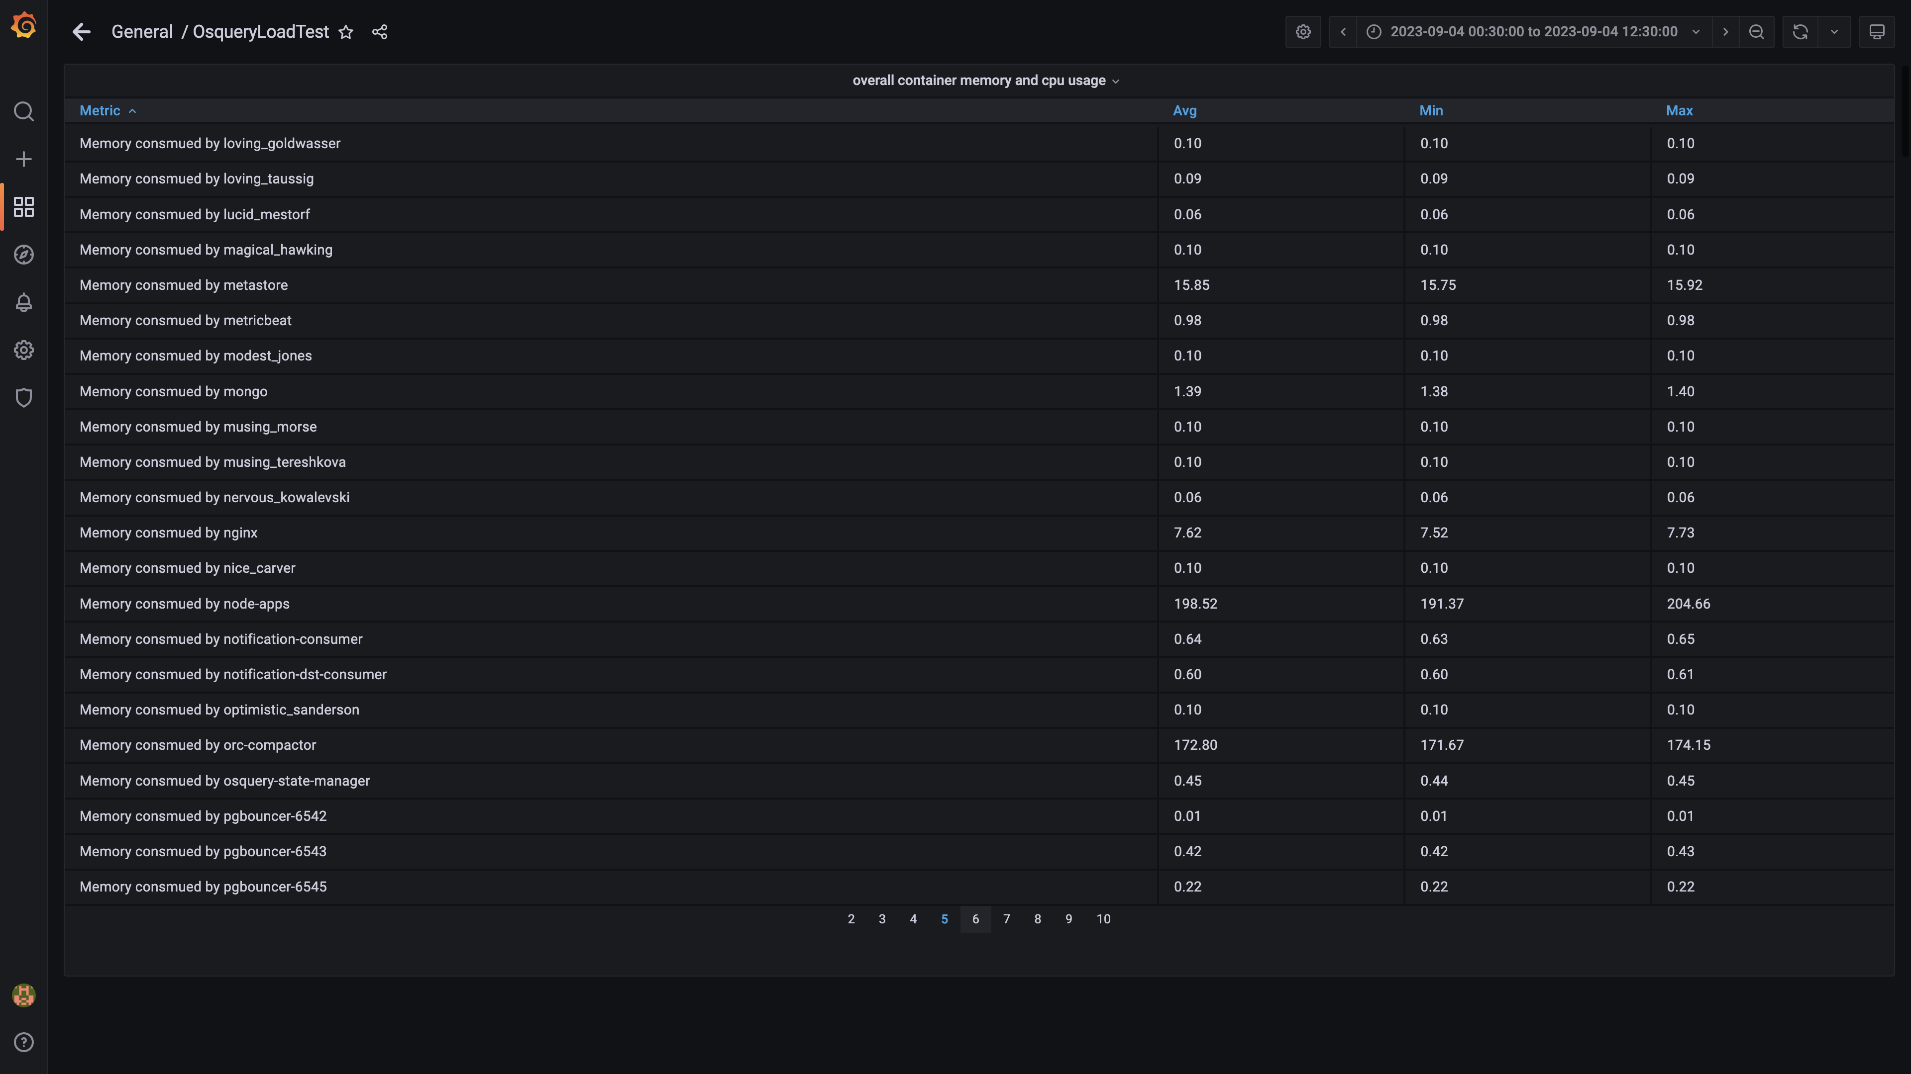

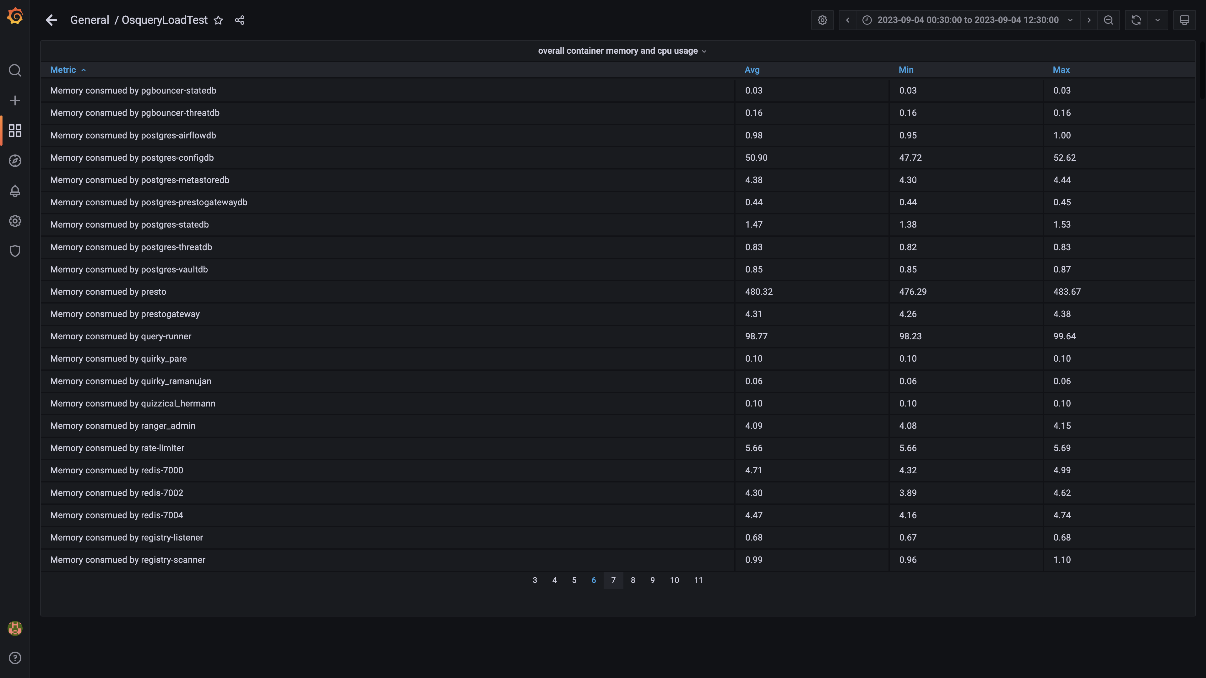

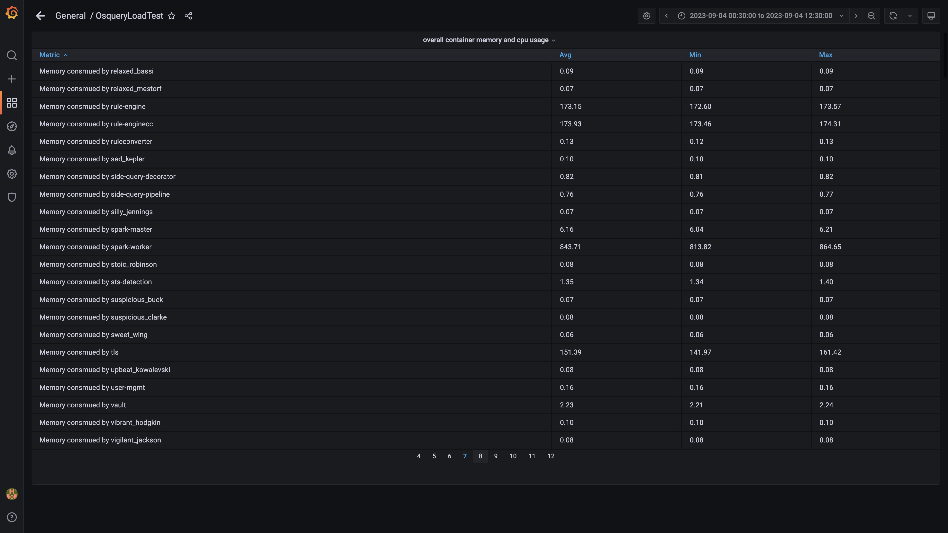

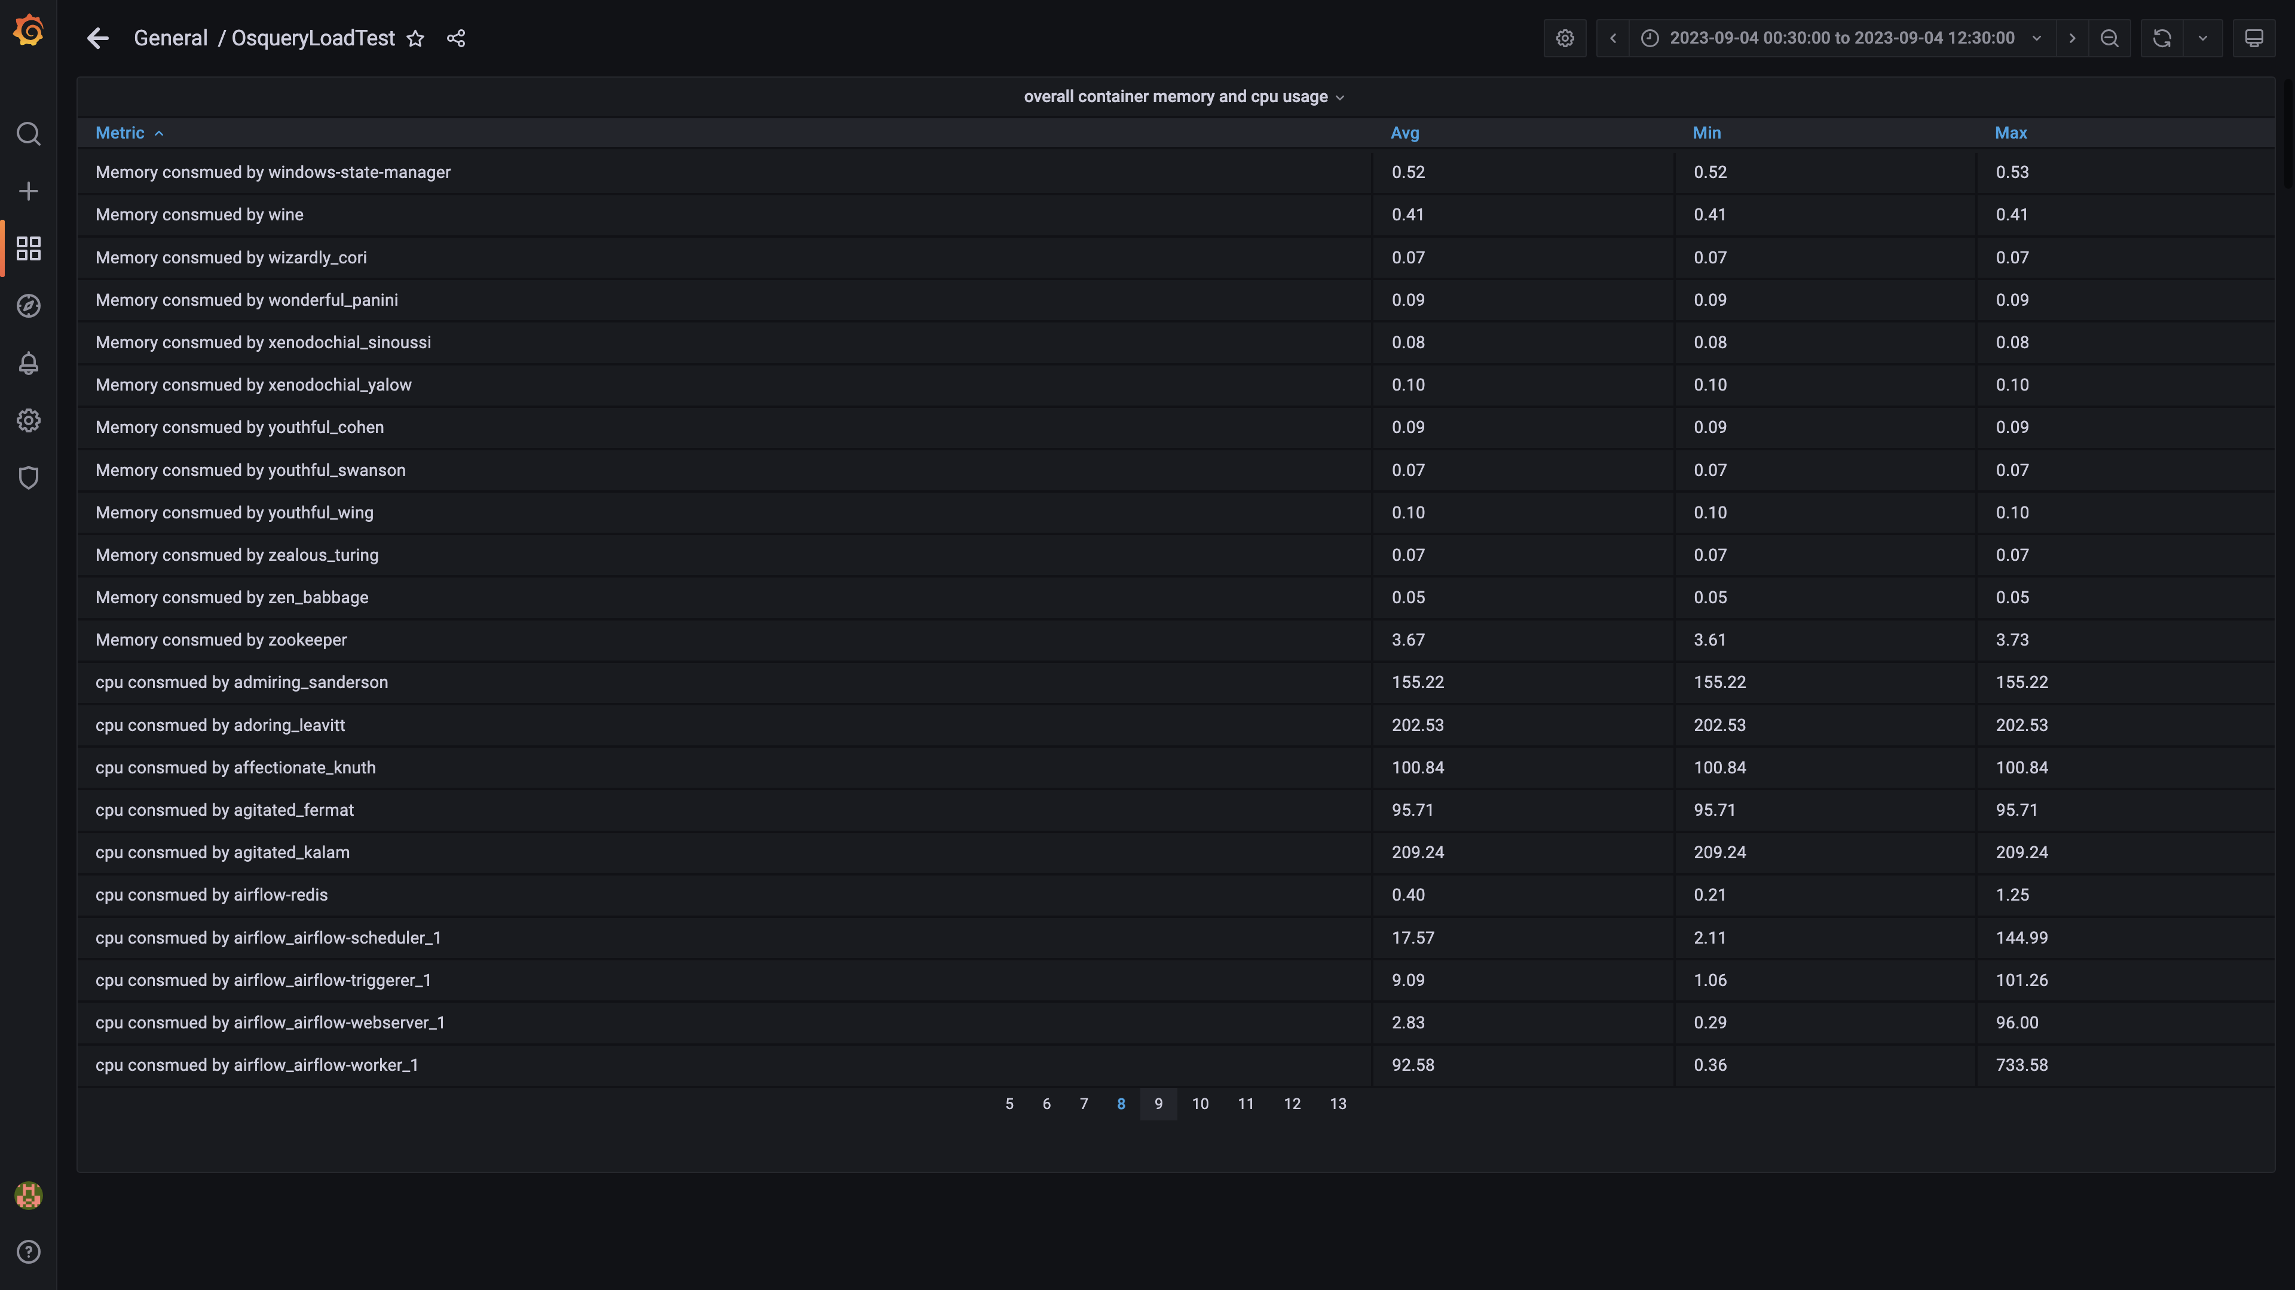

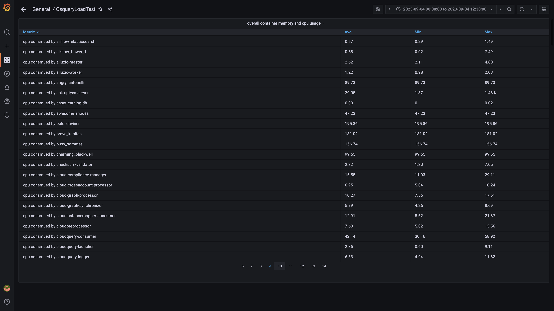

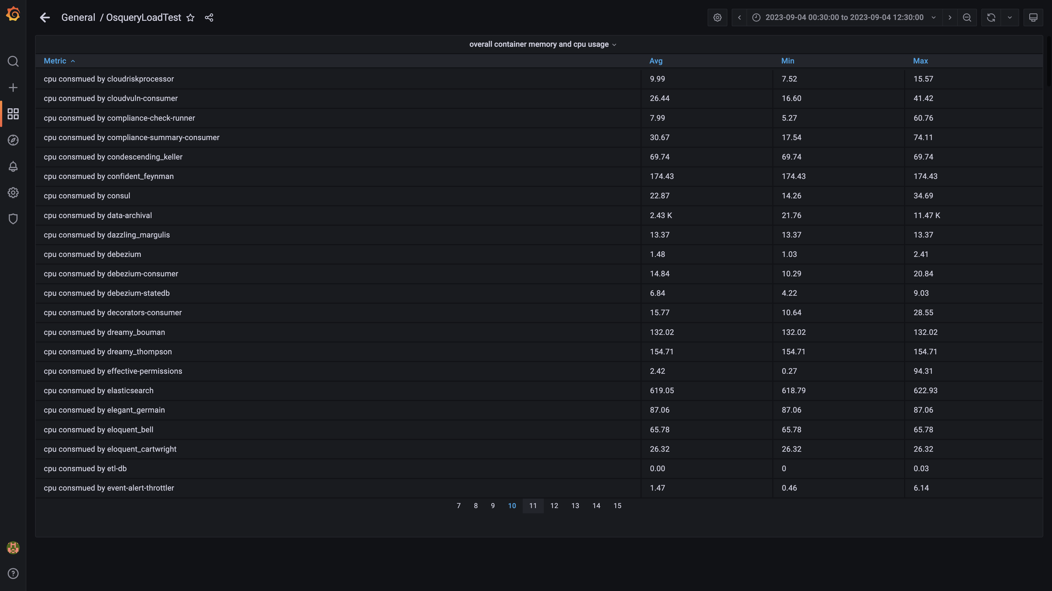

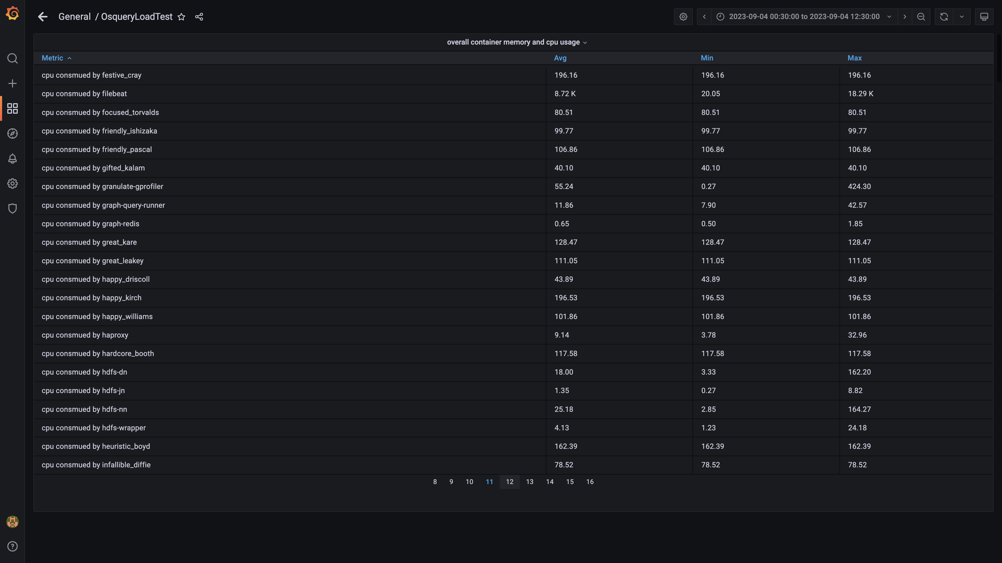

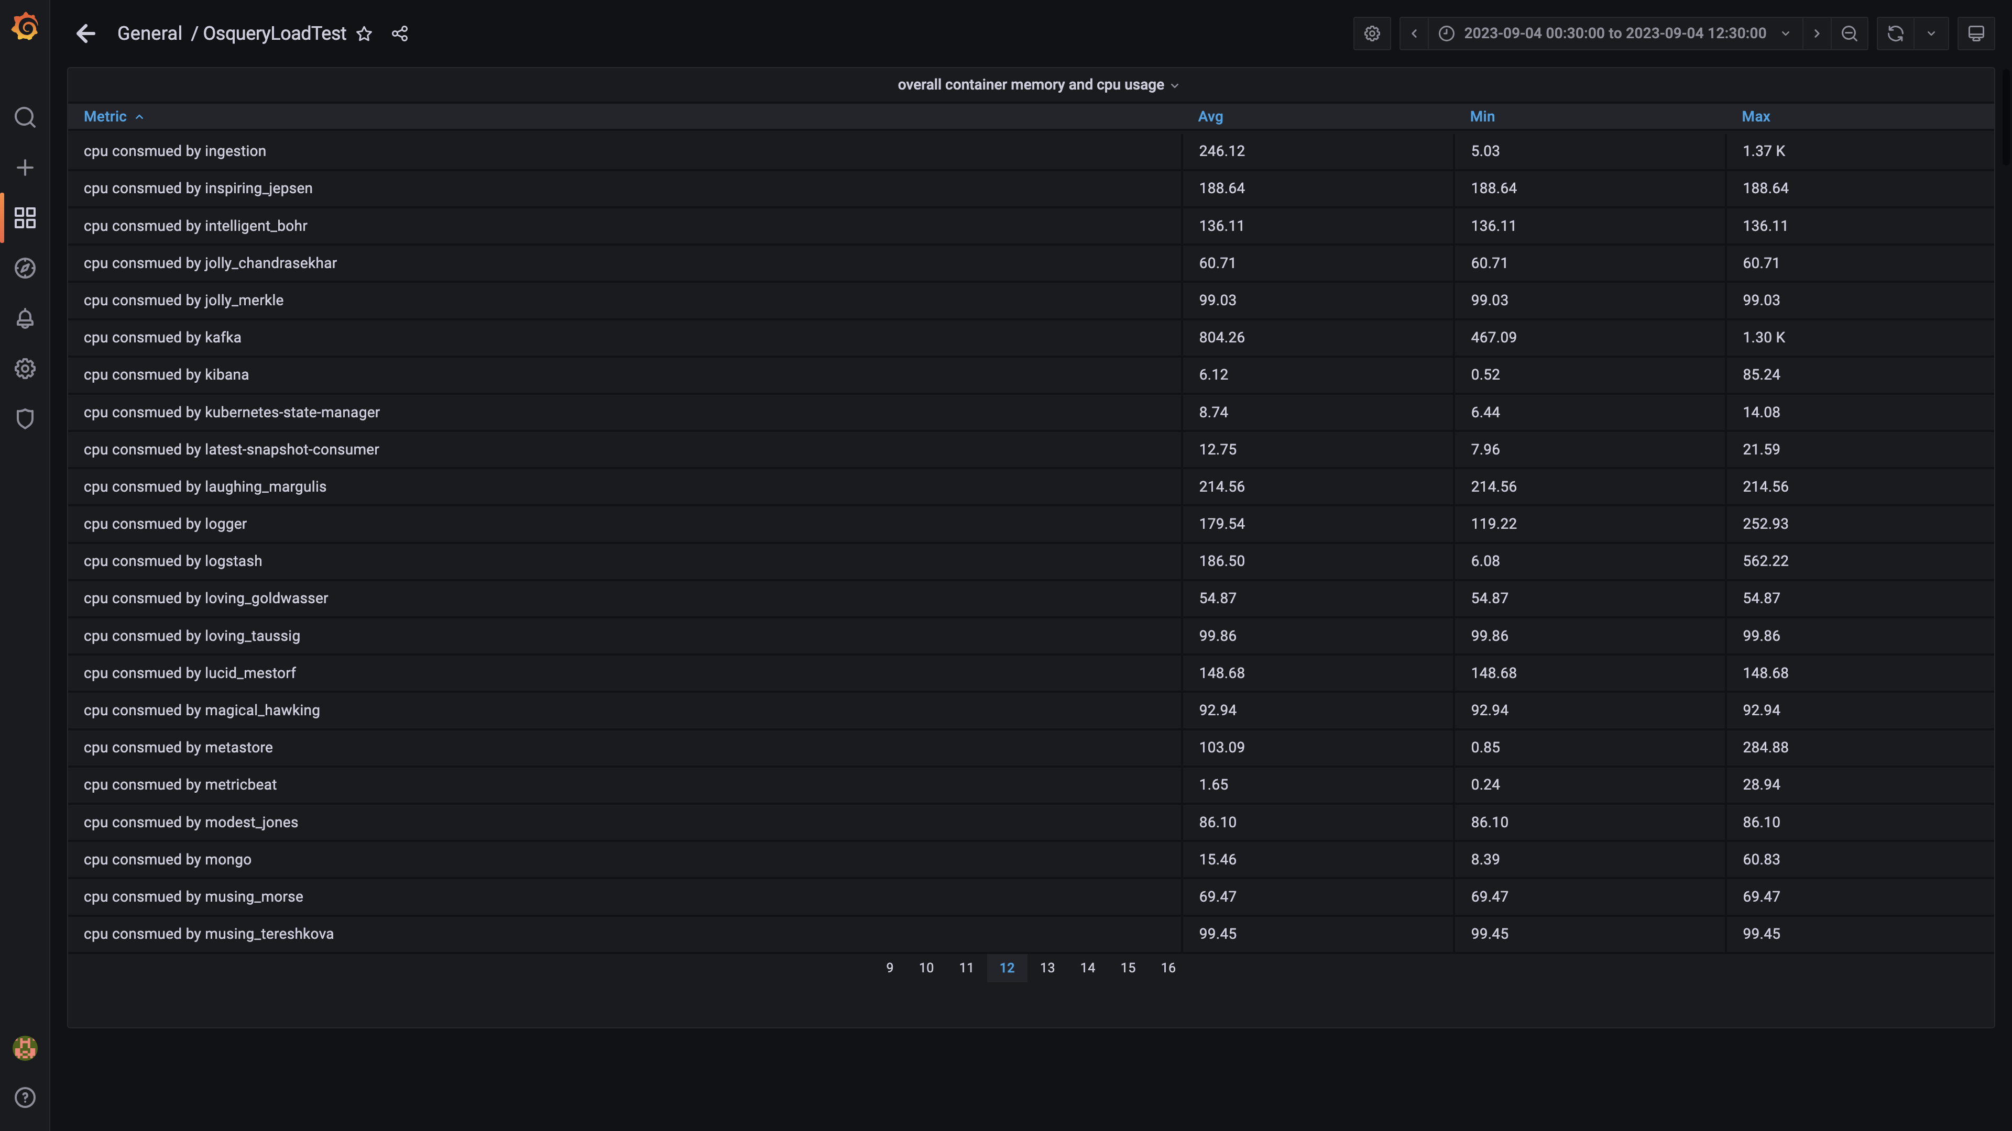

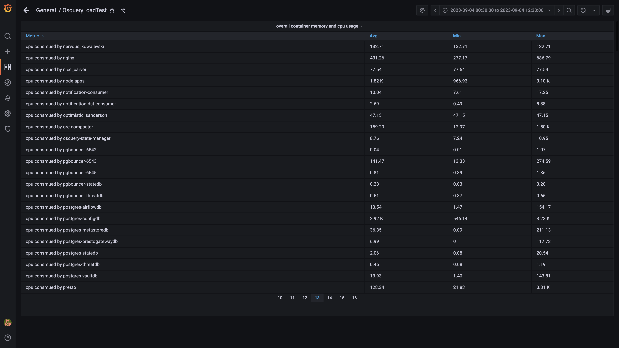

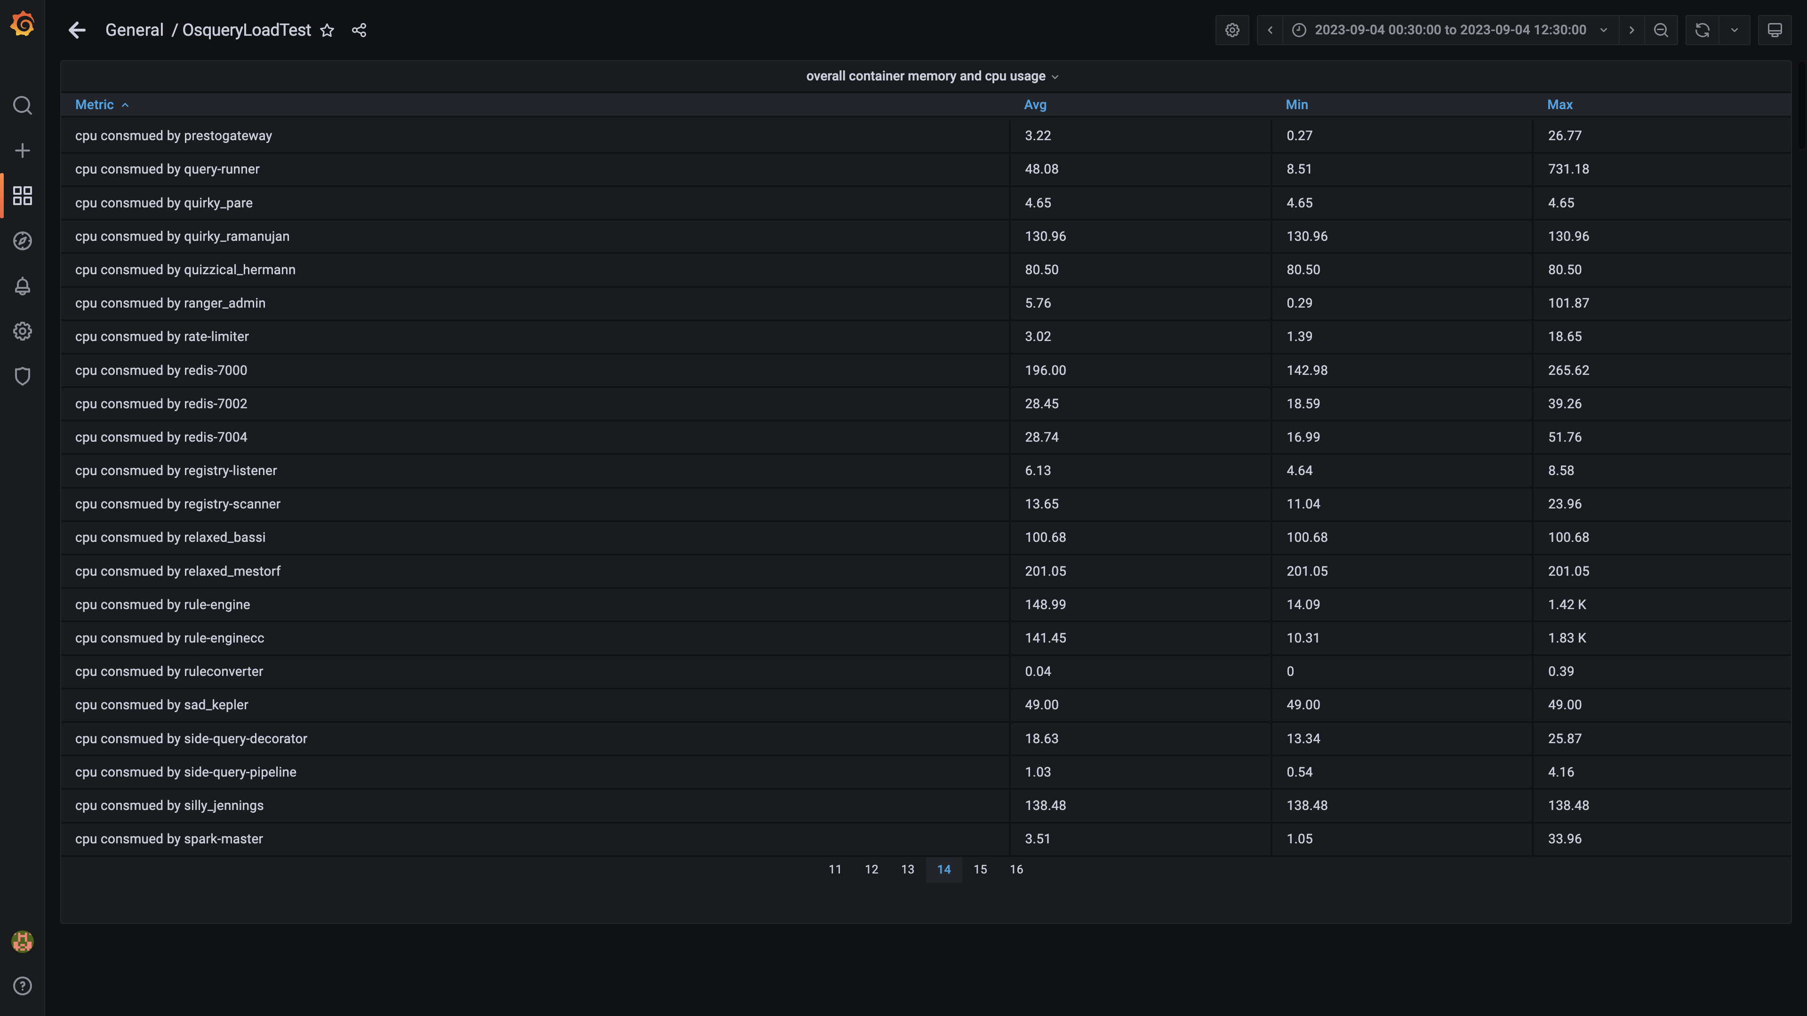

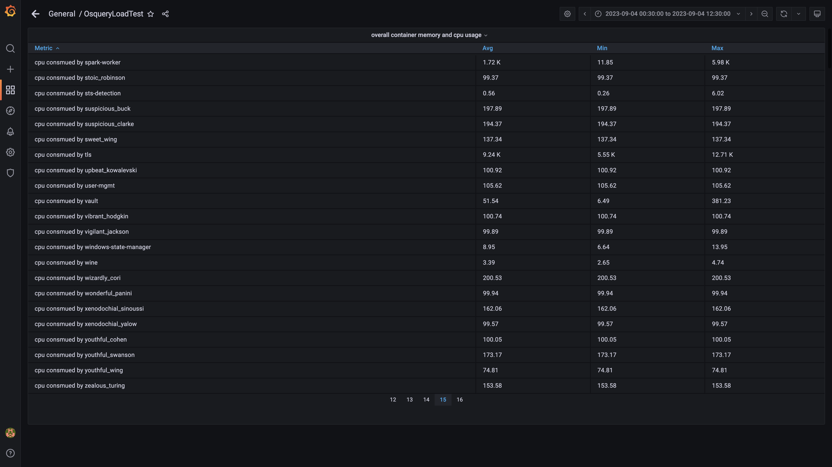

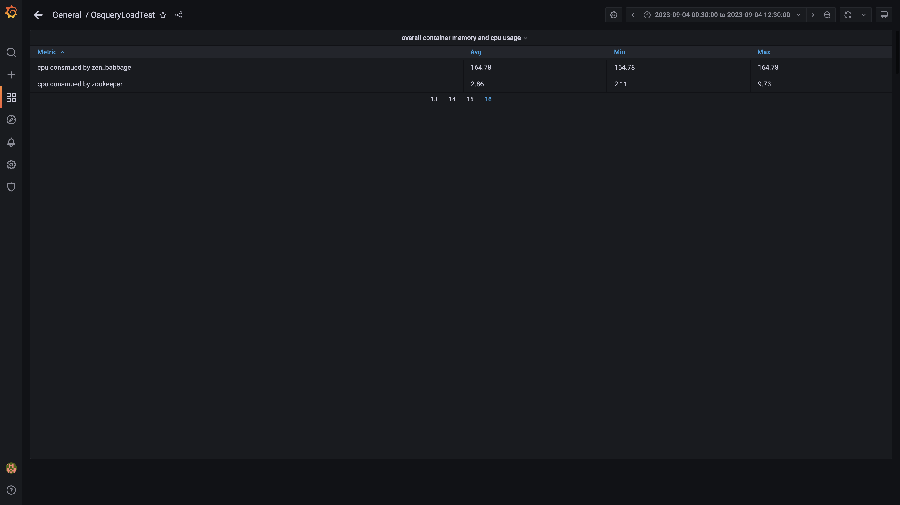

### Overall memory and cpu usages

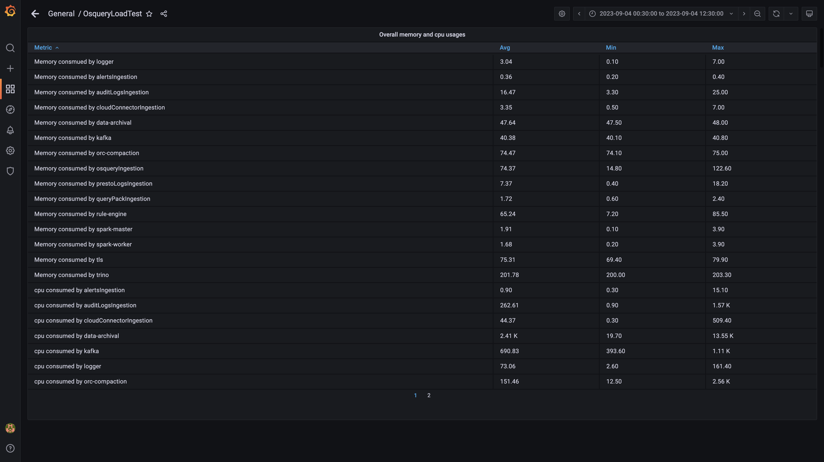

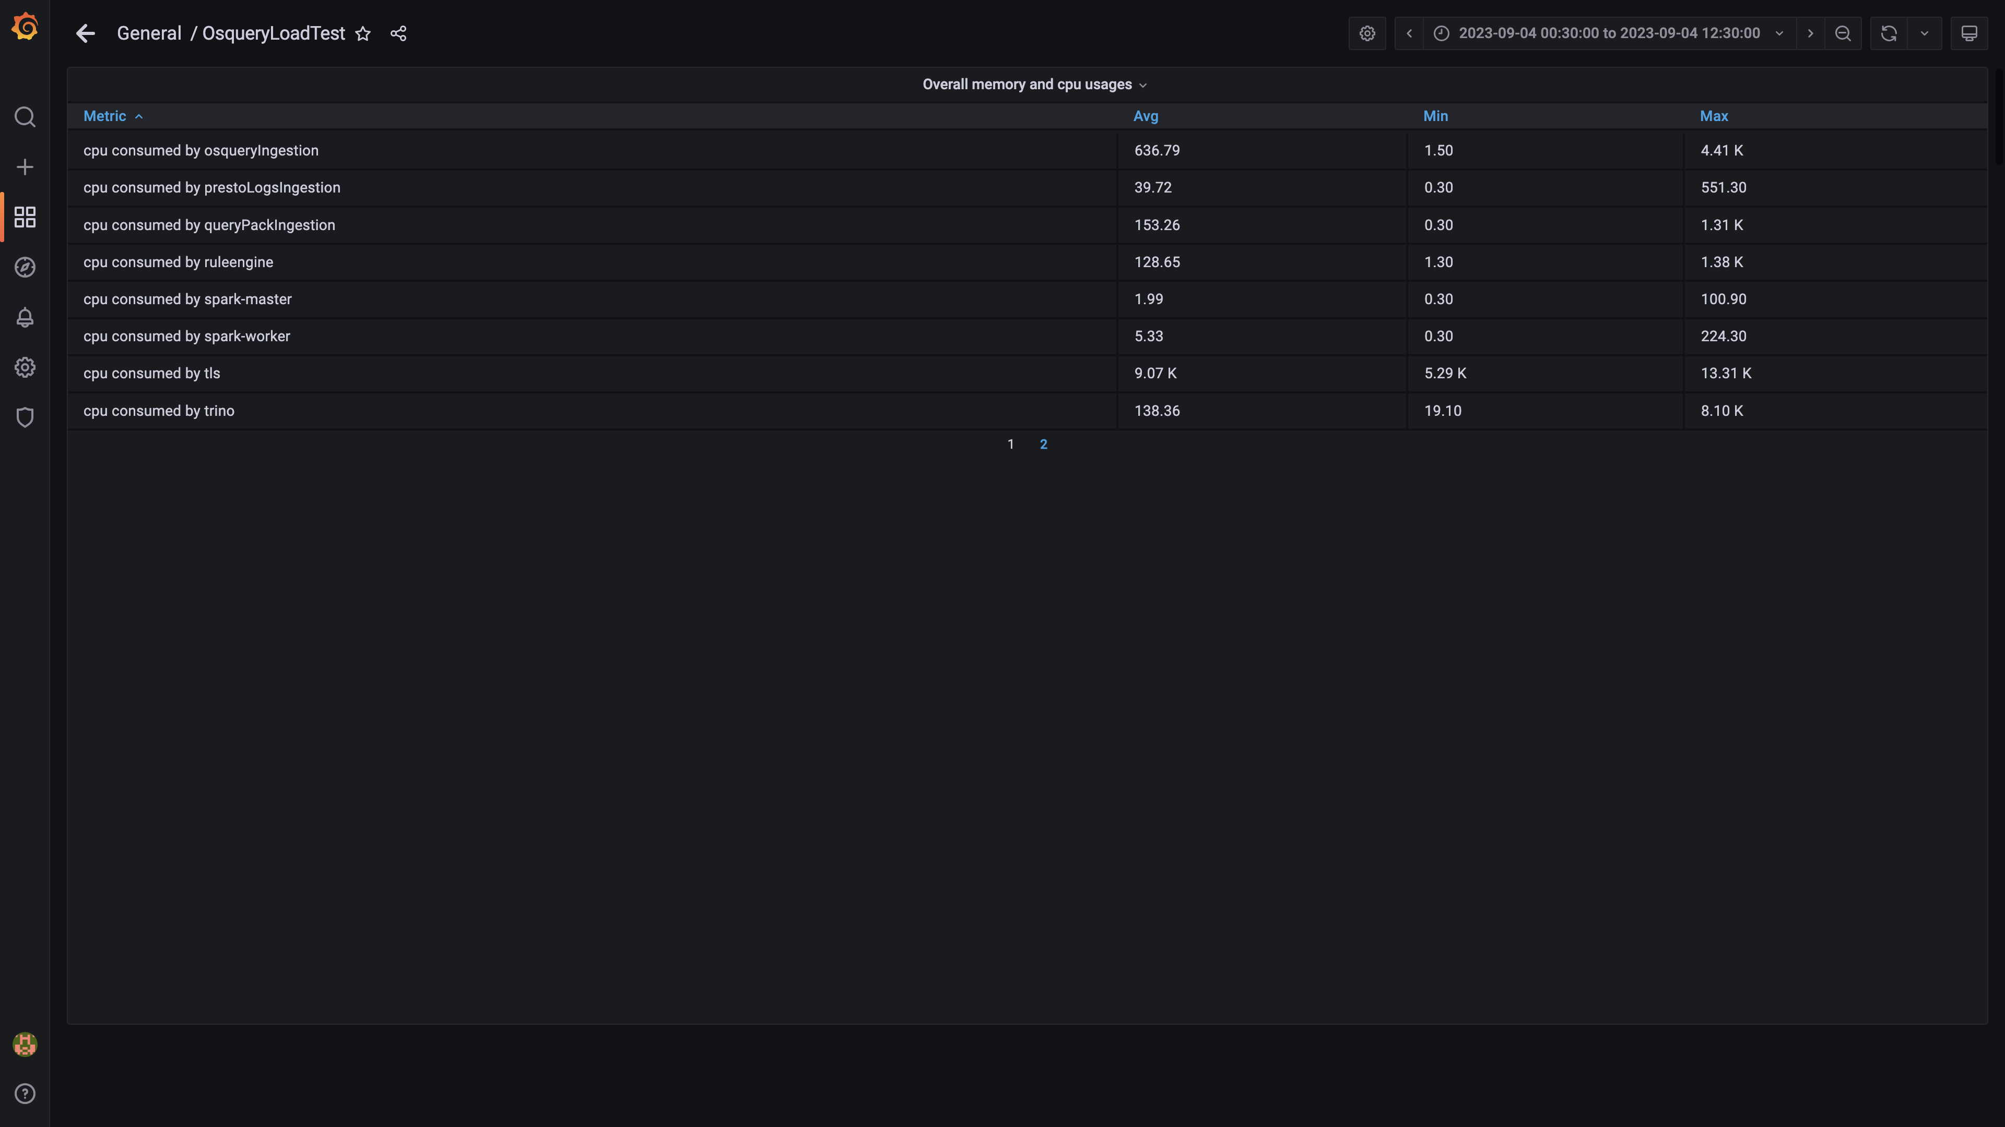

### Compaction status

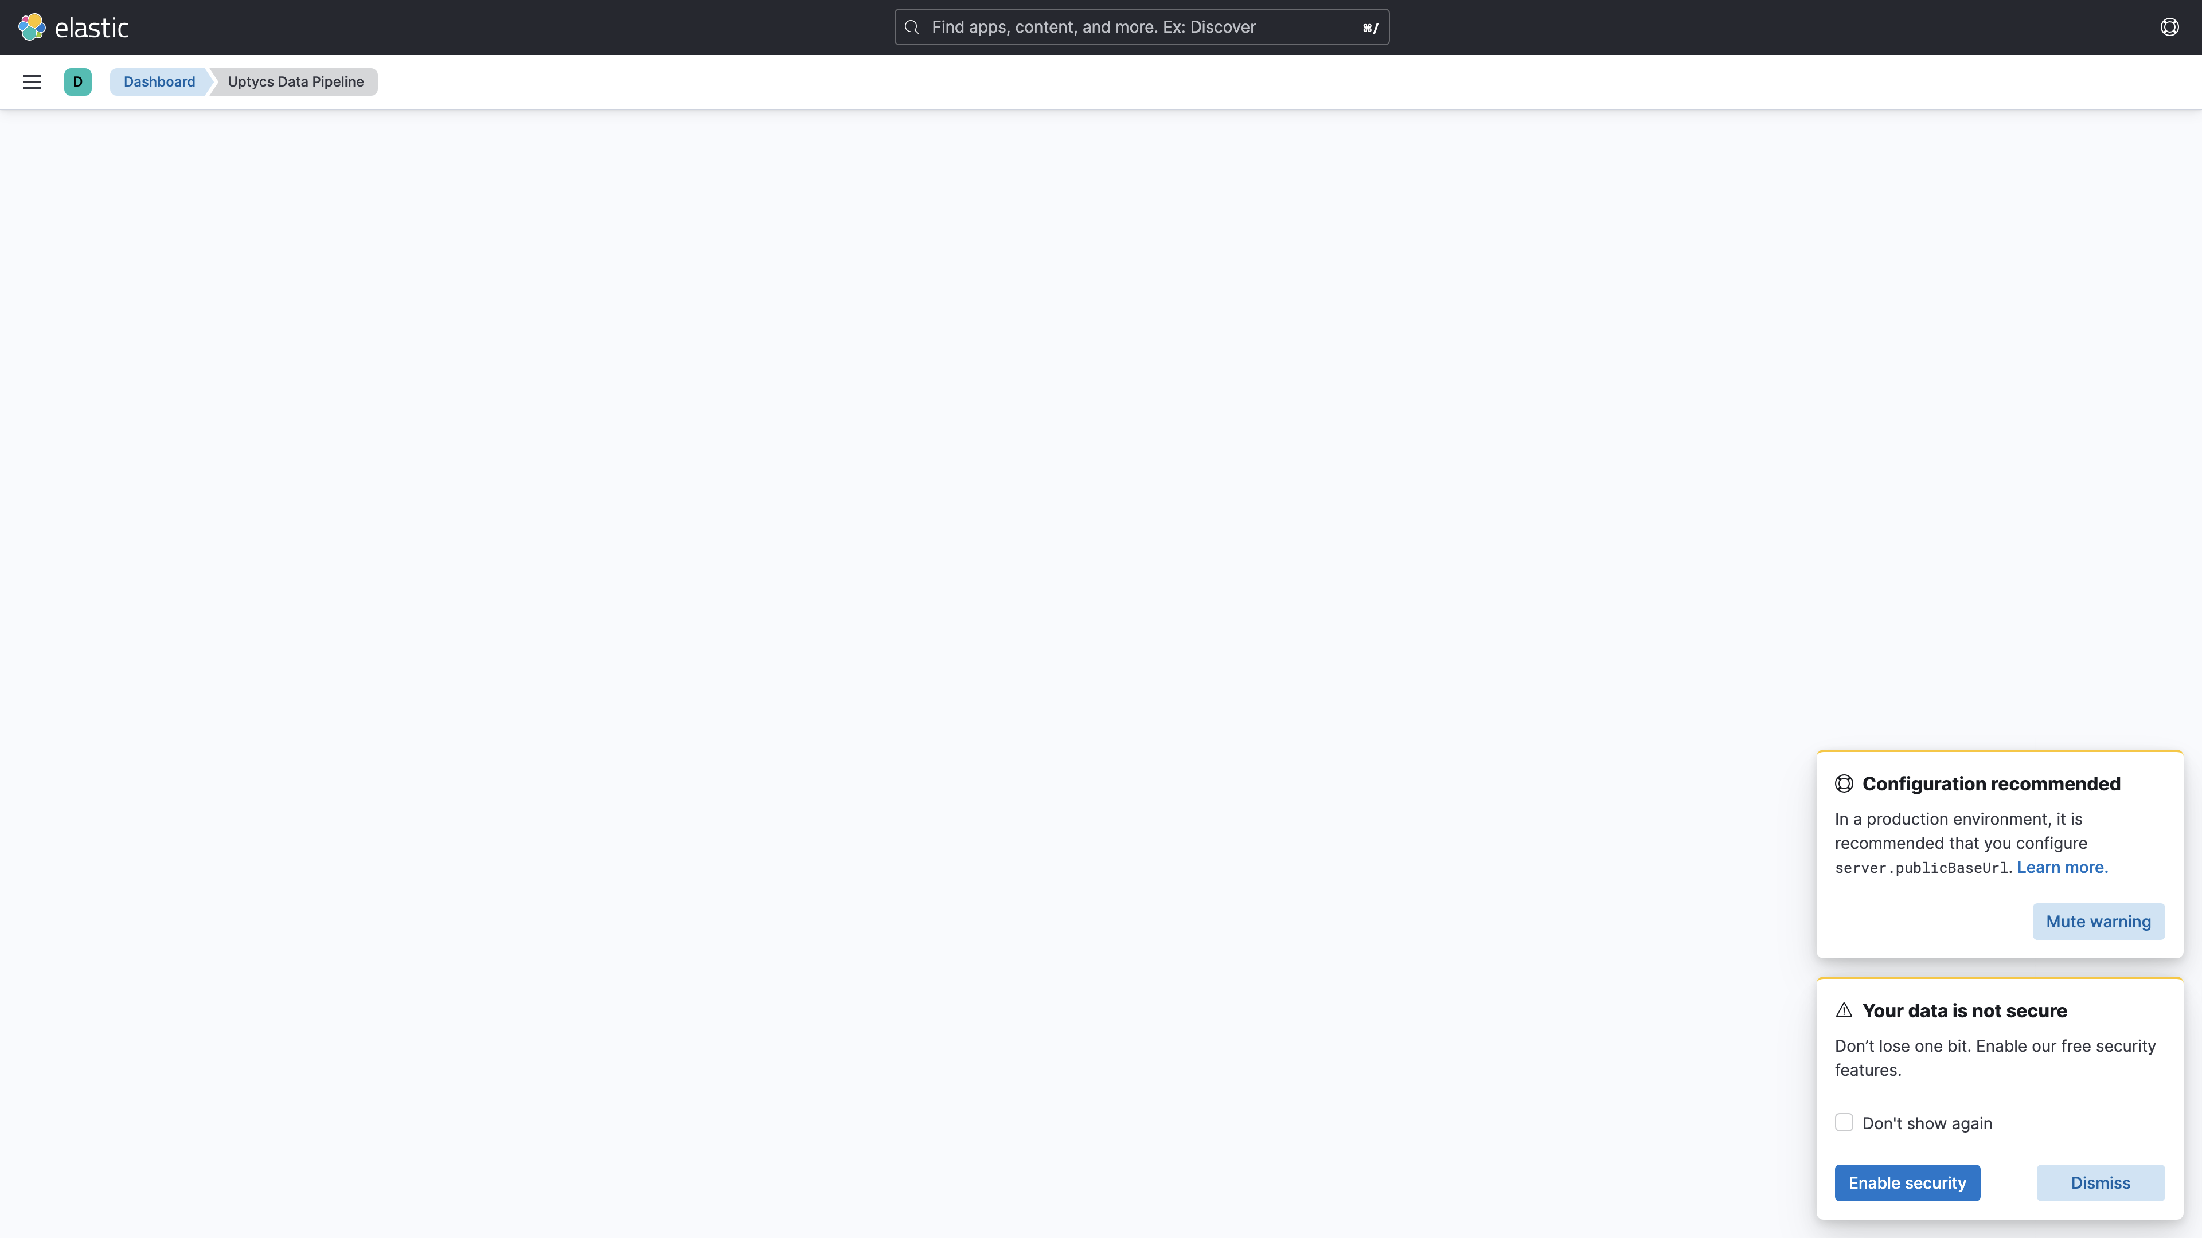

## Average Resource Utilization

### Comparision of Average Memory utilization

|  |  |  |  |  |
| --- | --- | --- | --- | --- |
| Metric | 137006 | 138023 | Absolute(%) | Relative(%) |
| Memory used by s1c1dn1 | 69.64% (174.80 GB) | 53.59% (134.50 GB) | 16.06% (40.30 GB) ⬇️ | 23.06% ⬇️ |
| Memory used by s1c1dn2 | 57.48% (144.26 GB) | 53.67% (134.70 GB) | 3.81% (9.56 GB) ⬇️ | 6.63% ⬇️ |
| Memory used by s1c1dn3 | 57.94% (145.43 GB) | 49.71% (124.78 GB) | 8.23% (20.65 GB) ⬇️ | 14.20% ⬇️ |
| Memory used by s1c1dn4 | 62.24% (117.02 GB) | 53.83% (101.21 GB) | 8.41% (15.81 GB) ⬇️ | 13.51% ⬇️ |
| Memory used by s1c1dn5 | 62.09% (116.73 GB) | 49.92% (93.86 GB) | 12.16% (22.87 GB) ⬇️ | 19.59% ⬇️ |
| Memory used by s1c1dn6 | 64.15% (120.61 GB) | 51.57% (96.94 GB) | 12.59% (23.67 GB) ⬇️ | 19.62% ⬇️ |
| Memory used by s1c1pn1 | 35.06% (65.91 GB) | 47.18% (88.70 GB) | 12.12% (22.79 GB) ⬆️ | 34.57% ⬆️ |
| Memory used by s1c1pn2 | 34.37% (64.61 GB) | 49.46% (92.99 GB) | 15.09% (28.38 GB) ⬆️ | 43.92% ⬆️ |
| Memory used by s1c1pn3 | 30.41% (57.17 GB) | 46.37% (87.18 GB) | 15.96% (30.01 GB) ⬆️ | 52.48% ⬆️ |
| Memory used by s1c1pn4 | 24.87% (46.76 GB) | 51.78% (97.35 GB) | 26.91% (50.59 GB) ⬆️ | 108.21% ⬆️ |
| Memory used by s1c1pn5 | 33.51% (63.00 GB) | 53.25% (100.11 GB) | 19.74% (37.11 GB) ⬆️ | 58.91% ⬆️ |
| Memory used by s1c1pn6 | 32.34% (60.80 GB) | 52.36% (98.44 GB) | 20.02% (37.65 GB) ⬆️ | 61.92% ⬆️ |
| Memory used by s1c2dn1 | 49.72% (124.79 GB) | 53.49% (134.26 GB) | 3.77% (9.46 GB) ⬆️ | 7.58% ⬆️ |
| Memory used by s1c2dn2 | 45.60% (114.45 GB) | 43.00% (107.94 GB) | 2.60% (6.51 GB) ⬇️ | 5.69% ⬇️ |
| Memory used by s1c2dn3 | 46.55% (116.83 GB) | 40.87% (102.59 GB) | 5.68% (14.25 GB) ⬇️ | 12.19% ⬇️ |
| Memory used by s1c2dn4 | 56.72% (106.64 GB) | 53.81% (101.17 GB) | 2.91% (5.47 GB) ⬇️ | 5.13% ⬇️ |
| Memory used by s1c2dn5 | 57.05% (107.25 GB) | 51.27% (96.39 GB) | 5.78% (10.86 GB) ⬇️ | 10.13% ⬇️ |
| Memory used by s1c2dn6 | 56.38% (106.00 GB) | 52.92% (99.50 GB) | 3.46% (6.50 GB) ⬇️ | 6.14% ⬇️ |
| Memory used by s1c2pn1 | 27.00% (50.76 GB) | 41.86% (78.70 GB) | 14.86% (27.94 GB) ⬆️ | 55.03% ⬆️ |
| Memory used by s1c2pn2 | 27.58% (51.84 GB) | 48.93% (91.98 GB) | 21.35% (40.14 GB) ⬆️ | 77.43% ⬆️ |
| Memory used by s1c2pn3 | 26.09% (49.05 GB) | 49.09% (92.28 GB) | 23.00% (43.24 GB) ⬆️ | 88.15% ⬆️ |
| Memory used by s1c2pn4 | 26.81% (50.39 GB) | 48.31% (90.82 GB) | 21.50% (40.43 GB) ⬆️ | 80.22% ⬆️ |
| Memory used by s1c2pn5 | 31.30% (58.85 GB) | 48.78% (91.71 GB) | 17.48% (32.86 GB) ⬆️ | 55.85% ⬆️ |
| Memory used by s1c2pn6 | 29.64% (55.73 GB) | 48.95% (92.02 GB) | 19.30% (36.29 GB) ⬆️ | 65.12% ⬆️ |
| Memory used by s1cloudquery | - | 3.81% (1.18 GB) | - | - |
| Memory used by s1configdb1 | 13.62% (25.61 GB) | 2.10% (3.95 GB) | 11.52% (21.66 GB) ⬇️ | 84.57% ⬇️ |
| Memory used by s1configdb2 | 1.20% (2.25 GB) | 13.68% (25.72 GB) | 12.48% (23.46 GB) ⬆️ | 1041.15% ⬆️ |
| Memory used by s1elasticsearch | - | 26.53% (16.45 GB) | - | - |
| Memory used by s1kibana | - | 4.39% (1.36 GB) | - | - |
| Memory used by s1logstash1 | - | 16.50% (10.23 GB) | - | - |
| Memory used by s1logstash2 | - | 16.51% (10.24 GB) | - | - |
| Memory used by s1mlnode1 | - | 12.90% (8.00 GB) | - | - |
| Memory used by s1mlnode2 | - | 6.42% (3.98 GB) | - | - |
| Memory used by s1monitor | 22.22% (13.77 GB) | 4.41% (2.74 GB) | 17.80% (11.04 GB) ⬇️ | 80.13% ⬇️ |
| Memory used by s1stsnode1 | - | 6.78% (3.18 GB) | - | - |
| Memory used by s1stsnode2 | - | 16.32% (7.67 GB) | - | - |
| Memory used by s1stsnode3 | - | 8.50% (3.99 GB) | - | - |
| Memory used by Rule Engine s1c1pn1 | 3.30% (6.21 GB) | 7.22% (13.57 GB) | 3.91% (7.36 GB) ⬆️ | 118.47% ⬆️ |
| Memory used by Rule Engine s1c1pn2 | 3.40% (6.39 GB) | 7.10% (13.35 GB) | 3.70% (6.96 GB) ⬆️ | 109.00% ⬆️ |
| Memory used by Rule Engine s1c1pn3 | 3.30% (6.21 GB) | 7.01% (13.17 GB) | 3.70% (6.96 GB) ⬆️ | 112.10% ⬆️ |
| Memory used by Rule Engine s1c1pn4 | 3.31% (6.22 GB) | 7.13% (13.40 GB) | 3.82% (7.18 GB) ⬆️ | 115.58% ⬆️ |
| Memory used by Rule Engine s1c1pn5 | 3.40% (6.40 GB) | 6.94% (13.05 GB) | 3.54% (6.65 GB) ⬆️ | 103.95% ⬆️ |
| Memory used by Rule Engine s1c1pn6 | 3.40% (6.39 GB) | 7.30% (13.72 GB) | 3.90% (7.33 GB) ⬆️ | 114.71% ⬆️ |
| Memory used by Rule Engine s1c2pn1 | 3.20% (6.02 GB) | 7.16% (13.47 GB) | 3.96% (7.45 GB) ⬆️ | 123.87% ⬆️ |
| Memory used by Rule Engine s1c2pn2 | 3.20% (6.02 GB) | 7.24% (13.62 GB) | 4.04% (7.60 GB) ⬆️ | 126.40% ⬆️ |
| Memory used by Rule Engine s1c2pn3 | 3.30% (6.20 GB) | 7.15% (13.44 GB) | 3.85% (7.23 GB) ⬆️ | 116.60% ⬆️ |
| Memory used by Rule Engine s1c2pn4 | 3.40% (6.39 GB) | 6.94% (13.04 GB) | 3.54% (6.65 GB) ⬆️ | 104.18% ⬆️ |
| Memory used by Rule Engine s1c2pn5 | 3.30% (6.20 GB) | 6.91% (12.99 GB) | 3.61% (6.78 GB) ⬆️ | 109.36% ⬆️ |
| Memory used by Rule Engine s1c2pn6 | 3.40% (6.39 GB) | 7.26% (13.64 GB) | 3.86% (7.26 GB) ⬆️ | 113.62% ⬆️ |
| Memory used by Osquery Ingestion s1c1dn1 | 5.55% (13.92 GB) | 6.73% (16.90 GB) | 1.19% (2.98 GB) ⬆️ | 21.41% ⬆️ |
| Memory used by Osquery Ingestion s1c1dn2 | 5.93% (14.87 GB) | 6.27% (15.75 GB) | 0.35% (0.88 GB) ⬆️ | 5.90% ⬆️ |
| Memory used by Osquery Ingestion s1c1dn3 | 6.11% (15.33 GB) | 6.76% (16.97 GB) | 0.65% (1.64 GB) ⬆️ | 10.67% ⬆️ |
| Memory used by Osquery Ingestion s1c1dn4 | 8.04% (15.11 GB) | 8.95% (16.83 GB) | 0.91% (1.71 GB) ⬆️ | 11.35% ⬆️ |
| Memory used by Osquery Ingestion s1c1dn5 | 8.59% (16.14 GB) | 8.76% (16.47 GB) | 0.17% (0.33 GB) ⬆️ | 2.04% ⬆️ |
| Memory used by Osquery Ingestion s1c1dn6 | 8.67% (16.29 GB) | 8.81% (16.55 GB) | 0.14% (0.26 GB) ⬆️ | 1.59% ⬆️ |
| Memory used by Osquery Ingestion s1c2dn1 | 4.86% (12.20 GB) | 6.17% (15.48 GB) | 1.30% (3.27 GB) ⬆️ | 26.84% ⬆️ |
| Memory used by Osquery Ingestion s1c2dn2 | 5.44% (13.65 GB) | 6.67% (16.75 GB) | 1.24% (3.10 GB) ⬆️ | 22.75% ⬆️ |
| Memory used by Osquery Ingestion s1c2dn3 | 6.01% (15.08 GB) | 6.78% (17.02 GB) | 0.77% (1.94 GB) ⬆️ | 12.87% ⬆️ |
| Memory used by Osquery Ingestion s1c2dn4 | 7.68% (14.44 GB) | 8.94% (16.81 GB) | 1.26% (2.37 GB) ⬆️ | 16.44% ⬆️ |
| Memory used by Osquery Ingestion s1c2dn5 | 7.89% (14.83 GB) | 8.77% (16.48 GB) | 0.88% (1.65 GB) ⬆️ | 11.13% ⬆️ |
| Memory used by Osquery Ingestion s1c2dn6 | 7.61% (14.31 GB) | 8.77% (16.49 GB) | 1.16% (2.18 GB) ⬆️ | 15.24% ⬆️ |
| Memory used by Kafka s1c1pn1 | 3.04% (5.72 GB) | 2.80% (5.27 GB) | 0.24% (0.45 GB) ⬇️ | 7.91% ⬇️ |
| Memory used by Kafka s1c1pn2 | 3.30% (6.21 GB) | 3.31% (6.22 GB) | 0.01% (0.01 GB) ⬆️ | 0.20% ⬆️ |
| Memory used by Kafka s1c1pn3 | 3.42% (6.44 GB) | 3.30% (6.20 GB) | 0.12% (0.23 GB) ⬇️ | 3.62% ⬇️ |
| Memory used by Kafka s1c1pn4 | 3.45% (6.48 GB) | 3.36% (6.31 GB) | 0.09% (0.17 GB) ⬇️ | 2.60% ⬇️ |
| Memory used by Kafka s1c1pn5 | 3.40% (6.39 GB) | 3.39% (6.37 GB) | 0.01% (0.03 GB) ⬇️ | 0.41% ⬇️ |
| Memory used by Kafka s1c1pn6 | 3.36% (6.31 GB) | 3.37% (6.33 GB) | 0.01% (0.02 GB) ⬆️ | 0.35% ⬆️ |
| Memory used by Kafka s1c2pn1 | 2.67% (5.02 GB) | 2.93% (5.51 GB) | 0.26% (0.49 GB) ⬆️ | 9.74% ⬆️ |
| Memory used by Kafka s1c2pn2 | 3.14% (5.91 GB) | 3.40% (6.39 GB) | 0.26% (0.48 GB) ⬆️ | 8.14% ⬆️ |
| Memory used by Kafka s1c2pn3 | 3.12% (5.87 GB) | 3.40% (6.39 GB) | 0.28% (0.52 GB) ⬆️ | 8.94% ⬆️ |
| Memory used by Kafka s1c2pn4 | 3.01% (5.65 GB) | 3.37% (6.33 GB) | 0.36% (0.68 GB) ⬆️ | 12.11% ⬆️ |
| Memory used by Kafka s1c2pn5 | 3.17% (5.95 GB) | 3.40% (6.39 GB) | 0.23% (0.43 GB) ⬆️ | 7.27% ⬆️ |
| Memory used by Kafka s1c2pn6 | 3.07% (5.78 GB) | 3.32% (6.23 GB) | 0.24% (0.46 GB) ⬆️ | 7.92% ⬆️ |
| Memory used by Trino s1c1dn1 | 22.41% (56.24 GB) | 11.16% (28.02 GB) | 11.25% (28.23 GB) ⬇️ | 50.19% ⬇️ |
| Memory used by Trino s1c1dn2 | 15.33% (38.47 GB) | 15.10% (37.90 GB) | 0.23% (0.57 GB) ⬇️ | 1.47% ⬇️ |
| Memory used by Trino s1c1dn3 | 15.70% (39.40 GB) | 14.50% (36.40 GB) | 1.20% (3.00 GB) ⬇️ | 7.63% ⬇️ |
| Memory used by Trino s1c1dn4 | 15.86% (29.81 GB) | 15.40% (28.95 GB) | 0.46% (0.86 GB) ⬇️ | 2.88% ⬇️ |
| Memory used by Trino s1c1dn5 | 16.19% (30.43 GB) | 15.20% (28.58 GB) | 0.99% (1.86 GB) ⬇️ | 6.10% ⬇️ |
| Memory used by Trino s1c1dn6 | 16.29% (30.63 GB) | 14.90% (28.01 GB) | 1.39% (2.62 GB) ⬇️ | 8.55% ⬇️ |
| Memory used by Trino s1c2dn1 | 15.45% (38.79 GB) | 24.36% (61.14 GB) | 8.90% (22.35 GB) ⬆️ | 57.61% ⬆️ |
| Memory used by Trino s1c2dn2 | 15.31% (38.42 GB) | 16.44% (41.27 GB) | 1.14% (2.85 GB) ⬆️ | 7.43% ⬆️ |
| Memory used by Trino s1c2dn3 | 15.51% (38.94 GB) | 16.34% (41.00 GB) | 0.82% (2.06 GB) ⬆️ | 5.29% ⬆️ |
| Memory used by Trino s1c2dn4 | 16.23% (30.51 GB) | 17.74% (33.35 GB) | 1.51% (2.84 GB) ⬆️ | 9.30% ⬆️ |
| Memory used by Trino s1c2dn5 | 16.14% (30.34 GB) | 17.43% (32.77 GB) | 1.30% (2.44 GB) ⬆️ | 8.04% ⬆️ |
| Memory used by Trino s1c2dn6 | 16.01% (30.10 GB) | 17.54% (32.98 GB) | 1.53% (2.87 GB) ⬆️ | 9.54% ⬆️ |
| Memory used by Tls s1c1pn1 | 0.34% (0.63 GB) | 0.75% (1.41 GB) | 0.41% (0.78 GB) ⬆️ | 122.96% ⬆️ |
| Memory used by Tls s1c1pn2 | 0.34% (0.63 GB) | 0.73% (1.38 GB) | 0.40% (0.75 GB) ⬆️ | 117.83% ⬆️ |
| Memory used by Tls s1c1pn3 | 0.34% (0.64 GB) | 0.78% (1.47 GB) | 0.44% (0.83 GB) ⬆️ | 130.41% ⬆️ |
| Memory used by Tls s1c1pn4 | 0.34% (0.63 GB) | 0.76% (1.43 GB) | 0.43% (0.80 GB) ⬆️ | 126.86% ⬆️ |
| Memory used by Tls s1c1pn5 | 0.33% (0.63 GB) | 0.80% (1.50 GB) | 0.47% (0.88 GB) ⬆️ | 139.19% ⬆️ |
| Memory used by Tls s1c1pn6 | 0.34% (0.64 GB) | 0.80% (1.51 GB) | 0.46% (0.87 GB) ⬆️ | 135.47% ⬆️ |
| Memory used by Tls s1c2pn1 | 0.34% (0.64 GB) | 0.77% (1.45 GB) | 0.43% (0.81 GB) ⬆️ | 126.86% ⬆️ |
| Memory used by Tls s1c2pn2 | 0.34% (0.63 GB) | 0.77% (1.44 GB) | 0.43% (0.81 GB) ⬆️ | 127.56% ⬆️ |
| Memory used by Tls s1c2pn3 | 0.34% (0.64 GB) | 0.79% (1.49 GB) | 0.45% (0.85 GB) ⬆️ | 134.18% ⬆️ |
| Memory used by Tls s1c2pn4 | 0.34% (0.64 GB) | 0.77% (1.44 GB) | 0.42% (0.80 GB) ⬆️ | 124.98% ⬆️ |
| Memory used by Tls s1c2pn5 | 0.34% (0.64 GB) | 0.85% (1.59 GB) | 0.51% (0.96 GB) ⬆️ | 149.77% ⬆️ |
| Memory used by Tls s1c2pn6 | 0.34% (0.64 GB) | 0.84% (1.57 GB) | 0.50% (0.94 GB) ⬆️ | 146.86% ⬆️ |
| Memory used by Logger s1c1pn4 | - | 0.50% (0.94 GB) | - | - |
| Memory used by Logger s1c1pn5 | - | 0.47% (0.89 GB) | - | - |
| Memory used by Logger s1c1pn6 | - | 0.50% (0.95 GB) | - | - |
| Memory used by Logger s1c2pn2 | - | 0.43% (0.81 GB) | - | - |
| Memory used by Logger s1c2pn3 | - | 0.49% (0.91 GB) | - | - |
| Memory used by Logger s1c2pn4 | - | 0.53% (1.00 GB) | - | - |
| Memory used by Logger s1c2pn5 | - | 0.36% (0.69 GB) | - | - |
| Memory used by Logger s1c2pn6 | - | 0.39% (0.74 GB) | - | - |

### Comparision of Average CPU utilization

|  |  |  |  |  |
| --- | --- | --- | --- | --- |
| Metric | 137006 | 138023 | Absolute(%) | Relative(%) |
| CPU used by s1c1dn1 | 44.48% (14.24 cores) | 15.13% (4.84 cores) | 29.36% (9.39 cores) ⬇️ | 65.99% ⬇️ |
| CPU used by s1c1dn2 | 44.05% (14.10 cores) | 15.23% (4.87 cores) | 28.82% (9.22 cores) ⬇️ | 65.42% ⬇️ |
| CPU used by s1c1dn3 | 40.41% (12.93 cores) | 13.56% (4.34 cores) | 26.85% (8.59 cores) ⬇️ | 66.44% ⬇️ |
| CPU used by s1c1dn4 | 40.57% (12.98 cores) | 13.26% (4.24 cores) | 27.31% (8.74 cores) ⬇️ | 67.31% ⬇️ |
| CPU used by s1c1dn5 | 41.54% (13.29 cores) | 14.36% (4.60 cores) | 27.17% (8.70 cores) ⬇️ | 65.42% ⬇️ |
| CPU used by s1c1dn6 | 41.73% (13.35 cores) | 15.34% (4.91 cores) | 26.39% (8.44 cores) ⬇️ | 63.24% ⬇️ |
| CPU used by s1c1pn1 | 68.07% (21.78 cores) | 40.21% (12.87 cores) | 27.87% (8.92 cores) ⬇️ | 40.93% ⬇️ |
| CPU used by s1c1pn2 | 57.02% (18.25 cores) | 50.09% (16.03 cores) | 6.93% (2.22 cores) ⬇️ | 12.15% ⬇️ |
| CPU used by s1c1pn3 | 62.34% (19.95 cores) | 47.91% (15.33 cores) | 14.43% (4.62 cores) ⬇️ | 23.14% ⬇️ |
| CPU used by s1c1pn4 | 51.37% (16.44 cores) | 66.67% (21.33 cores) | 15.30% (4.89 cores) ⬆️ | 29.78% ⬆️ |
| CPU used by s1c1pn5 | 61.02% (19.53 cores) | 66.45% (21.26 cores) | 5.43% (1.74 cores) ⬆️ | 8.89% ⬆️ |
| CPU used by s1c1pn6 | 57.78% (18.49 cores) | 66.29% (21.21 cores) | 8.51% (2.72 cores) ⬆️ | 14.73% ⬆️ |
| CPU used by s1c2dn1 | 42.29% (13.53 cores) | 15.49% (4.96 cores) | 26.80% (8.58 cores) ⬇️ | 63.38% ⬇️ |
| CPU used by s1c2dn2 | 38.98% (12.47 cores) | 12.84% (4.11 cores) | 26.14% (8.36 cores) ⬇️ | 67.06% ⬇️ |
| CPU used by s1c2dn3 | 38.83% (12.43 cores) | 12.97% (4.15 cores) | 25.87% (8.28 cores) ⬇️ | 66.61% ⬇️ |
| CPU used by s1c2dn4 | 38.23% (12.23 cores) | 12.66% (4.05 cores) | 25.57% (8.18 cores) ⬇️ | 66.89% ⬇️ |
| CPU used by s1c2dn5 | 39.55% (12.66 cores) | 15.81% (5.06 cores) | 23.74% (7.60 cores) ⬇️ | 60.02% ⬇️ |
| CPU used by s1c2dn6 | 40.09% (12.83 cores) | 12.91% (4.13 cores) | 27.18% (8.70 cores) ⬇️ | 67.79% ⬇️ |
| CPU used by s1c2pn1 | 54.10% (17.31 cores) | 47.96% (15.35 cores) | 6.14% (1.96 cores) ⬇️ | 11.35% ⬇️ |
| CPU used by s1c2pn2 | 48.50% (15.52 cores) | 65.66% (21.01 cores) | 17.16% (5.49 cores) ⬆️ | 35.38% ⬆️ |
| CPU used by s1c2pn3 | 49.26% (15.76 cores) | 67.64% (21.65 cores) | 18.38% (5.88 cores) ⬆️ | 37.30% ⬆️ |
| CPU used by s1c2pn4 | 53.12% (17.00 cores) | 66.84% (21.39 cores) | 13.73% (4.39 cores) ⬆️ | 25.84% ⬆️ |
| CPU used by s1c2pn5 | 51.55% (16.50 cores) | 66.45% (21.26 cores) | 14.90% (4.77 cores) ⬆️ | 28.91% ⬆️ |
| CPU used by s1c2pn6 | 59.01% (18.88 cores) | 67.90% (21.73 cores) | 8.89% (2.84 cores) ⬆️ | 15.06% ⬆️ |
| CPU used by s1cloudquery | - | 6.94% (0.28 cores) | - | - |
| CPU used by s1configdb1 | 19.69% (6.30 cores) | 1.84% (0.59 cores) | 17.84% (5.71 cores) ⬇️ | 90.63% ⬇️ |
| CPU used by s1configdb2 | 4.83% (1.54 cores) | 96.44% (30.86 cores) | 91.61% (29.32 cores) ⬆️ | 1897.45% ⬆️ |
| CPU used by s1elasticsearch | - | 4.90% (0.78 cores) | - | - |
| CPU used by s1kibana | - | 4.94% (0.20 cores) | - | - |
| CPU used by s1logstash1 | - | 13.85% (1.11 cores) | - | - |
| CPU used by s1logstash2 | - | 13.97% (1.12 cores) | - | - |
| CPU used by s1mlnode1 | - | 11.00% (1.76 cores) | - | - |
| CPU used by s1mlnode2 | - | 6.34% (1.01 cores) | - | - |
| CPU used by s1monitor | 4.43% (0.71 cores) | 1.86% (0.30 cores) | 2.57% (0.41 cores) ⬇️ | 57.94% ⬇️ |
| CPU used by s1stsnode1 | - | 2.89% (0.46 cores) | - | - |
| CPU used by s1stsnode2 | - | 3.17% (0.51 cores) | - | - |
| CPU used by s1stsnode3 | - | 2.85% (0.46 cores) | - | - |
| CPU used by Rule Engine s1c1pn1 | 8.32% (0.08 cores) | 25.45% (0.25 cores) | 17.13% (0.17 cores) ⬆️ | 205.97% ⬆️ |
| CPU used by Rule Engine s1c1pn2 | 7.06% (0.07 cores) | 23.51% (0.24 cores) | 16.45% (0.16 cores) ⬆️ | 232.85% ⬆️ |
| CPU used by Rule Engine s1c1pn3 | 7.71% (0.08 cores) | 19.21% (0.19 cores) | 11.50% (0.12 cores) ⬆️ | 149.26% ⬆️ |
| CPU used by Rule Engine s1c1pn4 | 6.22% (0.06 cores) | 15.58% (0.16 cores) | 9.36% (0.09 cores) ⬆️ | 150.58% ⬆️ |
| CPU used by Rule Engine s1c1pn5 | 7.31% (0.07 cores) | 17.02% (0.17 cores) | 9.71% (0.10 cores) ⬆️ | 132.84% ⬆️ |
| CPU used by Rule Engine s1c1pn6 | 6.84% (0.07 cores) | 15.78% (0.16 cores) | 8.94% (0.09 cores) ⬆️ | 130.78% ⬆️ |
| CPU used by Rule Engine s1c2pn1 | 7.38% (0.07 cores) | 18.90% (0.19 cores) | 11.52% (0.12 cores) ⬆️ | 156.10% ⬆️ |
| CPU used by Rule Engine s1c2pn2 | 6.81% (0.07 cores) | 18.03% (0.18 cores) | 11.22% (0.11 cores) ⬆️ | 164.82% ⬆️ |
| CPU used by Rule Engine s1c2pn3 | 6.41% (0.06 cores) | 16.76% (0.17 cores) | 10.34% (0.10 cores) ⬆️ | 161.24% ⬆️ |
| CPU used by Rule Engine s1c2pn4 | 7.50% (0.08 cores) | 17.70% (0.18 cores) | 10.20% (0.10 cores) ⬆️ | 136.01% ⬆️ |
| CPU used by Rule Engine s1c2pn5 | 6.96% (0.07 cores) | 16.01% (0.16 cores) | 9.05% (0.09 cores) ⬆️ | 129.97% ⬆️ |
| CPU used by Rule Engine s1c2pn6 | 7.72% (0.08 cores) | 15.47% (0.15 cores) | 7.75% (0.08 cores) ⬆️ | 100.36% ⬆️ |
| CPU used by Osquery Ingestion s1c1dn1 | 32.57% (0.33 cores) | 30.57% (0.31 cores) | 2.00% (0.02 cores) ⬇️ | 6.15% ⬇️ |
| CPU used by Osquery Ingestion s1c1dn2 | 40.21% (0.40 cores) | 19.26% (0.19 cores) | 20.96% (0.21 cores) ⬇️ | 52.12% ⬇️ |
| CPU used by Osquery Ingestion s1c1dn3 | 39.83% (0.40 cores) | 31.78% (0.32 cores) | 8.05% (0.08 cores) ⬇️ | 20.21% ⬇️ |
| CPU used by Osquery Ingestion s1c1dn4 | 35.39% (0.35 cores) | 36.15% (0.36 cores) | 0.76% (0.01 cores) ⬆️ | 2.15% ⬆️ |
| CPU used by Osquery Ingestion s1c1dn5 | 38.51% (0.39 cores) | 33.41% (0.33 cores) | 5.10% (0.05 cores) ⬇️ | 13.23% ⬇️ |
| CPU used by Osquery Ingestion s1c1dn6 | 42.98% (0.43 cores) | 32.04% (0.32 cores) | 10.93% (0.11 cores) ⬇️ | 25.44% ⬇️ |
| CPU used by Osquery Ingestion s1c2dn1 | 20.51% (0.21 cores) | 28.43% (0.28 cores) | 7.92% (0.08 cores) ⬆️ | 38.61% ⬆️ |
| CPU used by Osquery Ingestion s1c2dn2 | 45.97% (0.46 cores) | 30.92% (0.31 cores) | 15.05% (0.15 cores) ⬇️ | 32.73% ⬇️ |
| CPU used by Osquery Ingestion s1c2dn3 | 44.76% (0.45 cores) | 32.89% (0.33 cores) | 11.87% (0.12 cores) ⬇️ | 26.52% ⬇️ |
| CPU used by Osquery Ingestion s1c2dn4 | 38.96% (0.39 cores) | 29.35% (0.29 cores) | 9.61% (0.10 cores) ⬇️ | 24.68% ⬇️ |
| CPU used by Osquery Ingestion s1c2dn5 | 36.77% (0.37 cores) | 31.65% (0.32 cores) | 5.12% (0.05 cores) ⬇️ | 13.93% ⬇️ |
| CPU used by Osquery Ingestion s1c2dn6 | 40.65% (0.41 cores) | 31.29% (0.31 cores) | 9.35% (0.09 cores) ⬇️ | 23.01% ⬇️ |
| CPU used by Kafka s1c1pn1 | 136.31% (1.36 cores) | 44.32% (0.44 cores) | 91.98% (0.92 cores) ⬇️ | 67.48% ⬇️ |
| CPU used by Kafka s1c1pn2 | 86.20% (0.86 cores) | 90.43% (0.90 cores) | 4.23% (0.04 cores) ⬆️ | 4.91% ⬆️ |
| CPU used by Kafka s1c1pn3 | 101.24% (1.01 cores) | 43.88% (0.44 cores) | 57.36% (0.57 cores) ⬇️ | 56.66% ⬇️ |
| CPU used by Kafka s1c1pn4 | 85.09% (0.85 cores) | 53.18% (0.53 cores) | 31.91% (0.32 cores) ⬇️ | 37.50% ⬇️ |
| CPU used by Kafka s1c1pn5 | 201.71% (2.02 cores) | 53.17% (0.53 cores) | 148.54% (1.49 cores) ⬇️ | 73.64% ⬇️ |
| CPU used by Kafka s1c1pn6 | 217.75% (2.18 cores) | 45.51% (0.46 cores) | 172.25% (1.72 cores) ⬇️ | 79.10% ⬇️ |
| CPU used by Kafka s1c2pn1 | 75.29% (0.75 cores) | 46.55% (0.47 cores) | 28.74% (0.29 cores) ⬇️ | 38.17% ⬇️ |
| CPU used by Kafka s1c2pn2 | 56.84% (0.57 cores) | 45.74% (0.46 cores) | 11.10% (0.11 cores) ⬇️ | 19.53% ⬇️ |
| CPU used by Kafka s1c2pn3 | 57.21% (0.57 cores) | 42.86% (0.43 cores) | 14.35% (0.14 cores) ⬇️ | 25.09% ⬇️ |
| CPU used by Kafka s1c2pn4 | 76.18% (0.76 cores) | 45.27% (0.45 cores) | 30.91% (0.31 cores) ⬇️ | 40.58% ⬇️ |
| CPU used by Kafka s1c2pn5 | 100.07% (1.00 cores) | 50.13% (0.50 cores) | 49.94% (0.50 cores) ⬇️ | 49.90% ⬇️ |
| CPU used by Kafka s1c2pn6 | 248.64% (2.49 cores) | 87.05% (0.87 cores) | 161.59% (1.62 cores) ⬇️ | 64.99% ⬇️ |
| CPU used by Trino s1c1dn1 | 49.67% (0.50 cores) | 4.40% (0.04 cores) | 45.28% (0.45 cores) ⬇️ | 91.15% ⬇️ |
| CPU used by Trino s1c1dn2 | 49.80% (0.50 cores) | 4.17% (0.04 cores) | 45.64% (0.46 cores) ⬇️ | 91.63% ⬇️ |
| CPU used by Trino s1c1dn3 | 51.21% (0.51 cores) | 3.58% (0.04 cores) | 47.63% (0.48 cores) ⬇️ | 93.01% ⬇️ |
| CPU used by Trino s1c1dn4 | 52.65% (0.53 cores) | 2.86% (0.03 cores) | 49.80% (0.50 cores) ⬇️ | 94.57% ⬇️ |
| CPU used by Trino s1c1dn5 | 52.33% (0.52 cores) | 2.93% (0.03 cores) | 49.39% (0.49 cores) ⬇️ | 94.39% ⬇️ |
| CPU used by Trino s1c1dn6 | 56.03% (0.56 cores) | 3.20% (0.03 cores) | 52.83% (0.53 cores) ⬇️ | 94.30% ⬇️ |
| CPU used by Trino s1c2dn1 | 52.90% (0.53 cores) | 27.26% (0.27 cores) | 25.63% (0.26 cores) ⬇️ | 48.46% ⬇️ |
| CPU used by Trino s1c2dn2 | 50.07% (0.50 cores) | 17.79% (0.18 cores) | 32.28% (0.32 cores) ⬇️ | 64.47% ⬇️ |
| CPU used by Trino s1c2dn3 | 50.87% (0.51 cores) | 17.16% (0.17 cores) | 33.70% (0.34 cores) ⬇️ | 66.26% ⬇️ |
| CPU used by Trino s1c2dn4 | 50.90% (0.51 cores) | 18.08% (0.18 cores) | 32.83% (0.33 cores) ⬇️ | 64.49% ⬇️ |
| CPU used by Trino s1c2dn5 | 51.88% (0.52 cores) | 17.61% (0.18 cores) | 34.28% (0.34 cores) ⬇️ | 66.06% ⬇️ |
| CPU used by Trino s1c2dn6 | 52.79% (0.53 cores) | 17.86% (0.18 cores) | 34.92% (0.35 cores) ⬇️ | 66.16% ⬇️ |
| CPU used by Tls s1c1pn1 | 142.56% (1.43 cores) | 88.36% (0.88 cores) | 54.20% (0.54 cores) ⬇️ | 38.02% ⬇️ |
| CPU used by Tls s1c1pn2 | 136.36% (1.36 cores) | 92.53% (0.93 cores) | 43.83% (0.44 cores) ⬇️ | 32.14% ⬇️ |
| CPU used by Tls s1c1pn3 | 151.02% (1.51 cores) | 94.09% (0.94 cores) | 56.93% (0.57 cores) ⬇️ | 37.70% ⬇️ |
| CPU used by Tls s1c1pn4 | 135.15% (1.35 cores) | 93.68% (0.94 cores) | 41.47% (0.41 cores) ⬇️ | 30.68% ⬇️ |
| CPU used by Tls s1c1pn5 | 135.93% (1.36 cores) | 93.24% (0.93 cores) | 42.69% (0.43 cores) ⬇️ | 31.40% ⬇️ |
| CPU used by Tls s1c1pn6 | 137.47% (1.37 cores) | 93.64% (0.94 cores) | 43.83% (0.44 cores) ⬇️ | 31.88% ⬇️ |
| CPU used by Tls s1c2pn1 | 135.52% (1.36 cores) | 91.17% (0.91 cores) | 44.35% (0.44 cores) ⬇️ | 32.72% ⬇️ |
| CPU used by Tls s1c2pn2 | 128.77% (1.29 cores) | 93.27% (0.93 cores) | 35.51% (0.36 cores) ⬇️ | 27.57% ⬇️ |
| CPU used by Tls s1c2pn3 | 131.88% (1.32 cores) | 103.68% (1.04 cores) | 28.20% (0.28 cores) ⬇️ | 21.38% ⬇️ |
| CPU used by Tls s1c2pn4 | 140.54% (1.41 cores) | 96.73% (0.97 cores) | 43.81% (0.44 cores) ⬇️ | 31.17% ⬇️ |
| CPU used by Tls s1c2pn5 | 134.87% (1.35 cores) | 95.89% (0.96 cores) | 38.98% (0.39 cores) ⬇️ | 28.90% ⬇️ |
| CPU used by Tls s1c2pn6 | 139.76% (1.40 cores) | 98.38% (0.98 cores) | 41.37% (0.41 cores) ⬇️ | 29.60% ⬇️ |
| CPU used by Logger s1c1pn1 | 23.12% (0.23 cores) | 4.32% (0.04 cores) | 18.80% (0.19 cores) ⬇️ | 81.32% ⬇️ |
| CPU used by Logger s1c1pn2 | 25.85% (0.26 cores) | 6.41% (0.06 cores) | 19.45% (0.19 cores) ⬇️ | 75.21% ⬇️ |
| CPU used by Logger s1c1pn3 | 17.92% (0.18 cores) | 6.50% (0.06 cores) | 11.42% (0.11 cores) ⬇️ | 63.75% ⬇️ |
| CPU used by Logger s1c1pn4 | 6.08% (0.06 cores) | 9.60% (0.10 cores) | 3.51% (0.04 cores) ⬆️ | 57.69% ⬆️ |
| CPU used by Logger s1c1pn5 | 17.64% (0.18 cores) | 8.85% (0.09 cores) | 8.79% (0.09 cores) ⬇️ | 49.85% ⬇️ |
| CPU used by Logger s1c1pn6 | 15.50% (0.16 cores) | 9.28% (0.09 cores) | 6.22% (0.06 cores) ⬇️ | 40.13% ⬇️ |
| CPU used by Logger s1c2pn1 | 10.70% (0.11 cores) | 7.47% (0.07 cores) | 3.23% (0.03 cores) ⬇️ | 30.20% ⬇️ |
| CPU used by Logger s1c2pn2 | 21.49% (0.21 cores) | 8.15% (0.08 cores) | 13.34% (0.13 cores) ⬇️ | 62.08% ⬇️ |
| CPU used by Logger s1c2pn3 | 16.86% (0.17 cores) | 8.79% (0.09 cores) | 8.07% (0.08 cores) ⬇️ | 47.87% ⬇️ |
| CPU used by Logger s1c2pn4 | 25.14% (0.25 cores) | 9.68% (0.10 cores) | 15.46% (0.15 cores) ⬇️ | 61.50% ⬇️ |
| CPU used by Logger s1c2pn5 | 11.81% (0.12 cores) | 6.66% (0.07 cores) | 5.14% (0.05 cores) ⬇️ | 43.56% ⬇️ |
| CPU used by Logger s1c2pn6 | 17.68% (0.18 cores) | 7.09% (0.07 cores) | 10.60% (0.11 cores) ⬇️ | 59.93% ⬇️ |

## Overall Usages

### Comparision of Overall Memory utilization

|  |  |  |  |
| --- | --- | --- | --- |
| Metric | 137006 | 138023 | Delta |
| Average Memory used by pnodes | 674.87 GB | 1102.29 GB | 63.33% (427.41 GB) ⬆️ |
| Average Memory used by dnodes | 1494.82 GB | 1327.83 GB | 11.17% (166.99 GB) ⬇️ |
| Average Memory used by pgnodes | 27.86 GB | 29.67 GB | 6.48% (1.81 GB) ⬆️ |

### Comparision of Overall CPU utilization

|  |  |  |  |
| --- | --- | --- | --- |
| Metric | 137006 | 138023 | Delta |
| Average CPU used by pnodes | 215.41 cores | 230.42 cores | 6.97% (15.02 cores) ⬆️ |
| Average CPU used by dnodes | 157.04 cores | 54.26 cores | 65.45% (102.78 cores) ⬇️ |
| Average CPU used by pgnodes | 7.84 cores | 31.45 cores | 300.94% (23.61 cores) ⬆️ |